Spellings Doves Date: 29.4.22 To be tested: 6.5.22
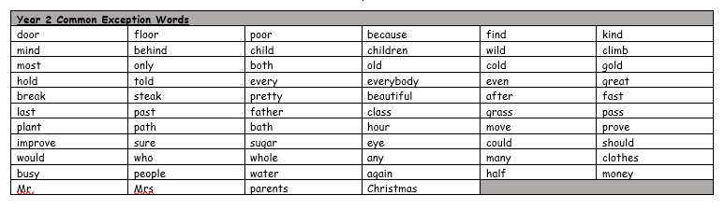
Group 1
Word
when
where
said
they
there
think

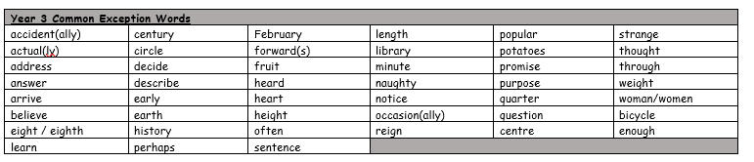
You will be tested on these words for the next few weeks. Please make sure you practise them at home.

Spellings Doves Date: 29.4.22 To be tested: 6.5.22
Group 2
Word
science
scissors
scene
descend
muscle
ascend

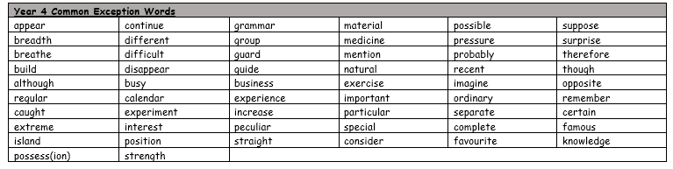

Spellings Doves Date: 29.4.22 To be tested: 6.5.22
Group 3
Word
ascend
scientist
scenery
fascinate
crescent
discipline

