Spellings Doves Date: 3.12.21 To be tested: 10.12.21
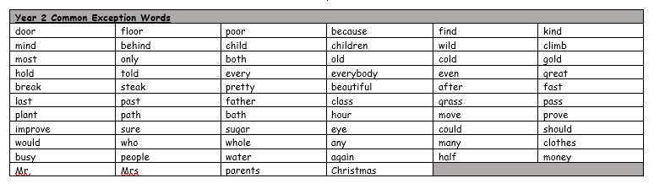
Group 1
Word
arrive
learn
circle
heart
stayed
played
sentence

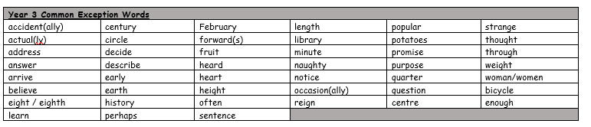

Spellings Doves Date: 3.12.21 To be tested: 10.12.21
Group 2
Word
minute
accident
quarter
promise
decide
bicycle
popular
library

Spellings Doves Date: 3.12.21 To be tested: 10.12.21
Group 3
Word
island
regular
straight
interest
surprise
complete
business
continue
