Spellings Doves Date: 4.2.22 To be tested: 11.2.22
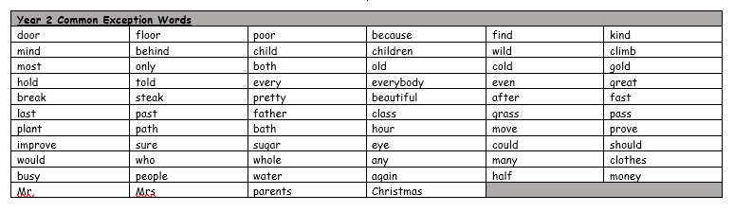
Group 1
Word
subway
subsoil
teleport
telephone
because
about

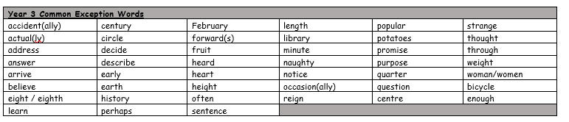

Spellings Doves Date: 4.2.22 To be tested: 11.2.22
Group 2 and 3
Word
television
telescope
submarine
submerge
subheading
telegraph

