Spellings Doves Date: 4.3.22 To be tested: 11.3.22
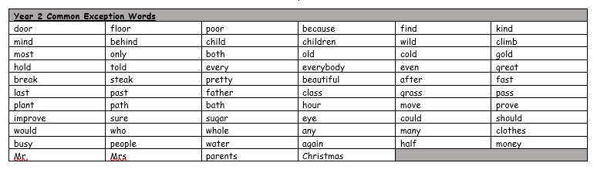
Group 1
Word
caution
option
fiction
action
vision
mission

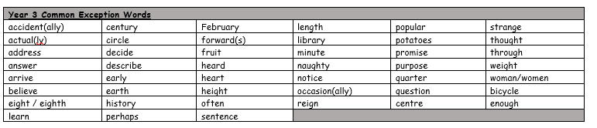

Spellings Doves Date: 4.3.22 To be tested: 11.3.22
Group 2
Word
creation
explosion
extension
subtraction
decision
position

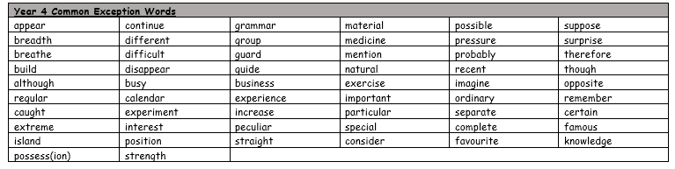

Spellings Doves Date: 4.3.22 To be tested: 11.3.22
Group 3
Word
possession
instruction
expression
confusion
decoration
protection

