Spellings Doves Date: 6.5.22 To be tested: 13.5.22
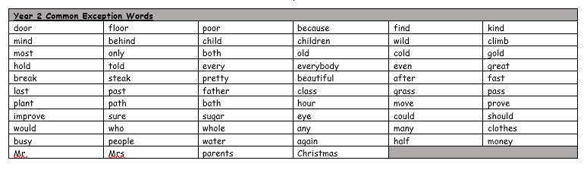
Group 1
Word
when
where
said
they
there
think

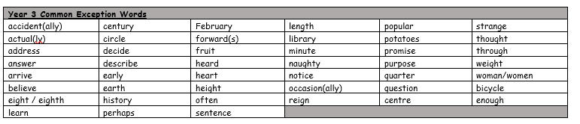
You will be tested on these words for the next few weeks. Please make sure you practise them at home.

Spellings Doves Date: 6.5.22 To be tested: 13.5.22
Group 2
Word
who’s
whose
mist
missed
team
teem

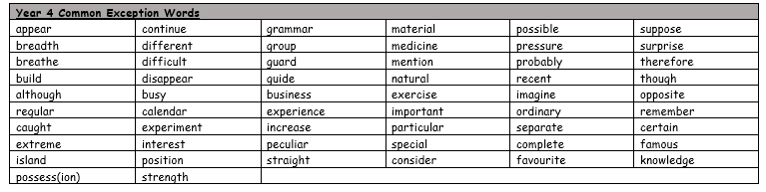

Spellings Doves Date: 6.5.22 To be tested: 13.5.22
Group 3
Word
medal
meddle
weather
whether
whose
who’s

