Spellings Doves Date: 7.1.22 To be tested: 14.1.22
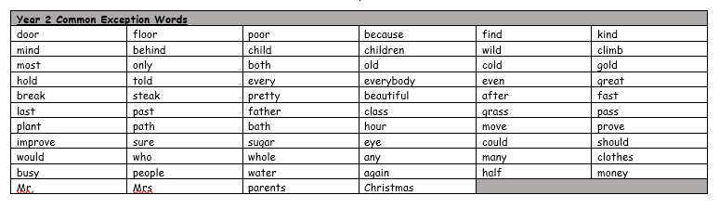
Group 1
Word
guess
guide
city
Ireland
England
Scotland
Wales

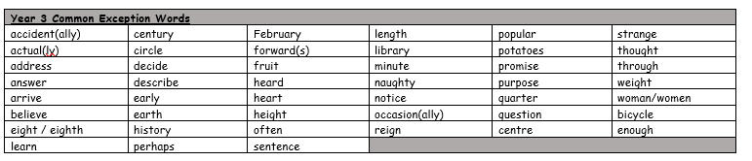

Spellings Doves Date: 7.1.22 To be tested: 14.1.22
Group 2
Word
guide
guess
guitar
guest
guard
guilt
country
cities

Spellings Doves Date: 7.1.22 To be tested: 14.1.22
Group 3
Word
guarantee
guidebook
guessed
guardian
guidance
guilty
country
cities
