Spellings Doves Date: 8.10.21 To be tested: 16.10.21
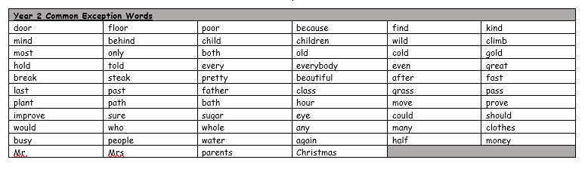
Group 1
Word
can’t
don’t
didn’t
doesn’t
I’ll
you’ll
hasn’t

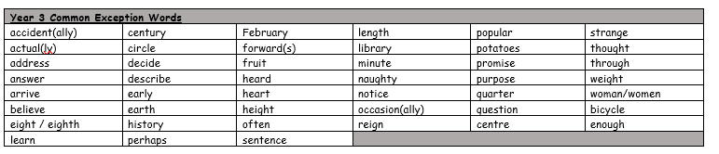

Spellings Doves Date: 8.10.21 To be tested: 16.10.21
Group 2
Word
hasn’t
shouldn’t
they’ll
they’re
doesn’t
couldn’t
the girl’s
the child’s

Spellings Doves Date: 8.10.21 To be tested: 16.10.21
Group 3
Word
could’ve
we’ll
they’ve
they’re
wouldn’t
children’s
teacher’s
