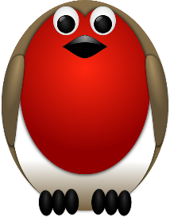
Transition Activities for Robins
To help you get ready for September please complete the activities below.

Watch my All About Me video.  I would like you to then complete the All About Me activity sheet to find out more about you and your favourite things. | Starting a new class and meeting new people can be a bit scary (even for grown ups!)  I would like you to do some writing about what you are looking forward to in Robins and any worries or questions you may have. | Take a look at the Transition Activity Pack. There are lots of things to keep you busy over the summer.  I’d love to see what you’ve been up to!
Read ‘The Little Book of Hope’ booklet.  What does hope mean?  What hopes do you have for the coming school year in year 1 or year 2? | Watch my story time video of ‘Barry The Fish With Fingers’.  Did you like the story? What was your favourite part?  'Barry was no ordinary fish'. What does 'ordinary' mean?  Puffy, the puffer fish, can blow the best bubbles. Think about your talents... what are you good at doing? | Research our class bird – Robin.  Where do they live?  What do they eat?  Create a picture of a Robin that we can display in our classroom in September.
Have a look at the photographs of our classroom. Talk about them with a grown up.  What can you see?  Where will you come into school?  Is there anything you want to know? | When we are learning it is important that we all follow our class rules.  What rules do you think we should have?  Can you write a list of ideas that we could share on our class charter? | I’d love to know what your favourite story is.  Can you draw a picture telling me about it that we can display in our reading area?  Perhaps you get a grown up to record you reading it in an unusual place! You could email me your video and we could share these during our first week back in September.

Have a fantastic Summer and I look forward to seeing you all soon!

Mr Boyd
s.boyd@carletongreen.lancs.sch.uk

