What have we been up to this half term?
Our topic for the Summer Term is World War II. We have been learning all about the causes of the war as well as the ‘Blitz’ and its impact on Britain. Linked to this, in our English lessons, we have been producing lots of wonderful written pieces including biographies, diaries and more. The fantastic novel that we are currently reading in our classes is ‘Letters from the Lighthouse’ by Emma Carroll.
We have been fortunate to have a visitor provide an assembly and in-class workshops all about the religion of Islam. This has enhanced the children’s understanding and learning of this topic.
This past week, we have been celebrating ‘Healthy Living Week’ during which the children have participated in a range of activities related to physical and mental health, keeping active and eating a healthy, balanced diet etc. The children also participated brilliantly in our whole-school Sports Day on Monday 23rd May. We celebrated the Queen’s Platinum Jubilee with a themed picnic during which all our classes performed songs/dances from different decades of the Queen’s reign.
Auditions have been held, and roles have been assigned for our upcoming production of ‘Shakespeare Rocks’… The children and the staff are all really excited about this!
What’s coming up?
We are going to be continuing with our topic of WW2 and will be diving deeper into the history and geography aspects of the war. We will also be producing some stunning ‘Blitz’-inspired artwork, creating our own morse code machines, and partaking in an exciting World War II workshop. Both year groups will have the opportunity to visit ‘Water Park’ – Year 5 will participate in day-visits, whereas Year 6 will be going on a residential. There will be two performances of ‘Shakespeare Rocks’ so make sure to keep your eye out for when tickets are released!
Homework
Thank you for all your help and support with your child’s learning at home. Just a reminder that homework can be found on each of the class’s home learning pages every Friday – please make sure to check this weekly to ensure you know what they are being asked to do. Aside from homework tasks, children should be reading every day with an adult, practising their spellings (to be tested on Fridays) and spending some time, daily, on IDL and TT Rockstars. Please record in your child’s reading record any work that you do with them outside of school.

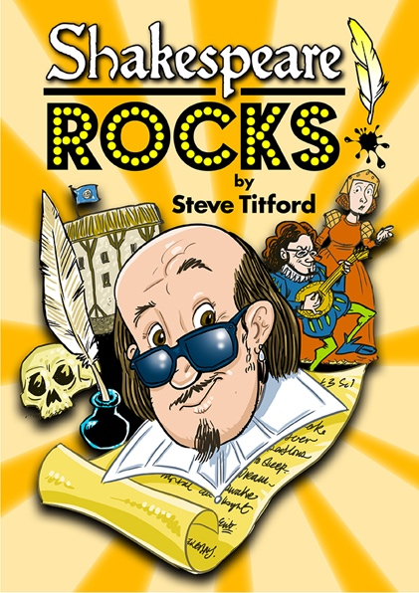

COMING SOON!

Dates for your diaries
21st / 22nd June – Year 5 Water Park visits (x2)
27th June – WW2 Workshop
29th June – ‘Shakespeare Rocks’ Performances (x2)
WB 4th July – Transition week
WB 11th July – Year 6 Water Park visits
15th July – Year 5 visit to St. Aidan’s
20th July – Year 6 Leavers Assembly & BBQ
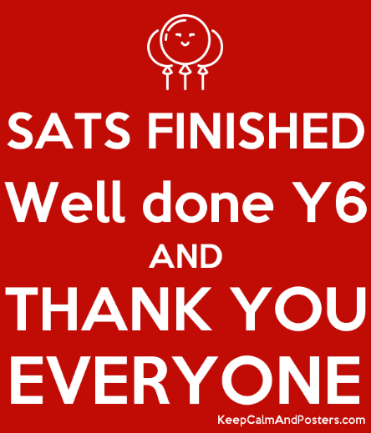

If you have any questions, please email your child’s class teacher:
Mrs Billington – j.billington@carletongreen.lancs.sch.uk
Mrs Bagwell – s.bagwell@carletongreen.lancs.sch.uk
Mrs Danyadi-Elliott - j.danyadi@carletongreen.lancs.sch.uk
Mr Thorpe - j.thorpe@carletongreen.lancs.sch.uk

