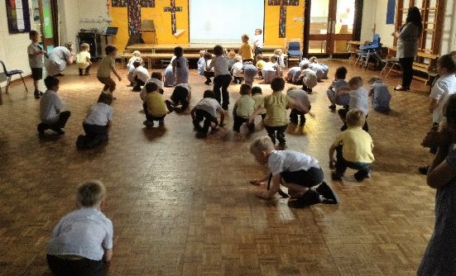
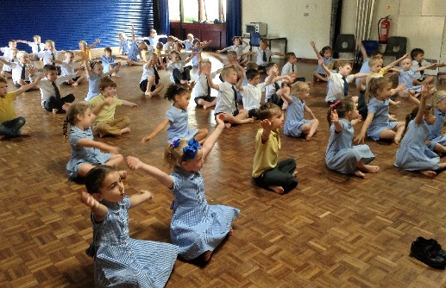
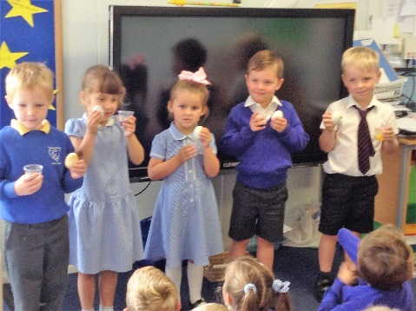
Last week was ‘Healthy Living’ week in school and we have done lots of exercise! Each day we have joined Ducklings and run/walked seven laps of the field which is equivalent to a mile! We split this into two sessions completing four laps in the morning and three in the afternoon. The children have also enjoyed a ‘Cosmic Yoga’ and a ‘Boogie Beebies’ session in the hall. We have talked about the things we need to keep healthy, plenty of sleep, healthy foods, healthy drinks, exercise and good hygiene. Along with Ducklings we did an experiment to see how different drinks effect our teeth. We placed a white duck egg in each of the following five drinks, milk, water, fresh orange, coke and sugar free blackcurrant squash and then watched what happened. All the staff were very surprised the next morning to see white sludge at the bottom of the squash cup where the squash had corroded the enamel off the egg shell.
This week is Transition week and we will take any children through to Ducklings who are due to attend the Stay ‘n’ Play sessions and collect at the end if they are due in Little Chicks that morning. On Tuesday we will be hosting our own Stay ‘n’ Play for the children joining us in September.

Graduation
Little Chicks Graduation will be held on Wednesday 19th July at 2pm. The children who are leaving Little Chicks will be performing their favourite story and there will be a presentation. If your child does not attend on this afternoon, please could they be in the setting by 1.45pm. A letter about costumes has been sent out and we would appreciate it if these could be sent in by Wednesday 12th if your child is in all day on a Wednesday. If you will be bringing your child for the Graduation please could they arrive already dressed.
Please complete the slip at the end of this newsletter to indicate how many people from your family will be attending the Graduation (4 seats available per family). Thank you.

Learning Journeys – For those children who are graduating from Little Chicks on Wednesday 19th we will be emailing the children’s Learning Journeys out at the beginning of next week. Please ensure we have an up to date email address for you.

You can help your child learn by: talking to your child about new beginnings. The similarities and differences they may find in their new school/class. Involving your child with the buying of their uniform and helping them to become as independent as possible in things like dressing, cutting up their own food and personal hygiene.

Wellies – This week we will be putting out the welly trolley each night, please can you take your child’s wellies home. Thank you.

Dates for your diary:
Monday 10th, Tuesday 11th and Wednesday 12th July – Ducklings Stay ‘n’ Play
Tuesday 11th July Stay ‘n’ Play for new Little Chicks 9.30 – 11 am
Wednesday 19th July – Little Chicks Graduation 2pm
Friday 21st July – Little Chicks closes for summer
Monday 4th September – Little Chicks opens for the Autumn term

Little Chicks Graduation Celebration

Child’s Name: ____________________

Please can I reserve ___________ seats for the Graduation Celebration.

Signed _______________________________

_____________________________________________________

