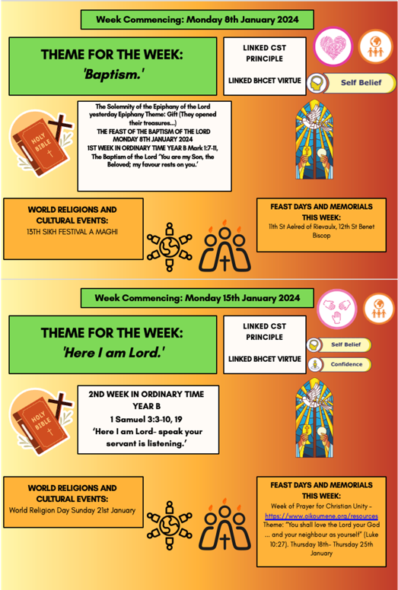
Updates for W/C 8th January- 19th January 2024. We are in the Season of Ordinary Time Year B
Social Media Platforms.
Keep up to date with our very active social media platform. We love to celebrate success and share great news. Please follow, like and share.
Facebook:@carmelcollegedarlington Instagram: @carmelcollegedarlington

Trips and Excursions
Ski Trip | 11th till 17th February 2024
Barcelona Trip | 15th till 18th February 2024
WW1 Battlefields Tour | 16th till 18th February 2024
Lourdes | 30th March till 6th April 2024
RE London Trip (Year 7s) | 02nd till 04th April 2024
Paris | 09th till 12th April 2024

Please click here for the latest copy of our online safety newsletter

- Attendance continues to be an important focus, with a weekly prize draw for those with 100% attendance. Your child could win a £5.00 Amazon voucher.
- Jewellery reminder - no hoops, rings, bracelets or necklaces.

PSHE and
Well-Being
Key Dates and Upcoming Events
Event | Date
Students return from Christmas Holiday | Tuesday 9th January 2024
Year 9 Option Evening | Tuesday 16th January 2024
Year 11 Parents Evening | Tuesday 30th January 2024
February Half Term Break – School Closed | Monday 12th February 2024
Students return to College from February Half Term | Monday 19th February 2024
Year 11 Prom Date | Monday 1st July 2024
*Passports needed in to scan for trips - Ski, WW1 Battlefields, Barcelona & Paris

Important Messages for Parents
- Click here for the College calendar
- Click here for more information on the importance of good attendance
- Click here for our parking pledge
- Please remind your children that chewing gum is prohibited at Carmel College.

Extra-Curricular
Opportunities
CARMEL COLLEGE HOUSE SYSTEM – SCORES ON THE DOORS.

Christmas Karaoke was a "sleigh"-tacular success on Fun House Friday! We had a blast spreading Christmas cheer and singing our hearts out. It's safe to say we sleighed the mic! Thanks to everyone who joined in.

Latest Newsletter
Carmel Sixth Form Information
Catholic Life
Prayer and Liturgy
Curriculum Overview
- The Christmas Liturgy was an overall success, it was nothing short of magical! A heartfelt thank you to everyone who played a part in making it a fantastic experience. The evening was filled with prayer, song, and Christmas cheer.
- Our amazing choir visited several care homes in the first few weeks of December, for a delightful Christmas carol session filled with joy and cheer! Our incredible students have shown their dedication to spreading the Light of Christ to all the residents, and we could not be prouder.
- We extended a warm welcome to our elderly friends of the community by hosting a festive party to our neighbours, the afternoon was filled with love, friendship, music and refreshments, a delightful afternoon enjoyed by all.

Wider College Events

