SEND Information Report
Carmel College
Approved on:
July 2023
Next review:
June-July 2024

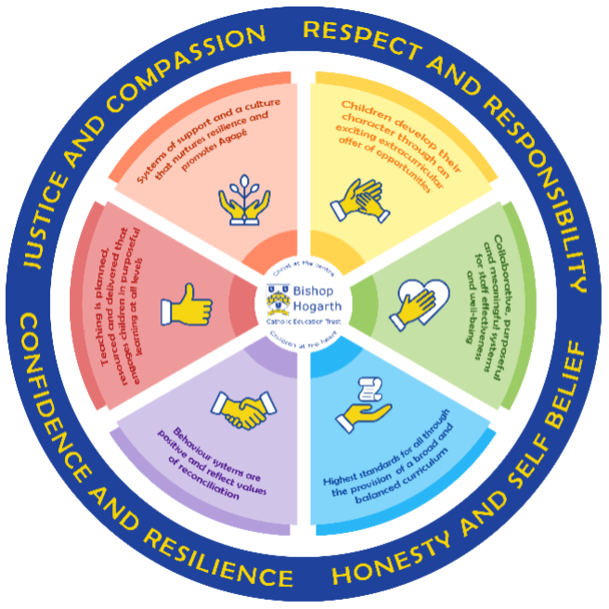
As part of the family of Bishop Hogarth Catholic Education Trust, our school has at its core, the virtues, and values of:
Respect for others and themselves, recognising that we are all created in the image of God and therefore must be compassionate towards others, especially the vulnerable. ​
Confidence in their own abilities, knowing that their talents are gifts from God and resilience to persevere when things become difficult. ​
Honesty in regard to the world around them and themselves and the ability to take responsibility for the times we may fall short of the mark. ​
Gratitude for all the amazing gifts from God and willingness to share their gifts both personal and material. ​

As an inclusive school, all teachers are teachers of pupils with Special Educational Needs & Disabilities. We deliver a curriculum and create an environment that meets the needs of every pupil within our school. We ensure that every pupil with Special Educational Needs and / or disabilities makes the best progress possible. We foster and promote effective working partnerships with parents / carers, pupils, and outside agencies. We consider the ‘whole’ child and strive to ensure that all our SEND pupils are prepared for adulthood.​

Our School’s approach to supporting pupils with SEND

The ethos of Carmel College is built around our mission as a Catholic college. Through following Gospel values in everything we do, we aim to ensure all members of our community are individually provided with the care, respect and compassion that all unique individuals deserve. Our community must be characterised by supportiveness, a welcoming approach, a caring ethos with justice given to all within it. We shall strive to provide opportunities and an environment in which all pupils develop according to their full potential. We must seek to ensure that all members of our community experience and find hope, joy and fulfilment and a sense of their own worth and that of others by participating as fully as possible in college life.

‘I came that you may have life in abundance.’

John Ch10 v10

Our Core Offer:
•Teachers are responsible for the progress of ALL students in their class. High quality teaching is personalised to meet every child’s need. This is the first step in supporting students who may have Special Educational Needs and Disabilities (SEND). All children are challenged to do their very best and make the most progress that they can.
• All children will be taught a broad and balanced curriculum. Where children require extra support, adaptive teaching, specialist resources or extension materials will be provided wherever possible.
• Where it is perceived that students may require access arrangements, such as a computer reader or access to a word processor for external exams, and it is their usual way of working in class, they will undergo psychometric testing in college via our specialist assessor. Identification of such students is a collaborative effort from teaching, pastoral and SEND staff. Assessment usually takes place in the summer term and results are shared with parents at the Academic Mentoring Day in the autumn term or before, where possible.
• All students are known well by their form tutor who develops strong relationships with them, with further support from their Pastoral Learning Manager, Assistant Pastoral Learning Manager, SENDCO and Teaching Assistants. Good behaviour and organisation are rewarded. Sanctions exist to support consistently high standards of behaviour.
• Your child can express their views in several ways, including via their school council representatives or directly to staff.
• We manage medical needs by working closely with parents and healthcare professionals and use the information and advice to develop and review students’ Individual Health Care Plans (IHCP). We also listen to and act on their advice, providing staff training when needed. Please see: Supporting students with Medical Needs.
• We run a wide range of extra-curricular clubs including rugby, football, arts and crafts, band, robotics, sailing and climbing. The Emmaus Centre is an inclusive space, available for any student who may need temporary additional support.
• Our SEND Governor has regular involvement with the Department and is kept appraised of all aspects relating to inclusion.

How will the school staff support my child?
The graduated response-identifying, planning for and supporting students with SEND.

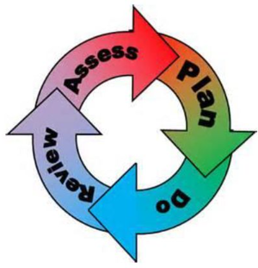

Where a student is identified as having a special educational need, college will follow a graduated response approach which takes the form of cycles of ‘Assess, Plan, Do, Review’. ​
• Assess a child’s special educational need. ​
• Plan the provision to meet your child’s aspirations and agreed outcomes. ​
• Do put the provision in place to meet those outcomes. ​
• Review the support and progress.

How does the school know if children need extra help and what do I do if I think my child has special educational needs?

- Assess
We follow the following steps in college, our aim is to follow a graduated approach:
•Identification – Students are identified in several ways including communication with parents,, primary schools, Year6-7 transition work and analysis of current and prior attainment data. The steps taken are a graduated approach as set out in the 0-25 Special Educational Need and Disability Code of Practice 2014. A copy of this can be found on the college website under SEND.
Where a student has received support in primary school, discussions with parents/carers, the student and the class teachers/SENDCo will help to inform provision.
Your child will be identified as having SEND if they have significantly greater difficulty in learning than the majority of children of the same age or if they have a disability preventing or hindering the use of educational facilities provided for children of the same age within the Local Education Authority.
•First steps - if from our rigorous tracking and monitoring of your child’s progress, it becomes apparent that he/she is not making expected progress then you will be invited to a meeting with their Pastoral Learning Manager, Mrs Pinnock (SENDCo) and / or Mrs Julian (Assistant Vice Principle for Learning Support). At the meeting we will begin to explore the possible barriers to learning and you will be asked how we can best support your child. We may agree to add your child to the ‘shadow SEN register’ for further monitoring and to alert all teaching staff.
• Observations and assessments will then be carried out and, if required, input from specialist services may be sought with your permission.
Below is a list of expertise/specialist services accessed by college where appropriate:
• Educational Psychologist • Mental Health Support Team
• Occupational Therapists • Speech and Language therapists
• Hearing Impaired Service • CAMHs – Child and Adolescent Mental Health Service
• School Nurse and Health Visitors • Emotional Resilience Nurse
• Social Communication Outreach Service (SCOS) • Cognition and Learning Outreach Service

• SEN Register: Where appropriate, your child may be placed on our college’s SEN Support Register and, where necessary, a support plan will be devised and agreed. This process will involve your child as much as possible in its development and, of course, will be strengthened with your own actively sought advice and suggestions.
•EHCPs (Education Health Care Plans) will be used when a child’s needs are deemed more complex and require the input from a range of outside agencies. This could be in the form of Educational Psychologists, Occupational Therapists or other professionals with an area of expertise, e.g. Autism. An EHCP helps to determine the level of educational, social and health support the child needs.
If you are concerned about your child’s progress or that your child may have SEND, please contact our SENDCo, Katrina Pinnock or the Assistant Vice Principle for Learning support, Lin Julian on 01325 254525.
In some cases, pupils may develop so that they no longer require specific SEND support. If this happens then the SENDCo will carry out observations and, in discussions with staff and parents/carers, look to remove the student from the SEND register.

- Plan
Our procedures are in line with the Special Educational Needs and Disability Code of Practice (2015).
• All teachers are teachers of students with SEND. All teachers and support staff will be made aware of the student’s needs, the support provided, and any strategies needed. This information will be recorded on the college’s SEND Information Microsoft Teams Tile and shared with staff. The information provides our staff with suitable strategies and approaches to help them meet a wide range of learning needs. Our team of Teaching Assistants are deployed where they can best serve students’ needs in close collaboration with teachers. The SENDCo oversees the deployment of staff.
• Where it is decided to provide a student with SEND support, parents/ carers and the student will be informed. The student will have an appropriate SEND information document put in place, such as a Pen Portrait, a One Page Learner Profile or a SEN Support Plan, with clear strategies and support based on their individual need.
• Where a student fails to make adequate progress, despite additional intervention, we seek advice from relevant outside professionals. These include, but are not exclusive of Educational Psychologist, Hearing/Visual Impairment Team, Occupational Therapy, Child and Adolescent Mental Health Service (CAMHS), Early Help and LA Outreach Services provided by the Local Authority SEND team. These professionals may need to carry out their own assessments and observations. This is done with full consent from parents/ carers.
• Information about a students’ SEND is securely shared with staff via the Microsoft Teams.
• Following discussion with students and parents/ carers, additional provision is planned carefully and overseen by Mrs Pinnock, the Special Educational Needs and Disabilities Co-ordinator (SENDCo). We modify teaching and learning approaches and the environment to facilitate access for all students. We happily comply within expectations set within equality and disability law.
• At Carmel we have an extensive range of different SEN resources and interventions available. These are closely matched to the needs of our children and their progress is monitored by the class teachers, the SENDCo and staff with specific curriculum responsibilities.
• Year 9 Reviews have a clear focus on options for Key Stage 4 and these are also the focus for Year 11 students when considering post-16 choices and we work closely with our own Careers Advisor and local colleges to ensure full participation post-16.
• Where provision does not result in adequate progress, as outlined in the Code of Practice, Mrs Pinnock / Mrs Julian should be consulted for advice.

- Do
Our teachers are skilled at adapting teaching and learning to meet the diverse needs in each class.:

- Daily planning considers individual children’s needs and requirements and is annotated and adapted according to need.

- Explicit reference is made in the teacher’s planning to the needs of those children identified with SEND. ​

- Adaptive teaching is approached in a range of ways to support access to the curriculum and ensure that all children can experience success and challenge in their learning. ​

- Grouping arrangements consider the different skills and abilities of each child. This ensures that learning is maximised. ​

- Additional adults support groups and individual children with the long-term goal of developing independent learning skills. The class teacher monitors this support to avoid students becoming over reliant on this. ​

- We fully encourage parental support and offer opportunities for individual meetings with parents/carers to provide clarity and recommendations on how they can support their child at home.

We fully encourage parental support and offer opportunities for individual meetings with parents/carers to provide clarity and recommendations on how they can support their child at home.

- Review
• The impact of the support on the students’ progress will be reviewed termly. The impact of this support along with the views of the students and his/her parents will be used to decide on any changes to the support considering the student’s progress.
• The student will always be at the heart of the review process at Carmel College. Every effort will be made to ensure that student welfare, well-being and academic progress is of the highest quality. The college will inform and involve the family at every stage and work with them to provide the support that the student requires to progress as expected. Your child’s teachers will manage and guide any relevant learning interventions which will be reflected in lesson planning. Data is closely monitored and reviewed by Heads of Department, class teachers, Pastoral Learning Managers and the Assistant Vice Principal for Learning Support to ensure that your child’s provision is having a positive impact on outcomes.
• It is sometimes appropriate for a member of the SEN Department to work with your child in lessons or within a time-limited intervention. This can provide the opportunity for close individual monitoring of engagement and progress, and you will be kept advised of any significant success or concerns.
• Where a student continues to make little or no progress, the college will consider, with parental consent, the involvement of external specialists. The SENDCo, subject teacher and specialists will consider what is required to support student progress e.g., strategies, appropriate equipment, etc. Following this, we set a date to review the support. Support may be adapted or replaced depending on how effective it has been in achieving expected outcomes.
• ‘Additional’ or ‘different’ provision is delivered in a range of ways, and we encourage you to get involved in your child’s additional provision as we believe that best outcomes are achieved when there is a consistent home/college approach being taken wherever possible.
If good progress is still not being made, despite all steps taken, we move to the next step of the graduated approach put forward withing the 0-25 Special Educational Needs and Disability Code of Practice.
• Consultation sessions are held in the Autumn and Spring terms when you can meet your child’s academic mentor to discuss work in different subject areas.
• If your child has an EHC plan, you will be invited to a review at least annually.

How will the curriculum at our school be matched to my child’s needs?
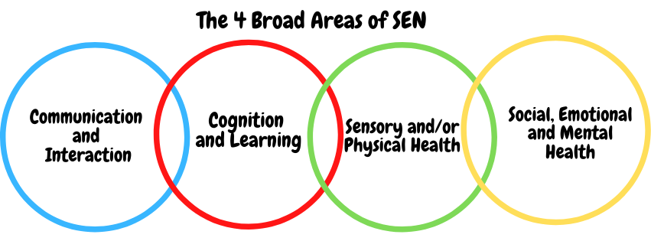

SEN needs are classified under four broad areas of need. Below are the strategies, in class support and interventions that school may put in place to support your child.

Communication and Interaction
Strategies to support children with these needs include:
- Carefully selected groups and support during group work.
- Support during unstructured time.
- Access to extra-curricular activities specifically designed to improve communication and interaction.
- Specific interventions where appropriate, e.g., to encourage improved management of anxiety.
- Access to external agencies for advice and example strategies.
- Home-School contact book to keep parents/carers readily informed of activities during the College day.
- Access to small group and/or individualised interventions
- Timetabled rest and regulation breaks
- TA support
- Access to low stimulus areas/safe space.
- Flexible approaches to timetable.
- Modifications to lunch and break times.
- Access to technology e.g., laptop.
- Access to social and emotional stories, feelings cards.
- Careful planning of transition
- Access to Social and Communication Outreach Service
- Access to Speech and Language Therapist
- Access to Educational Psychologist
- Access to Daisy Chain

Cognition and Learning
Strategies to support children with these needs include:
Highly differentiated class and homework tasks
• Key words sheets, scaffolding, sentence starters, writing frames and modelling
• Support with organisation e.g., pictorial timetables
• Activities broken down into chunks with clear, explicit instructions
• Small group and 1:1 intervention where appropriate
• Practical aids for learning, overlays, ‘now and next’ cards
• Increased adult support if needed.
• Adaptations to assessments to enable access - computer readers, word processor, additional time.
• Support from outside agencies e.g., Educational Psychologist
• Support from the LA Cognition and Learning Service
• Rest breaks
• Phonic/reading development programmes e.g., Read Write Inc Fresh Start and Accelerated Reading.
• Increased ICT - laptop, reading pen, iPad.
• Curriculum will be adapted to meet the learning needs of the child.
• Pre and post teaching of vocabulary and new concepts.
• Frequent repetition and reinforcement – retrieval practice.

Sensory/Physical
Strategies to support children with these needs include:
- Access to the Student Support Office to take medication
- Radio Aids, Roger Pen, Sound field System
- Access to Sensory Support Services e.g., Low Incidence Needs Team, for advice on planning for students with a visual or hearing impairment.
- Flexible teaching arrangements will enable students to move seats to access lessons
- Teachers will be made aware of the implications of physical and sensory impairments.
- Use of alternative coloured background on white boards.
- Development of an Individual Health Care Plan for the support of more serious medical needs
- Advice taken from outside agencies where appropriate and liaison with them for specific equipment to aid access to the curriculum.
- Access to specialist teachers for the hearing/visual impaired.
- Adapted curriculum to enable full access e.g., alternative recording device, modified PE curriculum.
- Where illness-related absences occur PLMs, Form Tutors and the SEND Department will liaise directly with parents/carers and pupils as to how best to support them and work will be sent home or shared on Microsoft Teams where appropriate.
- Individual Health Care Plans are written by the SEND Department in conjunction with parents/carers for students with more complex health care requirements. These are reviewed at least termly with PLMs and the Vice Principal for Pastoral Care.
- Parents/Carers are responsible for providing College with accurate information and an up to date supply of medication (Supporting Students with a Medical Condition Policy).

Social, Emotional and Mental Health
Strategies to support children with these needs include:
- Access to the Emmaus Centre, where your child can receive the support of an experienced Emotional Literacy Support Assistant, Thrive practitioner and Emotional Wellbeing Coordinator via individualised interventions.
- Support from PLMs and Form Tutors
- Monitoring of behaviour via ClassCharts.
- Meet and greets.
- Use of key worker mentoring to suite the needs of the individual.
- Consistent links with the SENDCo and families for support and information sharing
- Information from parents shared with relevant staff in College
- Positive Behaviour Support Plans
- Advice from outside agencies where appropriate e.g., Early Help to promote safe behaviours.
- Increased access to additional adults in the classroom
- Alternative curriculum opportunities including modified timetables.
- Regulation Breaks
- Advice from outside agencies where appropriate e.g., Early Help to promote safe behaviours.
- Individual rewards system
- Social and emotional stories
- Access to CAMHS and Educational Psychologist.
- Emotional Resilience Nurse
- Mental Health Support Team
- Access to Early Help Team (LA)
- Managed Moves

Well-being.
• Pastoral Care is at the heart of College life. There is an extensive PSHEE curriculum developed by PLMs and delivered by Form Tutors on a weekly basis. Key topic areas include career planning, relationships, self-awareness, E-Safety, bullying and Emotional Wellbeing and Mental Health.
• The Learning Support Department offers input which is embedded into the PSHEE curriculum to raise awareness of diversity issues and actively prevent bullying of those with SEN and/or a disability on an individual basis.
• Social Support for students is offered in a variety of individualised ways including support from the SEND Department during unstructured time, specialist 1:1 intervention programmes and extra-curricular activities aimed at building on communication and interaction skills, as well as support from the Emmaus Centre and an Emotional Literacy Support Assistant, Thrive Practitioner and Wellbeing Coordinator.

Emotional Health and Well-Being.
We have a whole school approach to promoting emotional health and wellbeing in accordance with the National Institute for Health and Care Excellence (NICE) guidelines.
• We take a strategic approach to the promotion of emotional health and wellbeing. We have developed a systematic and clear action plan to implement a carefully evidenced and research based policy.
• At the base of our model is the concept of universal provision whereby all our children are offered an entitlement of support and access to a curriculum and other provision including extra–curricular opportunities which helps to build independence and personal resilience.
• Children who require a higher level of support or intervention will be identified through a systematic plan, do, review methodology.
• We set up a wellbeing channel where staff access research-based guidance in their support of children experiencing difficulties linked to the impact of COVID-1
• Children with particularly complex needs will be formally assessed before they access targeted interventions or are referred to specialist provision.

Identifying needs and Referral Pathways for Interventions
Building resilience – Managing Demand
Specialist
Intervention

SDQ and Referral EHA/Educational Psychologist

In-School Targeted Interventions

Pastoral Lead/SENDCo
(Assess, Plan, Do, Review)

Universal Provision

What training is provided for staff supporting children with SEND?
Carmel College is committed to ensuring that staff training is monitored and kept up to date in order that this support is of maximum benefit to students. The College’s SENDCO is a qualified teacher and is completing the National Award for SEND co-ordination (NASENCo).
We fully comply with the requirements outlined in the Special Educational Needs Code of Practice (2014). We also make reasonable adjustments to our practices to comply with the Equality Act (2010). Staff have been trained to cater for learners who may have difficulties with:
- Cognition and Learning
- Communication and Interaction
- Sensory and/or Physical Needs
- Social, Emotional and Mental Health
Where new needs are identified for which the college is unprepared to offer provision, staff are selected and training is arranged. Where necessary, the college draws on the services of outside agencies and specialists.
We have a number of teaching assistants and support staff that are experienced/have received training in the following areas: Read Write Inc Fresh Start, Precision Teaching, Mental Health First Aid, Mental Health Champions, Emotional Literacy Support, First Aid, ACES and understanding trauma.

How do we support transition in our school?

Transition within classes/key stages: ​
• Information is passed to the new class teachers through department meetings and the SEND Microsoft Teams Tile.
Children who require additional support to ensure a smooth transition to their new classes, will also receive the required support from the pastoral and/or SEND team. Opportunities for enhanced transition for SEND pupils is available.
• If a student moves to a new school within or at the end of an academic year, we will contact the school SENDCo to ensure he/she knows about the special arrangements or support that needs to be made for the student. If necessary or possible a meeting will be arranged with other professionals. The college will also transfer all records held for the student to the new school as soon as possible.
• Our comprehensive PSHEE curriculum covers careers and a range of post-16 options.
• At all reviews from Year 9 there is a focus on levels of independence, aspirational post-16 placement, independent living and full participation in the local and wider community.
• Careers advice is delivered by the college's own qualified Careers Advisor. Where appropriate, the Careers Advisor is invited to annual reviews to discuss options for further and higher education. The Careers Advisor provides regular 1:1 careers guidance with students from years 7-13. The Careers Team arranges various careers events throughout the academic year including, school trips to local colleges and universities, employer engagement through school trips, workshops and careers fairs and provides group sessions to discuss careers, post 16-18 educational pathways, and employability. All students receive a personalised action plan which is uploaded onto Unifrog after every appointment.

Transition to Secondary settings: ​
Close links are formed with families, primary schools and any outside agencies early in the transitional phase.
- The Learning Support team, along with the Transition Lead, visit primary schools, gathers information and meets with families to gain a comprehensive understanding of students in order to provide a smooth transition and consistent support throughout.

- Students identified as requiring further enhanced transition following this are offered additional visits, activities and opportunities during the transition period e.g., tours afterhours and during the school day, 1:1 visits and lunch invitations for students with an EHCP and their families and activity afternoons for high needs students.

- The Learning support department work closely with PLMs and the Transition Lead throughout the transition period, ensuring that children are familiar with key individuals and their roles prior to transition.

- The SENDCO and Transition Lead share relevant information with teaching staff using information gathered throughout transition to teaching staff at the start of the academic year.

Transition to Post-16 Education: ​
• We link closely with the Head of Sixth Form to ensure that our young people who have identified SEND in our Sixth Form continue to receive the support they need to fully access the curriculum, assessment, advice and guidance. This increasingly includes advice about applications to universities or other training options beyond college.
• The transition process will begin in Year 10, particularly for some of our more vulnerable students. We work closely with all of the major post-16 education establishments in the area. Meetings are held for the transfer of essential information relating to EHCPS, Child and Family Services and pastoral matters. The pastoral team and the SEND team will also support students who require additional support during their transition period.
• We will also offer you the opportunity to speak to the college’s own qualified careers advisor so that you are able to support your child during the next stage of their education.
• We can also support you in organising, and if requested, joining meetings with post-16 college staff if you wish to speak to them personally.

Where can I get further information about services for my child?

The Local Offer
As a Learning Support department we work closely with Local groups and the Local Authority to explore and recommend provision surrounding the SEND needs of individuals and their families.
Please follow the link below to access information regarding services and support within Darlington:
https://livingwell.darlington.gov.uk/Categories/528

What key school documents refer to support and provision for pupils with SEND?

- SEND Policy
​ https://carmel.bhcet.org.uk/wp-content/uploads/2023/02/Special-Educational-Needs-and-Disabilities-SEND-Policy-Review-June2024.pdf

- Admissions Policy​
https://carmel.bhcet.org.uk/admissions-policy/

- Supporting Pupils with Medical Needs Policy​
https://carmel.bhcet.org.uk/wp-content/uploads/2021/09/Carmel-College-Supporting-Pupils-with-Medical-Conditions-Policy-Review-November-2023.pdf

- Accessibility Plan​
https://carmel.bhcet.org.uk/wp-content/uploads/2022/12/Accessibility-Plan-Review-July-2025.pdf

Accessibility​
We remain aware of our duties under the Equality Act (2010).
• We aim to ensure that we ‘make reasonable adjustments’ in order to comply with the duties, including adjustments to the PE curriculum where appropriate.
• Our College is highly accessible for wheelchair users.
• We work closely with the Low Incidence Needs Service (LINs) to inform ourselves and ensure we deliver the highest provision for children with Auditory and Visual impairments.
• We are committed to offering all students the same opportunity to activities outside of the classroom including extra-curricular activities and College trips, where Health and Safety is not compromised.
• The College SENDCo allocates support on a needs basis. This can take the form of 1:1 support, small group interventions and support to fully access the facilities or extra-curricular activities in College.
• We create an environment that meets the Special Educational Needs of each child and their family in order that pupils can achieve their full learning potential and engage in activities alongside pupils who do not have SEND.
We have high aspirations for all of our learners with SEND.

Activities Outside of School​
Carmel College is an inclusive college and we will put in place appropriate support, whenever possible, to enable students to be educated alongside their pers. This may include extra staffing and/or equipment.
Staff who are arranging an offsite trip will discuss with parents/carers and the SENDCO any requirements needed and the suitability of any trip which the school is taking part in.
We will not stop students from gong on a trip due to their special educational needs and/or disability if the trip is suitable for the student, and their safety and the safety of others is not compromised. Please refer to our college Equality Act policy.
There is a designated Assistant Vice Principal who oversees all trips to ensure students are safe and included where possible, along with the Principal.

What to do if you have a complaint, a compliment, or a query.

The school details and relevant contacts
If you have any concerns about your child at any time, you can contact your child’s Pastoral Learning Manager either via email or by contacting College directly via Reception, on 01325 254525
Alternatively, with regards to queries related to specific issues surrounding SEND provision, you can contact Mrs K Pinnock / Mrs L Julian on 01325 254525
Or
Email
kpinnock@carmel.bhcet.org.uk
ljulian@carmel.bhcet.org.uk

We welcome feedback from all of our parents.
​
Name of school SEND governor.
Awaiting re-election

