KS3 Geography Curriculum

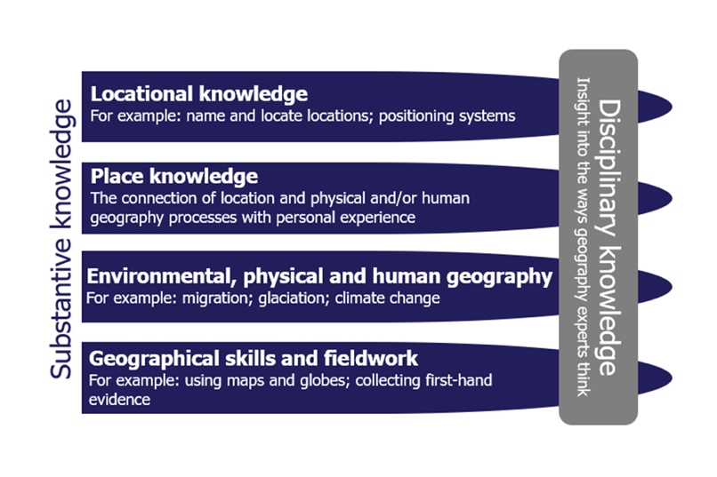
Our KS3 geography curriculum is centred upon place, synopticity and geographical skills as fundamental aspects of the spiral curriculum. The aim is for pupils to gain a knowledge and understanding of core geographical concepts and processes by embarking on a journey through the continents. This is an important aspect of our curriculum as this enables pupils to continuously revisit concepts/processes in a variety of contexts. The intention is that pupils will have not only gained an overall sense of how geography operates on a global scale but also have a multidimensional view of countries/regions. The geography curriculum can often fall into the trap of promoting a one-dimensional dialogue of a ‘place’ and therefore the intricacies and diversity of a ‘place’ can be missed i.e. pupils often only learn about flooding when examining Bangladesh. Therefore, our curriculum is designed to eliminate this narrow presentation of both place and geographical concepts/processes and instead promotes a much richer understanding of the world we live in.
Ofsted Geography Review, 2021

Key threshold concepts outlined in the National Curriculum including locational knowledge, place knowledge, human and physical geography and skills will underpin our curriculum. Pupils will be able to enhance their geographical understanding through the interpretation and analysis of source material. Furthermore, pupils will understand how geographical skills, both numerical and statistical, are used to describe and evaluate geographical patterns and trends.

Main continent/region of study:
Europe | Africa | North America | Middle East | Russia | South America | Antarctica/Arctic | Asia | Global

 | Year 7 | Year 8 | Year 9
Autumn half term 1  Sequential knowledge and skills | Me and my world  NC link: Sense of place, map skills  - What is geography?  - What is a sense of place?  - Locational knowledge (UK, Continents and Oceans)  - The geography of the UK  - Map skills: OS map symbols, 4/6 figure grid references, contour lines | The Almighty Dollar  NC link: Economic geography, sectors of industry, international trade and development, globalisation  - Where does money go when you spend it?  - What are the sectors of industry?  - China: the workshop of the world?  - Chinese investment in Africa  - Is China’s involvement in Africa neocolonialism? | Asia: tectonics and tropical rainforests  NC link: Plate tectonics, tropical Rainforests  - Where is Asia?  - Plate tectonics 101: structure of the earth; convection currents; plate boundaries  - How are earthquakes formed at destructive plate boundaries?  - Case study: Japan 2011  - Asia’s tropical rainforests: location and climate  - Asia’s tropical rainforests: structure of the rainforest and adaptations  - Case study: Deforestation in Malaysia
Assessment Content | Key Homeworks set in line with College homework policy.  There will be a mixture of teacher assessment, peer assessment and self-assessment.  Formal end of unit assessment; there will be a mix of short knowledge-based retrieval questions, as well as extended writing. | Key Homeworks set in line with College homework policy.  There will be a mixture of teacher assessment, peer assessment and self-assessment.  Formal end of unit assessment; there will be a mix of short knowledge-based retrieval questions, as well as extended writing. | Key Homeworks set in line with College homework policy.  There will be a mixture of teacher assessment, peer assessment and self-assessment.  Formal end of unit assessment; there will be a mix of short knowledge-based retrieval questions, as well as extended writing.
Autumn half term 2  Sequential knowledge and skills | Me and my world: Climate Change  NC link: Climate change, geological timescales  - What is climate change?  - What are the natural and human causes of climate change?  - What are the impacts of climate change on a local and global scale?  - What are adaptation and mitigation strategies?  - How can we reduce our individual carbon footprints? | The Middle East: a landscape of opportunity or challenge?  NC link: Use of natural resources (oil), deserts, global atmospheric circulation  - Why is the Middle East is an important world region?  - Hot Deserts (distribution, global atmospheric circulation, climate)  - Hot Deserts (plant and animal adaptations)  - How can the climate of the region create challenges?  - Why is the population of the Middle East so diverse? | Asia: the most populous place on Earth  NC link: Population and urbanisation, push-pull theory, demographics (population pyramids, one child policy etc), trade links, international development  - China: what is life like in China?  - Population distribution across Asia  - China: introduction to demography; including key terms, population pyramids and the demographic transition model  - China: The One Child policy  - Ageing populations in Asia  - China: an emerging superpower
Assessment Content | Key Homeworks set in line with College homework policy.  There will be a mixture of teacher assessment, peer assessment and self-assessment.  A POP task will be used as summative assessment. | Key Homeworks set in line with College homework policy.  There will be a mixture of teacher assessment, peer assessment and self-assessment.  A POP task will be used as summative assessment. | Key Homeworks set in line with College homework policy.  There will be a mixture of teacher assessment, peer assessment and self-assessment.  A POP task will be used as summative assessment.
Spring half term 3  Sequential knowledge and skills | Why does it always rain on me?  NC link: Weather and climate, air pressure, flooding  - What is the water cycle and what happens when rain hits the ground?  - How does it rain and how does air pressure influence this?  - What are the different types of rainfall?  - What is a drainage basin?  - What factors lead to flooding?  - Infiltration experiment (fieldwork)  - Flooding case study (Europe) | How do coastlines change shape?  NC link: Processes of erosion, transportation and deposition, rocks, weathering and soils, coastal landforms and management  - What are the features of coastlines?  - What are the two different types of waves and how do waves shape coastlines?  - What are the key coastal processes?  - How does coastal erosion shape coastal landscapes?  - What is the impact of coastal processes on people living on the coast?  - How can coastlines be managed? | Glaciation: the power of ice!  NC link: Glaciation, Russia  - What is the political and physical geography of Russia like?  - What is the climate and associated biomes of Russia like?  - Where do people live in Russia?  - How are glaciers formed and how do they move?  - What are the glacial processes?  - How are landscapes shaped by glacial processes?  - How is climate change impacting glaciers?
Assessment Content | Key Homeworks set in line with College homework policy.  There will be a mixture of teacher assessment, peer assessment and self-assessment.  Formal end of unit assessment; there will be a mix of short knowledge-based retrieval questions, as well as extended writing. | Key Homeworks set in line with College homework policy.  There will be a mixture of teacher assessment, peer assessment and self-assessment.  Formal end of unit assessment; there will be a mix of short knowledge-based retrieval questions, as well as extended writing. | Key Homeworks set in line with College homework policy.  There will be a mixture of teacher assessment, peer assessment and self-assessment.  Formal end of unit assessment; there will be a mix of short knowledge-based retrieval questions, as well as extended writing.
Spring half term 4 Sequential knowledge and skills | Who do you think you are?  NC link: Population in the UK, Migration  - The UK is a diverse country  - Measuring population  - The population of the UK  - The impacts of migration  - Migration within the UK  - Living in urban and rural areas. | Incredible India!  NC link: International development, population and urbanisation, specified region in Asia, weather and climate (monsoons)  - An introduction to India  - The climate of India  - Is Mumbai the heart of India?  - Why is Mumbai’s population growing?  - What are the main issues within Dharavi?  - How should Dharavi be improved? | From source to mouth  NC link: River processes, landforms and management  - Revisiting the water cycle and drainage basin.  - The long and cross profile of a river, including processes of erosion.  - How does a river erode a V-shaped valley?  - How do waterfalls and gorges form?  - How do meanders and oxbow lakes form?  - How can humans use rivers for development?
Assessment Content | Key Homeworks set in line with College homework policy.  There will be a mixture of teacher assessment, peer assessment and self-assessment.  A POP task will be used as summative assessment. | Key Homeworks set in line with College homework policy.  There will be a mixture of teacher assessment, peer assessment and self-assessment.  A POP task will be used as summative assessment. | Key Homeworks set in line with College homework policy.  There will be a mixture of teacher assessment, peer assessment and self-assessment.  A POP task will be used as summative assessment.
Summer half term 5 Sequential knowledge and skills | Africa: a continent of contrasts  NC link: Tectonics (volcanoes), development, biomes, human and physical geography of a region within Africa  - Introduction to Africa: Perceptions of place  - The physical and human geography of Africa  - The structure of the earth and plate boundaries  - Types of volcanoes  - What were the causes, impacts and responses to the 2022 Mount Nyiragongo eruption? | Development in SE Asia  NC link: Development, tourism  - Why is India classified as a NEE?  - Mumbai vs Bihar  - Coca Cola and India  - How can tourism be used as a means for economic development?  - Is ecotourism the way forward for India? | Why are people moving to the city?  NC link: Population and migration, push-pull theory, waste and traffic management  - Where is Brazil?  - How has migration shaped Brazil?  - The population of Brazil?  - Life in the Favelas  - Can cities in Brazil be sustainable?
 | Key Homeworks set in line with College homework policy.  There will be a mixture of teacher assessment, peer assessment and self-assessment.  END OF YEAR ASSESSMENT HERE | Key Homeworks set in line with College homework policy.  There will be a mixture of teacher assessment, peer assessment and self-assessment.  END OF YEAR ASSESSMENT HERE | Key Homeworks set in line with College homework policy.  There will be a mixture of teacher assessment, peer assessment and self-assessment.  END OF YEAR ASSESSMENT HERE
Summer half term 6  Sequential knowledge and skills | Africa: a continent of contrasts  NC link: Tectonics (volcanoes), development, biomes, human and physical geography of a region within Africa  - How has Africa’s past shaped its present?  - The legacy of colonisation  - A continent of contrasts: population and wealth | The Geography of Health  NC link: Beyond the national curriculum  - How is people’s health linked to geography?  - Local health issues  - Pandemics and epidemics  - The power of pharmaceutical companies. | From pole to pole  NC link: Beyond the national curriculum  - Antarctica – location and climate.  - Who owns Antarctica?  - Careers in the poles.  - Tensions across the poles.

