Year 7 PSHE Knowledge
Module | Substantive Knowledge | Disciplinary Knowledge
Confidence for Life  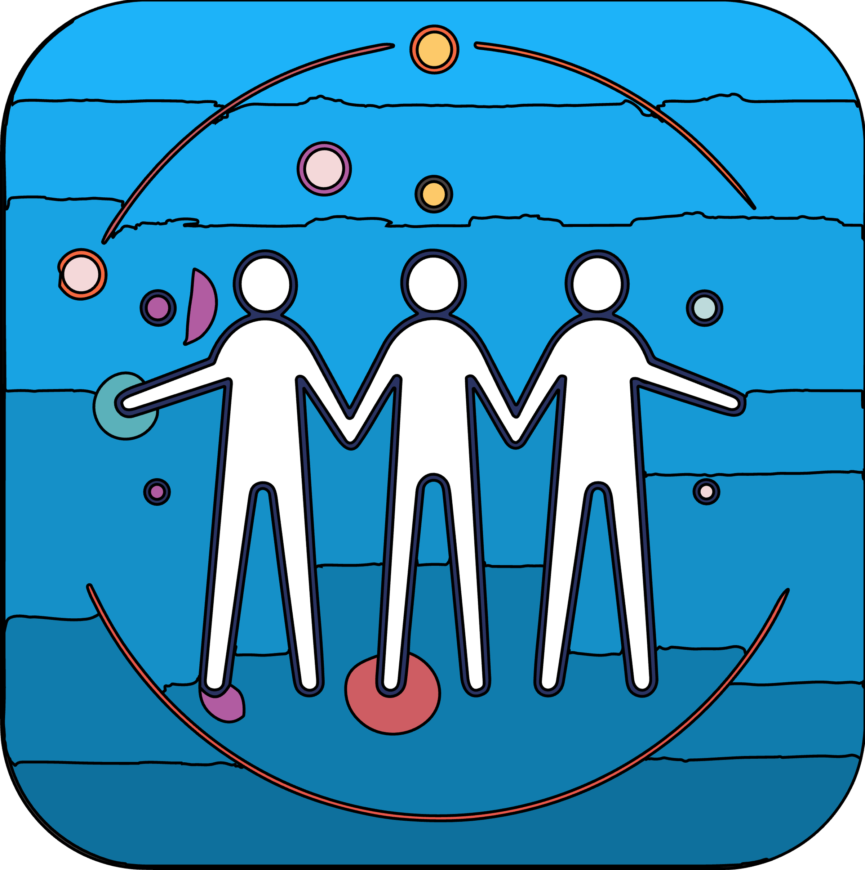 | Understanding personal identity and influences.  Navigating online safety and digital responsibility.  Developing coping skills for different social environments.  Embracing family dynamics and uniqueness. | Analysing how online behaviour impacts self and others.  Applying critical thinking to social influences.  Practicing empathy in various social contexts.  Enhancing social awareness through active engagement.
Aspirations for Life | Identifying personal dreams and future career goals.  Understanding the impact of decisions on future achievements.  Learning about money management and employability skills.  Balancing mental health with media influence. | Developing strategies for achieving career goals.  Creating balanced life plans incorporating personal well-being.  Utilising decision-making skills for life planning.  Engaging in open discussions about mental health and career.
Relationships for Life  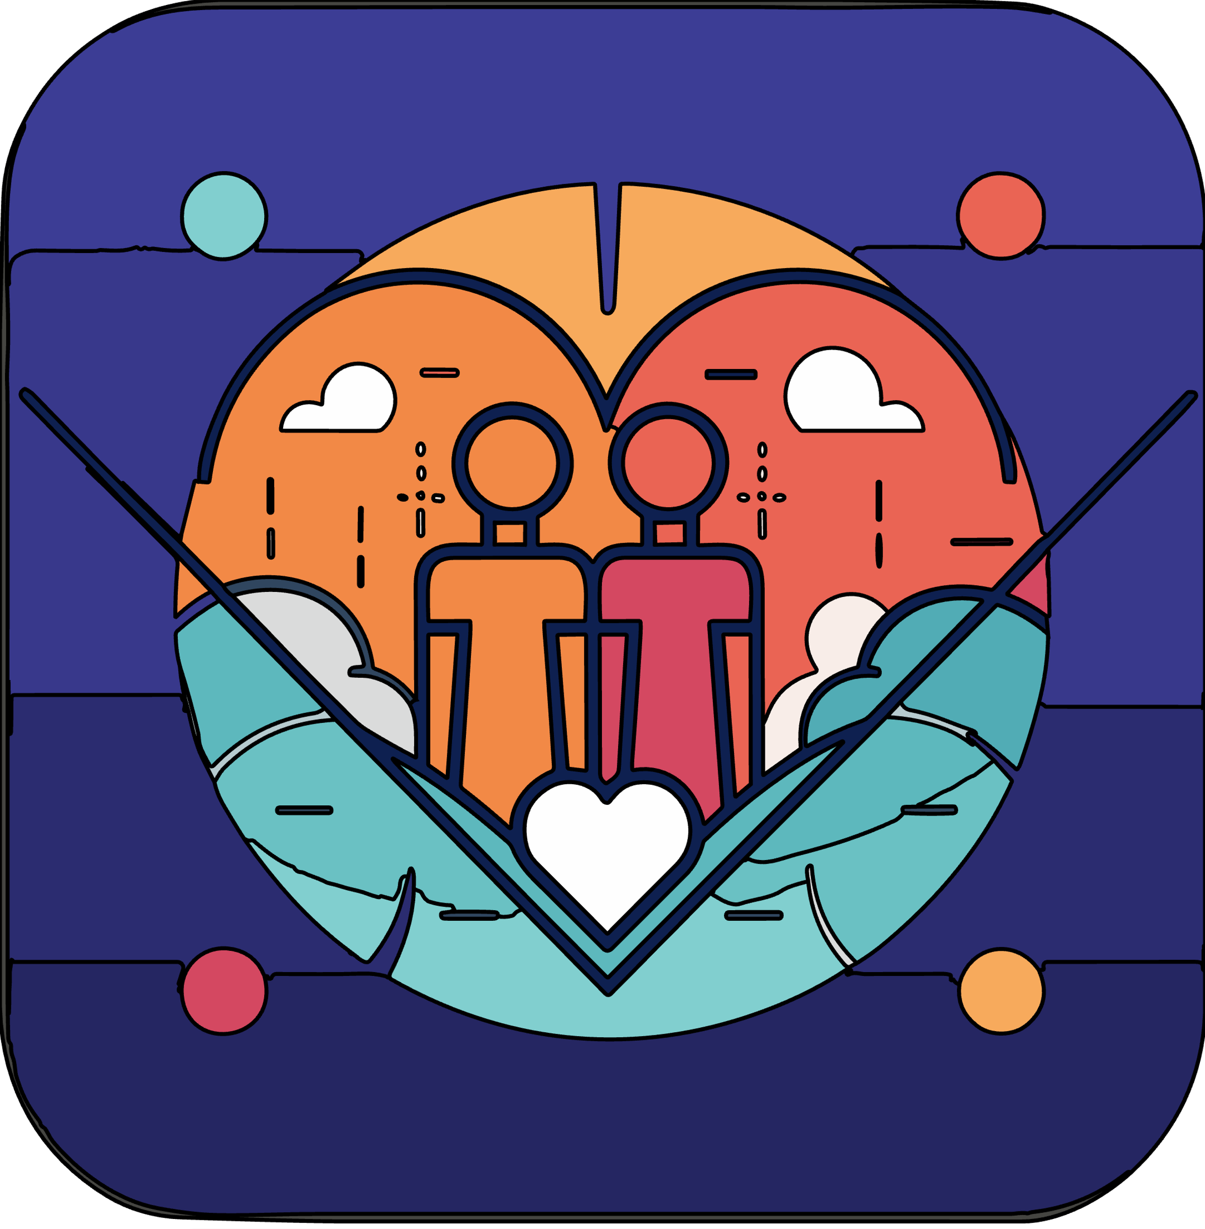 | Exploring the dynamics of healthy relationships.  Understanding consent and its importance.  Navigating self-image and media influences.  Delving into power dynamics and attraction complexities. | Developing skills to form and sustain healthy relationships.  Applying knowledge of consent in real-life scenarios.  Evaluating media's impact on relationships and self-perception.  Advocating for respect and inclusivity in relationships.
My Body for Life  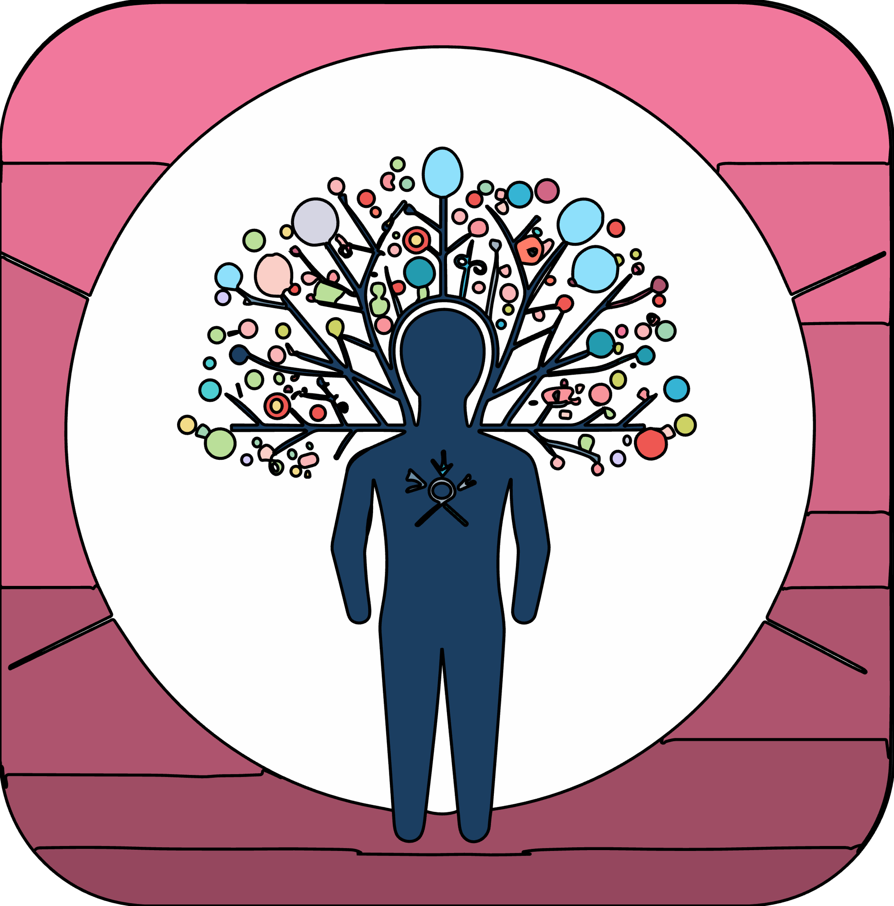 | Learning about stress management techniques.  Understanding the effects of substances on well-being.  Recognising the importance of balanced nutrition and lifestyle.  Acquiring knowledge about mental health disorders. | Practicing stress and anxiety management strategies.  Making informed choices about physical health.  Evaluating the impact of lifestyle choices on overall health.  Seeking support for mental health concerns and emergencies.
Evolving for Life  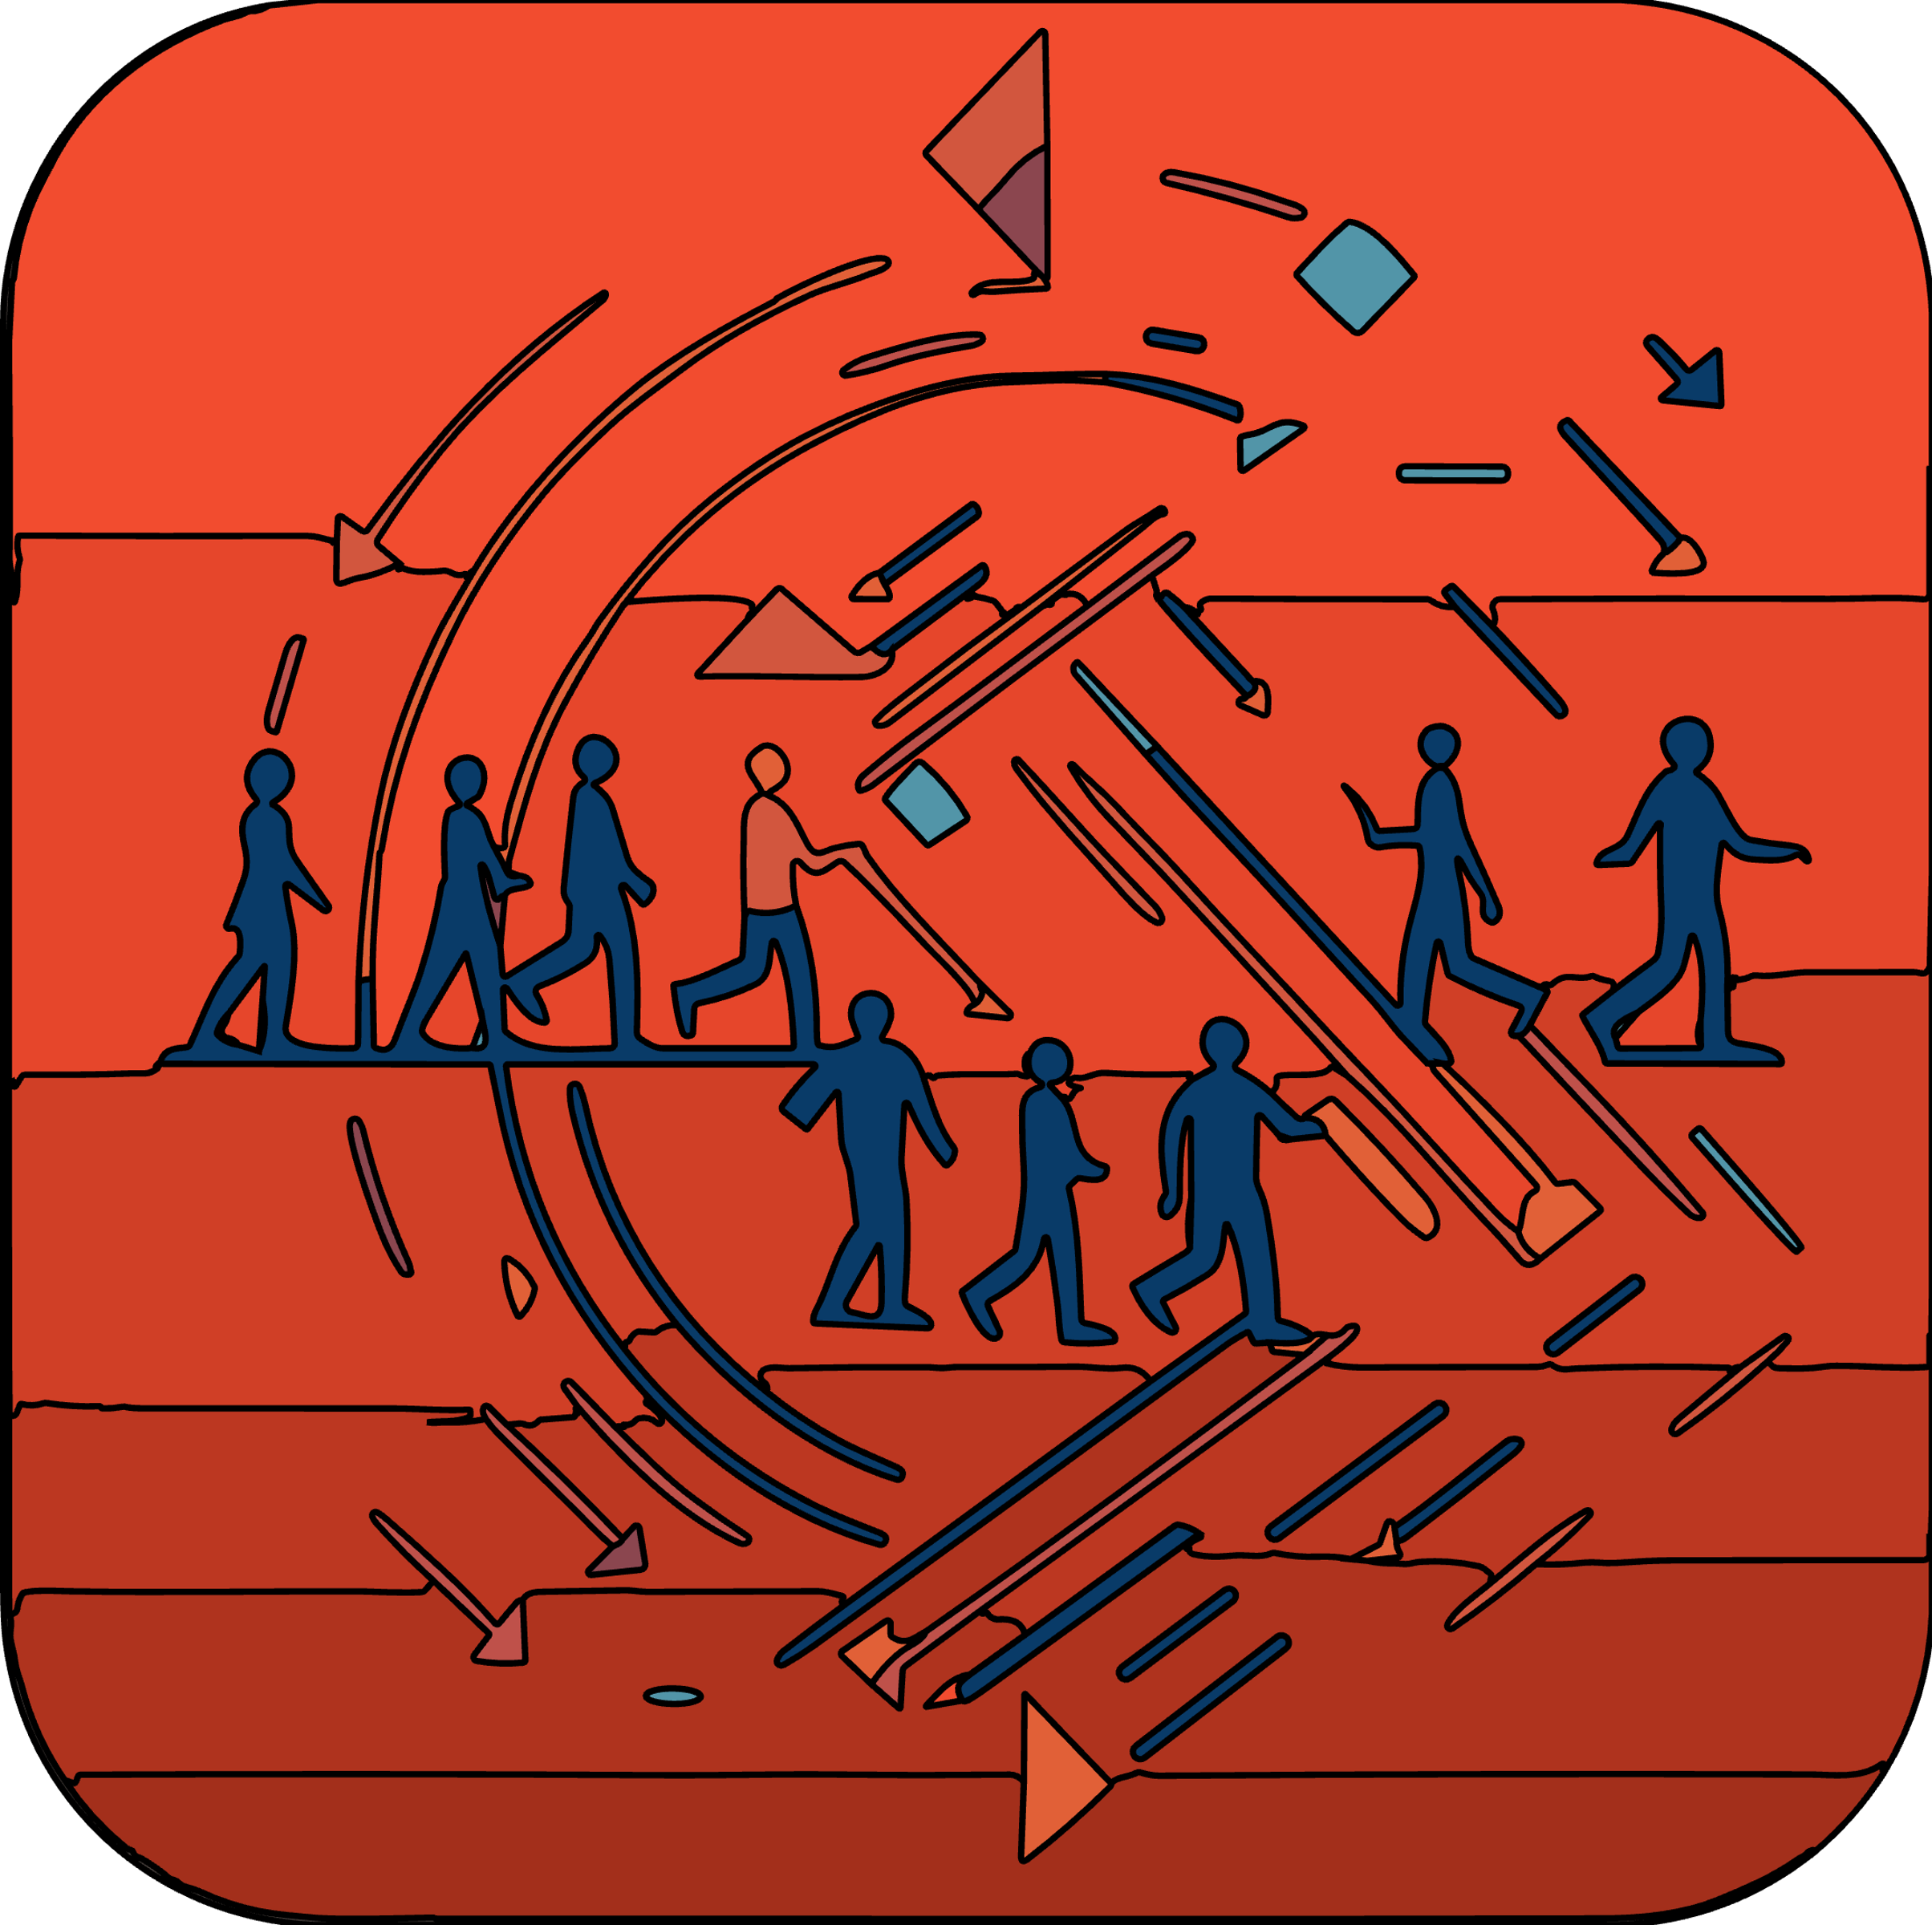 | Grasping the changes during puberty and self-identity.  Addressing mental health and resilience.  Understanding societal changes and gender stereotypes.  Exploring the impact of changes on identity and relationships. | Adapting to emotional and physical changes during puberty.  Building resilience to navigate life's challenges.  Critically assessing societal influences on personal development.  Managing evolving relationships and transitions effectively.
Life to the Full  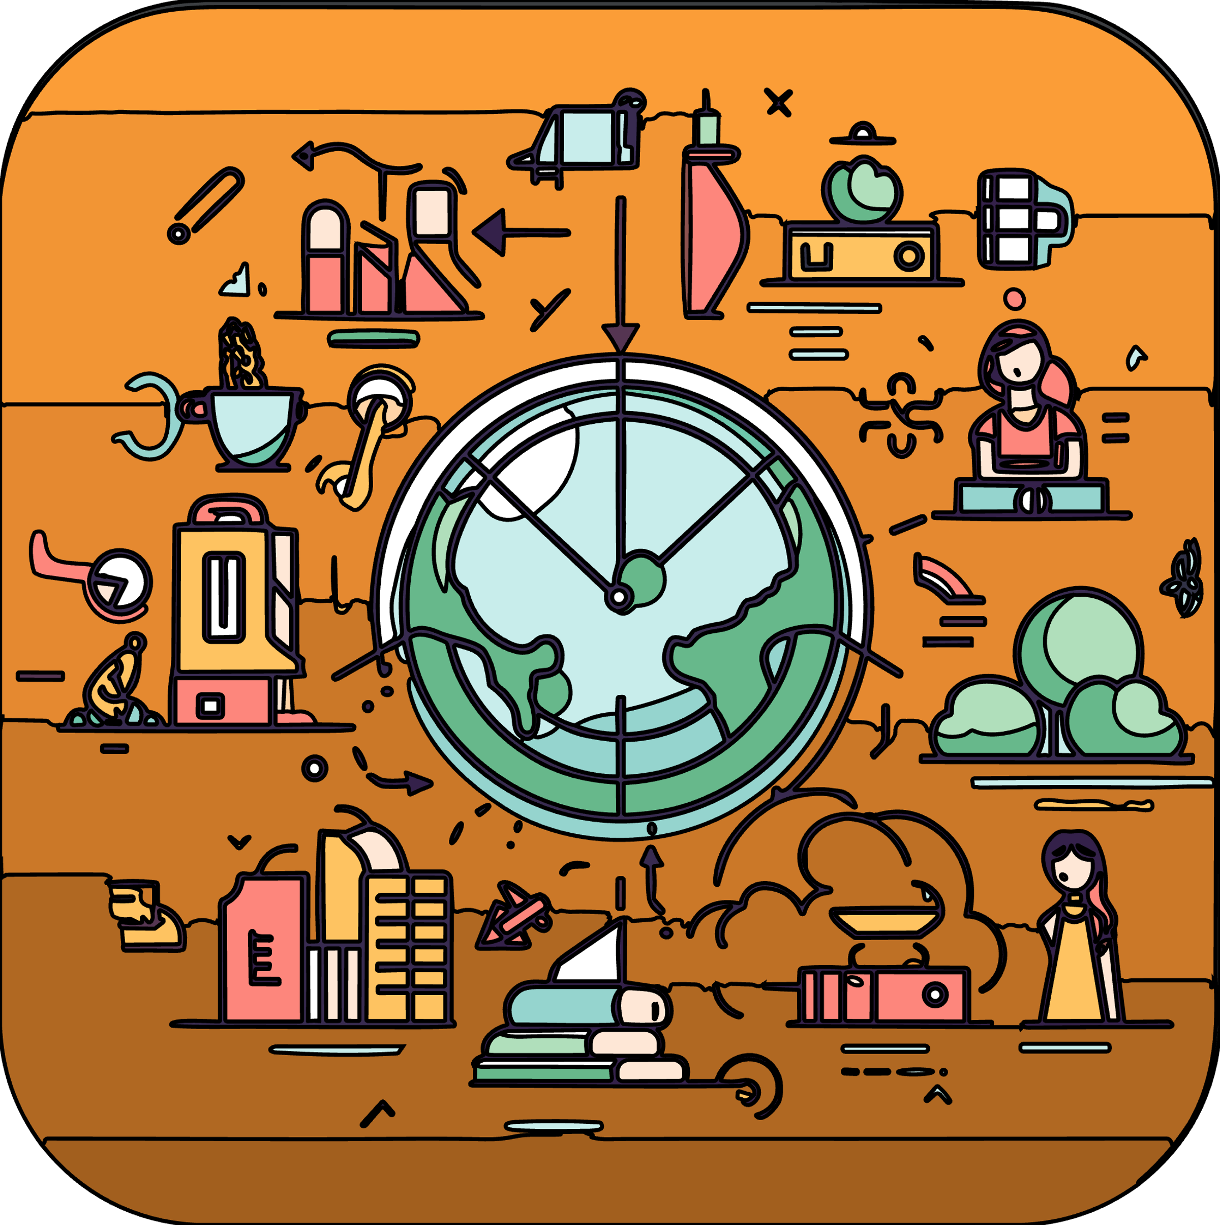 | Preparing for life transitions and celebrating achievements.  Navigating puberty and associated feelings.  Understanding societal changes and their impact.  Fostering self-esteem and managing self-image. | Adapting to changes and embracing diversity.  Developing strategies for positive self-perception.  Making informed decisions amidst societal influences.  Cultivating well-being and resilience for life's journey.

Year 8 PSHE Knowledge
Module | Substantive Knowledge | Disciplinary Knowledge
Confidence for Life | Self-identity, family and identity, stereotypes, personal beliefs, managing expectations, first impressions, respect for others' beliefs, active listening. | Appreciate complex identities, understand family influence on identity, define stereotypes, understand judgements based on first impressions, recognise personal beliefs, appreciate cultural diversity in identities.
Aspirations for Life | Long-term goals including skills, qualifications, careers, budgeting, income variation, impact of money, online legal responsibilities, gambling issues. | Set and achieve long-term goals, link skills to career interests, understand money's role in society, protect online identity, reason about spending and budgeting, understand global income variations, recognise gambling addiction signs.
Relationships for Life | Positive self-relationship, social media impact on self, negative self-talk, managing diverse relationships, online etiquette, privacy, safety, coercion in relationships. | Understand relationship skills, manage social media's impact on self-image, understand dynamics in various relationships, recognise positive and negative aspects in relationships, safely navigate online relationships, understand power dynamics in relationships.
My Body for Life | Long-term physical health, responsibility for health, substances and mood, legislation, exploitation, medicine, vaccinations, blood donation. | Support good physical health, understand factors affecting health, manage emotions and stress, recognise substance abuse risks, understand legal aspects of substance use, appreciate medicine's role, understand choices impacting health.
Evolving for Life | Types of intimate relationships, physical attraction, legal status of relationships, behaviours in romantic relationships, pornography, sexuality, alcohol, and risky behaviour. | Understand diverse intimate relationships, recognise physical attraction aspects, understand legality in relationships, distinguish healthy and unhealthy romantic behaviours, comprehend pornography's impact, navigate sexuality and attraction changes, manage risks associated with alcohol.
Life to the Full | Celebrating achievements, preparing for transitions, understanding societal change, stereotypes, self-esteem, managing change, embracing diversity. | Recognise personal growth, plan for life transitions, understand societal impacts on self, manage changing self-perceptions, embrace and respect diversity, nurture well-being, develop positive self-image.

Year 9 PSHE Knowledge
Module | Substantive Knowledge | Disciplinary Knowledge
Confidence for Life | Perceptions about intimate relationships, consent, sexual exploitation, grooming, radicalisation, county lines, risky experimentation, abuse, and coercion. | Understand different expectations of relationships, peer influence, grooming awareness, positive self-identity development, understanding consent, reporting abuse or coercion, managing peer influences and self-esteem.
Aspirations for Life | Personal strengths, health goals, SMART planning, body image and mental health, non-financial goals, media manipulation, mental health issues. | Identify personal strengths and health goals, create SMART plans, understand mental health and its stigma, recognise media manipulation, understand mental ill-health and ways to maintain mental health.
Relationships for Life | Power and control in relationships, sexual consent, assertiveness skills, sex and the law, pornography, contraception, STIs, family planning. | Recognise power dynamics in relationships, consent importance, use of assertiveness skills, legal understanding of sex and online media, contraception choices, sexual health awareness.
My Body for Life | Misperceptions about health choices, effects of alcohol and drugs, emergency first aid, CPR, drug legislation. | Understand health choices made by peers, physical and psychological effects of substances, legal aspects of substance use, first aid and CPR knowledge, impacts of substance misuse.
Evolving for Life | Mental health stigma, triggers and support strategies, emotional changes, resilience, importance of sleep, stereotypes. | Recognise mental health issues, manage emotional changes, develop resilience, understand the importance of sleep, reflect on body and brain changes, challenge stereotypes.
Life to the Full | Protected characteristics, phobic and racist language, legal aspects of bullying, sexism, ageism, discrimination, harassment, prejudice, bullying in the workplace. | Understand diversity and protected characteristics, challenge prejudice and discrimination, recognise sexism and ageism, understand legal consequences of bullying, address workplace bullying, empathise with discrimination victims.

Year 10 PSHE Knowledge
Module | Substantive Knowledge | Disciplinary Knowledge
Confidence for Life | Human rights, societal freedom, online safety and data use, threats to online safety, assessing and managing risk, stages of grief and bereavement. | Appreciate personal and societal freedoms, understand online safety and data usage, manage risks in various situations, understand emotional aspects of relationships ending, navigate social media and cultural influences.
Aspirations for Life | Physical health and goal attainment, work/life balance, mental health impacts, benefits of helping others, online profile management. | Identify health goals, plan for work/life balance, understand mental health impacts on goals, utilise online profiles positively, recognise importance of community support in achieving goals.
Relationships for Life | Sustaining long-term relationships, relationship choices, consequences of relationship endings, understanding love, abuse in relationships, fake news impact, legislation. | Understand long-term relationship dynamics, manage relationship endings, comprehend love's role in relationships, identify healthy and unhealthy relationship patterns, navigate fake news and rumours, understand legal aspects of relationships.
My Body for Life | Sexual health, blood-borne infections, self-examination, diet, misuse of prescription drugs, mental health disorders, chronic disease, epidemics, misuse of antibiotics, organ donation. | Understand sexual health, manage physical health and diet, recognise prescription drug misuse, comprehend common mental health disorders, understand chronic diseases and epidemics, make informed decisions about organ donation.
Evolving for Life | Societal change impact, media role in societal change, decision-making, sexual identity, gender, spectrum of sexuality, stereotypes in relationships, family change. | Assess societal changes, understand media influence, make informed decisions, explore sexual and gender identity, challenge stereotypes, navigate family changes, understand physical and emotional changes.
Life to the Full | Equality in workplace and society, power and control, vulnerable groups, workplace bullying, direct and indirect discrimination, harassment, victimisation. | Promote equality, understand power dynamics in relationships, recognise workplace bullying, address discrimination and harassment, empathise with vulnerable groups, advocate for victimised individuals.

Year 11 PSHE Knowledge
Module | Substantive Knowledge | Disciplinary Knowledge
Confidence for Life | Equality related to disability, employers' responsibilities, benefits of multicultural societies, impact of unfair treatment, misuse of power, campaigning for equality. | Define equality, understand the consequences of not adhering to the Equality Act, recognise employers' responsibilities, appreciate multicultural societies, assess the impact of unfair treatment on mental health, develop strategies for campaigning for equality.
Aspirations for Life | Aspirations on career, finances, relationships, health, skills identification, realistic goals, gambling, financial pressure and debt, dream jobs, long-term relationship goals, parenting challenges, resilience, coping strategies. | Manage anxiety and stress, develop concentration strategies, balance work-life, understand sexual health and hygiene, navigate sexual pressure, identify help, and support avenues.
Relationships for Life | Stages of intimate relationships, positive and negative aspects of sex, protecting sexual and reproductive health, ending relationships safely, spectrum of gender and sexuality, LGBT+ rights, challenges of 'coming out', media stereotypes, power dynamics, forced marriage, honour-based violence, FGM, hate crime. | Understand stages of intimate relationships, recognise positive and negative connotations of sex, manage sexual and reproductive health, navigate relationship endings, understand gender and sexuality spectrum, recognise LGBT+ rights and challenges, understand and challenge media stereotypes, identify power dynamics in relationships, understand forced marriage and honour-based violence, recognise, and respond to hate crime.
My Body for Life | Managing anxiety and stress, exam pressure, concentration strategies, work-life balance, sexual health, STIs, sexual pressure, fertility, contraception, pregnancy facts and myths. | Develop strategies for managing anxiety and stress, understand the impact of exam pressure, employ concentration strategies, maintain a work-life balance, navigate sexual health issues, understand fertility and contraception, recognise pregnancy facts and myths, assess health risks, and develop safety strategies.
Evolving for Life | Equality in relation to disability, impact of unfair treatment, misuse of power, campaigning for equality, employers' responsibilities, mental health management, sexual health, fertility, contraception, pregnancy, health risks. | Understand equality related to disability, assess the impact of unfair treatment, recognise misuse of power, campaign for equality, understand employers' responsibilities, manage mental health, navigate sexual health and fertility, understand contraception and pregnancy options, identify health risks and safety strategies.
Life to the Full | Equality in workplace and society, benefits of multicultural societies, campaigning for equality, managing anxiety and stress, work-life balance, aspirations on career and relationships, identifying realistic goals, understanding gambling and debt, resilience and coping strategies. | Define and promote equality, appreciate multicultural societies, develop campaigning strategies, manage anxiety and stress, maintain a work-life balance, set, and achieve career and relationship aspirations, identify, and overcome barriers to goals, understand the impact of gambling and debt, develop resilience and coping strategies.

