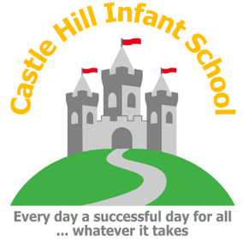
The Herald
1st May 2026

This week in school, Year 2 have continued with Swimming at Cranbourne. They are really enjoying this opportunity, made possible by Cranbourne providing the transport. I am really pleased to share with you that Mr Whistler has successfully passed his MIDAS training, meaning that we will be able to hire minibuses in the future and he will drive. I hope that this will lead to more opportunities for visits which are local but not in walking distance. I know that Mrs Cameron would love the opportunity to take the children to the library in town.

Can I remind parents that the wooden double gates on the bottom playground are only for vehicle use and should not be used as a cut through to the Junior site.

Finally, Monday is a Bank Holiday, so we will welcome the children back on Tuesday. I hope you all enjoy the long week.

Thank you for all of the support you give myself and staff,

Mrs Fitz

Stars of the Week
Isaac
Billie
Sophia
Louie
Mollie
Chandra
Mrs Fitz’s Star of the Week
Coach Keira



National Year of Reading

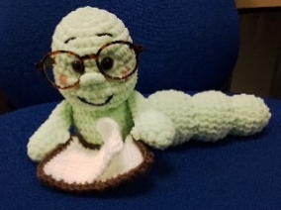
This week I was excited to receive an email containing a certificate recognising our engagement in the Spring Term activities for the National Year of Reading. Why not come along to the library after school see our certificate and reward badges on display!

Class Book Worms of the week Challenge
Class percentages have remained similar this week.
Well done to everyone who has read at home at least 3 times. I know
that lots of children have been reading at home, but they will
only count in their class count if 3 or more reads are recorded in their Home
Learning Diaries. Please help your child by recording when you read with them at home.

This week’s Book Worms of the Week are:

Birch Class
Class percentages for the week:

Fir Class | 35.7%
Ash Class | 22%
Rowan Class | 14%
Birch Class | 52%
Sycamore Class | 25%
Maple Class | 34%

REMEMBER - library sessions every Friday from 3.15pm to 4pm. Entry to the library can be made through the school office once you have picked up your child. I look forward to seeing you there!

Thank you for your continued support,

Mrs Cameron

Up-coming events:
Friday Library Opening– 3.15pm – 4pm every Friday (visit with your child)
Class Book Worms of the week Challenge







Early Years
This week we have been busy story tellers, using our voices differently to tell the story of Little Red Riding Hood. We have looked closely at the beginning, middle and end of the story and talked about what it teaches us. Our houses are almost complete and ready to see if they stand up to the ‘Huff and puff’ of the Big Bad wolf from The Three Little Pigs! The children have shown resilience and determination with their houses and we look forward to sharing them with you at our project outcome.

In maths the children have been learning all about the numbers 17, 18, 19 and 20. They have been using Numicon, multilink and counters to make teen numbers in different ways.

Next week we will be using the Bee-bots to plan routes for Little Red Riding Hood. The children will have the opportunity to build on their learning about direction and creating their own algorithm.

Please continue to read with your child at home at least three times a week and write this in their home diary. We would really like Book Worm’s presence in our Early Years classroom.
Next, we will be sending home any specific sounds that your child needs to focus on. Please do continue to practice their sounds at home. They are making great progress with these. Thank you for your support and have a lovely, Bank Holiday weekend.
The Early Years Team

Year 1

This week in our ‘Meet the Author’ project we have been reading the non-fiction narrative ‘The Tiny Seed’ by Eric Carle. The children have produced a story mountain based on this text in order to write their own version of the story next week. They have revisited adjectives and how these can be used to make their writing more interesting. The children have also learnt a new art technique called sgraffito.

In maths we have been using 2’s, 5’s and 10’s to make equal groups and to share into equal groups. The children have used repeated addition to show this. For example:

5 + 5 + 5 + 5 = 20
Please could you continue to support your child with practising counting in their 2’s, 5’s and 10’s.

Have a lovely weekend,
The Year 1 Team

Year 2
The children have really been enjoying this project so far!
Next week, in English, we are finishing our narrative writing by carefully editing and improving our stories, before bringing them to life through engaging role play, helping us to deepen our understanding of characters and events.
In DT, we are stepping into the role of engineers as we design, build and evaluate a wheeled vehicle that can safely transport a dragon’s egg, thinking carefully about stability, movement and materials.
In Art, we are developing our clay skills by exploring techniques such as scoring, pinching and coiling to create detailed dragon eyes, considering texture, shape and pattern in our designs.
This week in maths, we have been consolidating our understanding of fractions, including recognising and finding three quarters of shapes and quantities. We are now beginning our new topic on time, where we will be learning to read the clock to o’clock, half past, quarter past and quarter to, and applying this knowledge to real-life situations.
Have a lovely Bank Holiday weekend!
The Year 2 Team

Forest School

The sessions for next week’s Forest School are:
Tuesday – Rowan Class
Wednesday – Maple Class

Thank you
Mrs Fulbrook

Castle Hill Friends

Thursday 14th May- Sponsored hop 🏅

This is an event that is in school for the children only, but you can participate by sponsoring your child. This can be done via our website, or by cash/card on the day when the PTA are on the playground. Please don't forget to return the sponsorship forms on the day so that we can allocate prizes to the children.

Friday 12th June- Summer fair ☀️

This will be held between 4:00pm - 6:30pm on the Infant school site. We are busy planning as many fun activities as we can for all the family to enjoy! We have external stall holders, PTA games stalls, trampolines, food trucks and more. Adult entry is 50p, but children under 16 can enter for free!

INSET Days

2025/2026
Friday 22nd May 2026
Friday 10th July 2026

2026/2027
Tuesday 1st September 2026
Wednesday 2nd September 2026
Monday 4th January 2027
Thursday 25th March 2027
Friday 9th July 2027

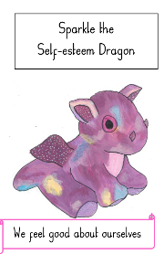
Thought of the Week

Next week in school we will focus on our school value of Self-esteem.
With this value we are looking to develop the skill of feeling good about ourselves.
We are particularly thinking about:
I believe in myself

Diary Dates

Monday 4th May – May Bank Holiday – School Closed
Tuesday 5th May – Class photos
Tuesday 5th May – Maple Swimming
Thursday 7th May – Sycamore swimming
Tuesday 12th May – Maple swimming
Wednesday 13th May – Open door 15:15pm – 18:00pm
Thursday 14th May – Castle Hill Friends sponsored hop event (pm)
Thursday 14th May – Sycamore swimming

