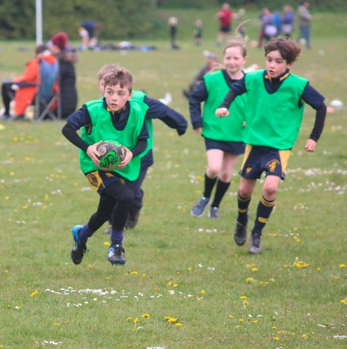
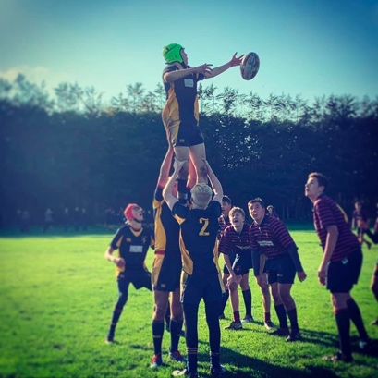
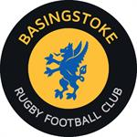

Have you thought about playing rugby?
Basingstoke Rugby Club are currently recruiting players for teams within the Mini and Youth section.
Basingstoke RFC is a fantastic place for boys and girls to start playing rugby. It is a great way to get children running around and keeping fit and healthy, whilst having lots of FUN within a structured programme of training and competition that will keep them excited, but also start to build core rugby skills. It is also about creating an environment where the children start to understand the key values that rugby provides.
As a group of qualified England RFU volunteer coaches, we promise a commitment to giving your children a great first rugby experience, and hopefully create a future pathway for our rugby stars of the future.
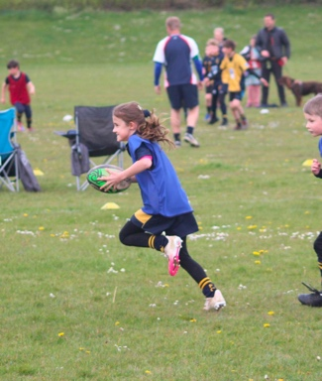
If you are interested in attending some free trial sessions, please contact the following Team Managers for more details.
We look forward to welcoming you to the Basingstoke Rugby Club community.
U6’s and U7’s (School Years 1 and 2) - Tricia Baugh: triciabaugh@me.com
U8’s (School Year 3) - Emma Cook: alorend@hotmail.com
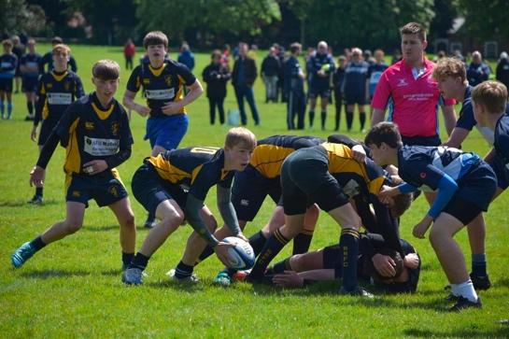
U12’s (school Year 7) - Sharon Allen: sharon.allen66@btinternet.com
U13’s (School Year 8) – Clare Ratcliff: clare.ratcliff@hotmail.co.uk
U14’s (School Year 9) - Martha Knapman: martha.knapman@gmail.com

Girls Year 7 and over - Michele Amos: maddog.amos@talktalk.net

For further details and details for other age groups please visit: http://www.basingstokerfc.com

