**PAEDIATRIC FIRST AID**

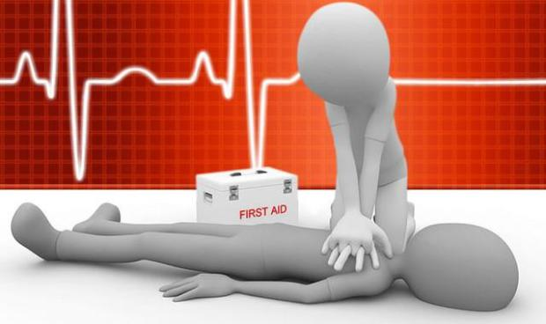



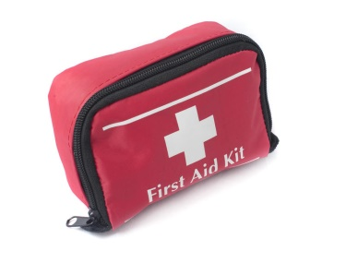

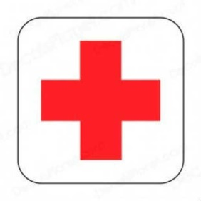

**This is an accredited Paediatric First Aid Course, teaching you basic lifesaving First Aid skills**

**Free course, £20 for certificate**

Concessions available for job centre referrals, certificates do not have to be purchased

This course covers emergency life saving techniques and gives learners the confidence to use these in an emergency situation

We have a Paediatric First Aid course running

**Monday 16th & Tuesday 17th September**

**9.30 – 16.30**

At Westside Community Centre,

RG22 6QB

**To book a place on the course, please call 01264 359 223 or email longmeadow.rcs@gmail.com**

*Servicing the needs of the Community*

**www.rcsservices.org.uk enquiries.rcs123@gmail.com**



Andover: 01264 359223

Romsey: 01794 522106

RCSSERVICES