Flu Vaccine
The NHS School Age Immunisation Service are planning the roll out of the 2026 winter flu vaccination programme to all year groups. The service offers the flu vaccine between September and December. You will receive an email, with details on how to complete the online form, for your child to receive the vaccine in school.
Flu can be a very unpleasant illness for children and young people. High vaccine uptake reduces the risk of flu spreading rapidly in school settings. This helps ensure they remain well, do not miss school days and continue to learn. Vaccinating children also helps protect others who are at higher risk of getting seriously ill from flu, such as babies, anyone who’s pregnant and older people.
The vaccine is given as a painless nasal spray. An alternative porcine free injection is offered to those who cannot have the nasal spray.
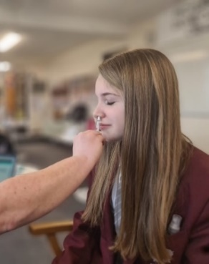
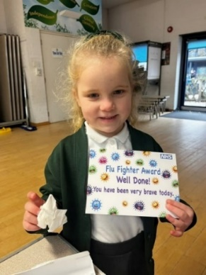
Vaccines offered to secondary age students during the spring and summer term include:
Human Papillomavirus (HPV)
HPV vaccine is offered to boys and girls in year 8. This vaccine protects against different types of cancers in the future.
Meningitis ACWY (MenACWY)
Meningitis vaccine is offered in year 9. This vaccine protects against four different strains of bacteria (groups A, C, W, Y) and protects against Meningitis and Sepsis (blood poisoning).
Tetanus, Diphtheria and Polio (3-in-1) booster vaccine
The 3-in-1 booster vaccine is offered in year 9. This vaccine protects against serious and potentially life-threatening diseases and provides long lasting immunity against these specific conditions.
Community clinics are available during the school holidays for missed vaccinations.
Find out more about the vaccine programmes and our contact details here: School Age Immunisation Service - Hampshire - Parents: Health for Kids

