A book about
Castle Hill Primary School

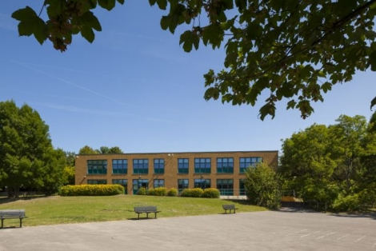

My name is_____________________

I am thinking about my new school and my new class. There will be lots of things that are the same as my Infant school and a few things that are different.

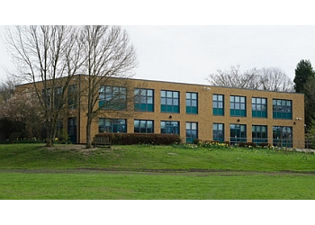I will be in Year 3 when I start school in September.
This is the Year 3 team. I will see them all when I am doing my learning. I can ask any one of them for help because they all care about me. I need to make sure I listen to all of them. Even if they are not my class teacher, they will all keep me safe.
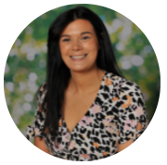
Miss Reed Miss Vickery
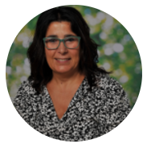
Mrs Perng Mrs Bone

Here are some pictures of what my classroom looks like:
Miss Reed’s classroom
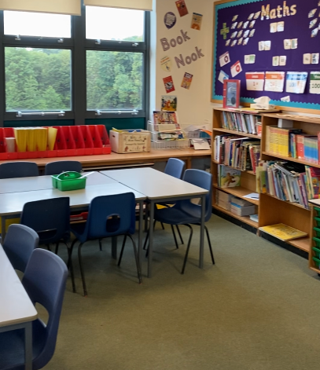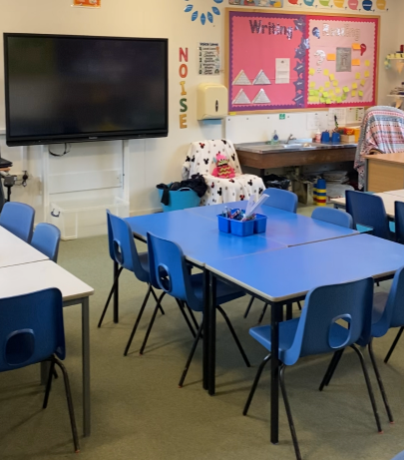
Miss Vickery’s classroom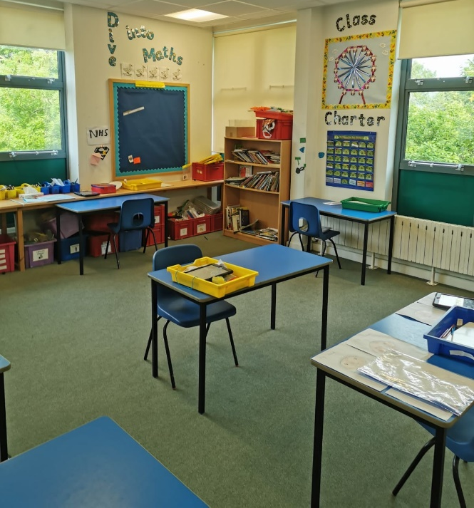 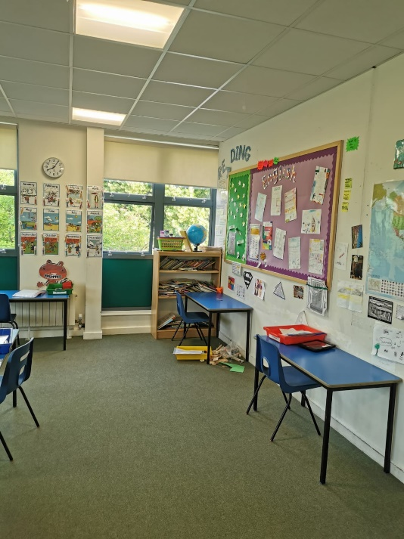

It is exciting to go to school.
These are what the Year 3 toilets will look like:
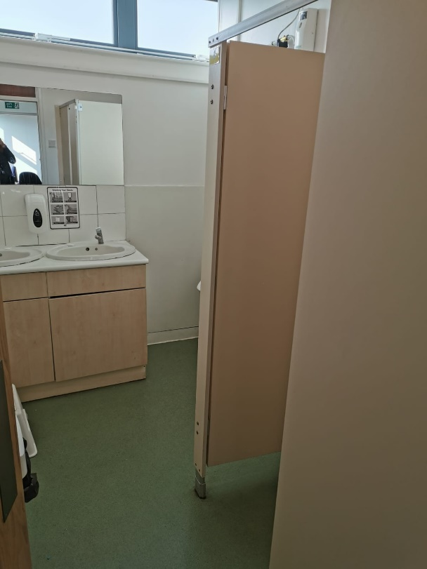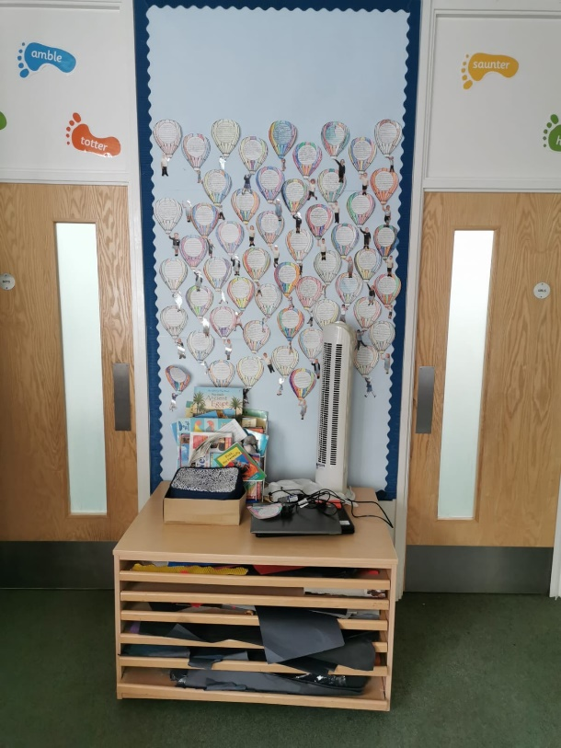

I can use these toilets when I need to. I have to remember to ask an adult when I would like to go. I use the toilet independently.
Here is the play area that I will use. My teacher will remind me of the playground rules. I can talk to any adult on the playground if I am feeling cross or upset about something.
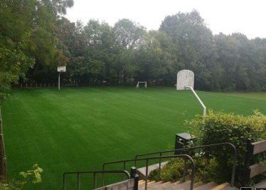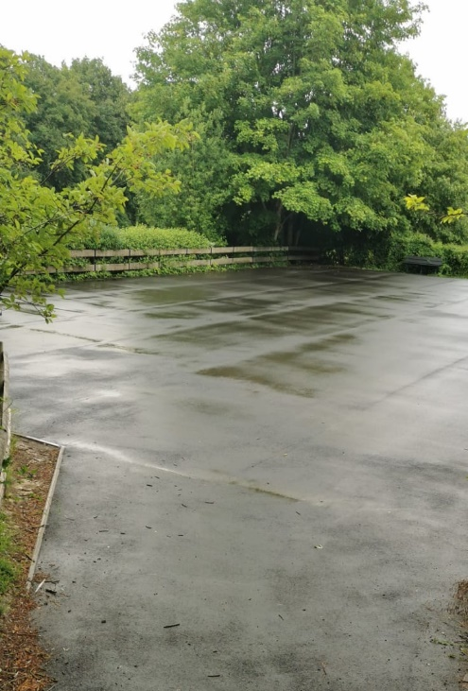

This is Mrs Hodge:

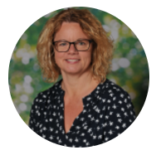

This is Mrs Rounce:
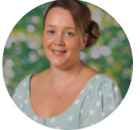
They will be in the office and is always here to help with lots of things.

The Lunchtime Supervisors are the grown-ups that look after the children at lunchtimes. I can talk to them if I am feeling cross, sad or I am not sure what to do.
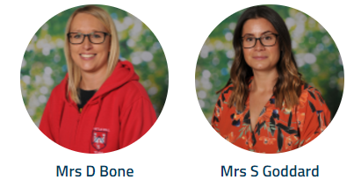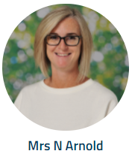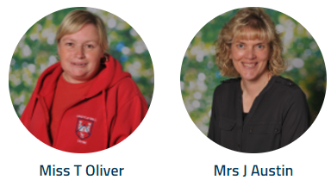

Here is where I will have P.E lessons. I may sometimes eat my lunch in here too.
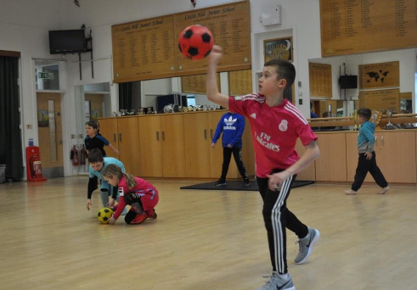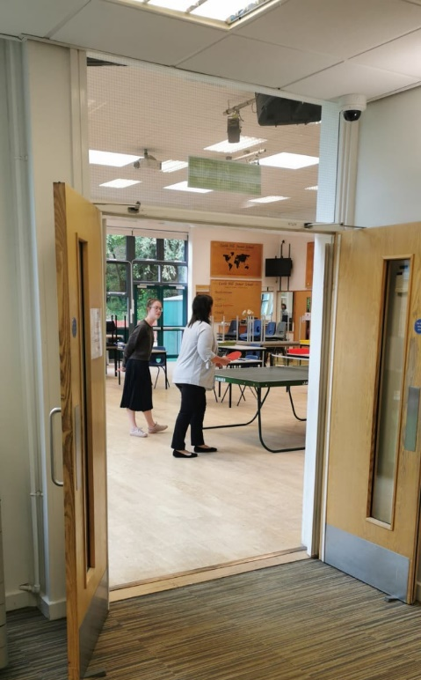
My teachers and the lunchtime supervisors are there to help me.
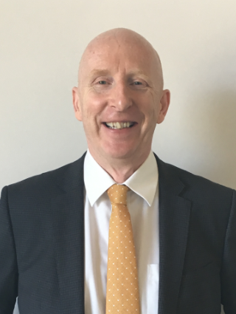
This is Mr Martin. He is the Head Teacher. He is in charge of the school.

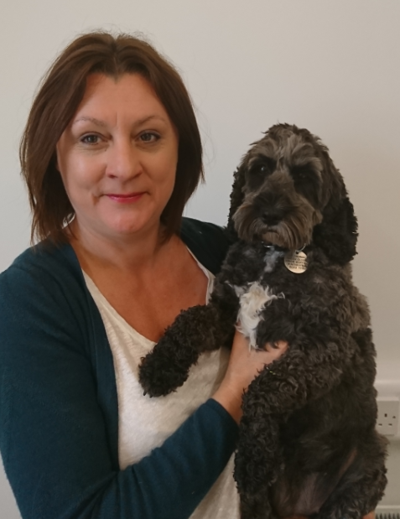
This is Ms Willmouth. She is the Deputy Head Teacher and is in charge when Mr Martin is away.

I can say hello to them when I see them. They care about everyone in the school.
The school has a dog called Ruffles. She is very friendly and she wags her tail when she sees the children. I do not have to go near the dog if I do not want to, but if I do, she likes to be stroked on her back gently.
Ruffles

