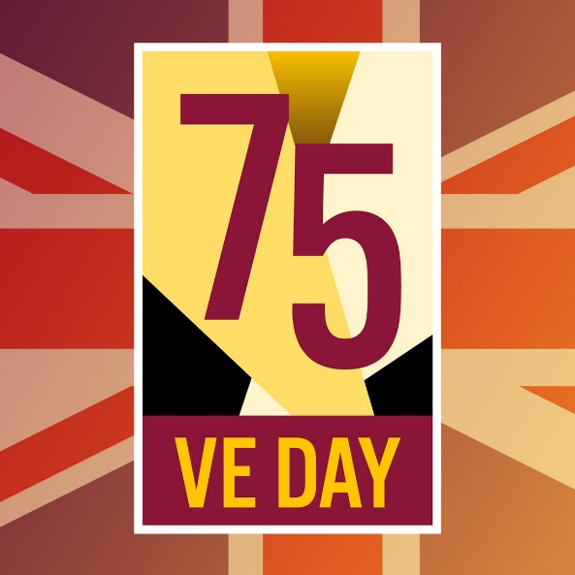

Welcome to this learning pack – I hope that there will be some activities that you enjoy. There are some activity sheets that go with the songs that might help you to talk about the songs and do some other musical activities too.
All of the work relates to music of World War II and songs that many people still know and love today. Have a go at as many activities as you like – choose which ones you would like to do but please at least listen to some music of the period. I hope you will enjoy your learning

There are 3 Parts to the pack –
- Warm Up song
- VE day activities and links to music with tasks for the week including colouring a poster for VE day on Friday, listening / learning another song also relevant to circumstances today
- Finish with a song

WARM UP - I HAVE A SONG TO SING https://youtu.be/SB8MoU1zkwg
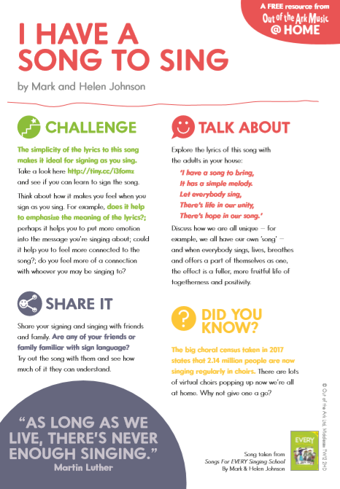

VE Day Activities 8th May 1945 75th Anniversary
Visit these links and find out about music of the period by listening to lots of different popular songs of the day.
Victory in Europe Day, generally known as VE Day, or simply V Day was the public holiday celebrated on 8 May 1945 in Commonwealth realms to mark the formal acceptance by the Allies of World War
- Listen to Glenn Miller’s In the Mood and watch some images from Britain on VE day
https://youtu.be/utH6pbsQHSY

- Check out some ideas to plan and create a VE Day party
https://ve-vjday75.gov.uk/plan-your-ve-day-party/

- Colour / decorate the poster on p4 and put in your window on Friday to commemorate VE day - – I am going to do this and use rainbow colours for the stripes.

- Sing / sign along or listen to We’ll Meet again
This version is signed and has some of the history too, (despite the date on the video being incorrect!!)
https://www.youtube.com/watch?v=BJOrBZmPunY
- Here is a link for VE DAY SONGS PLAYLIST - enjoy listening and singing along https://www.youtube.com/playlist?list=PL2n9jZypkPScwvINFnRWKCTwjPZ7yRQMD

- Lindy Hop was the famous dance that people did to swing music. Watch it and perhaps learn it here! : https://www.youtube.com/watch?v=r5DWLZGQOoE
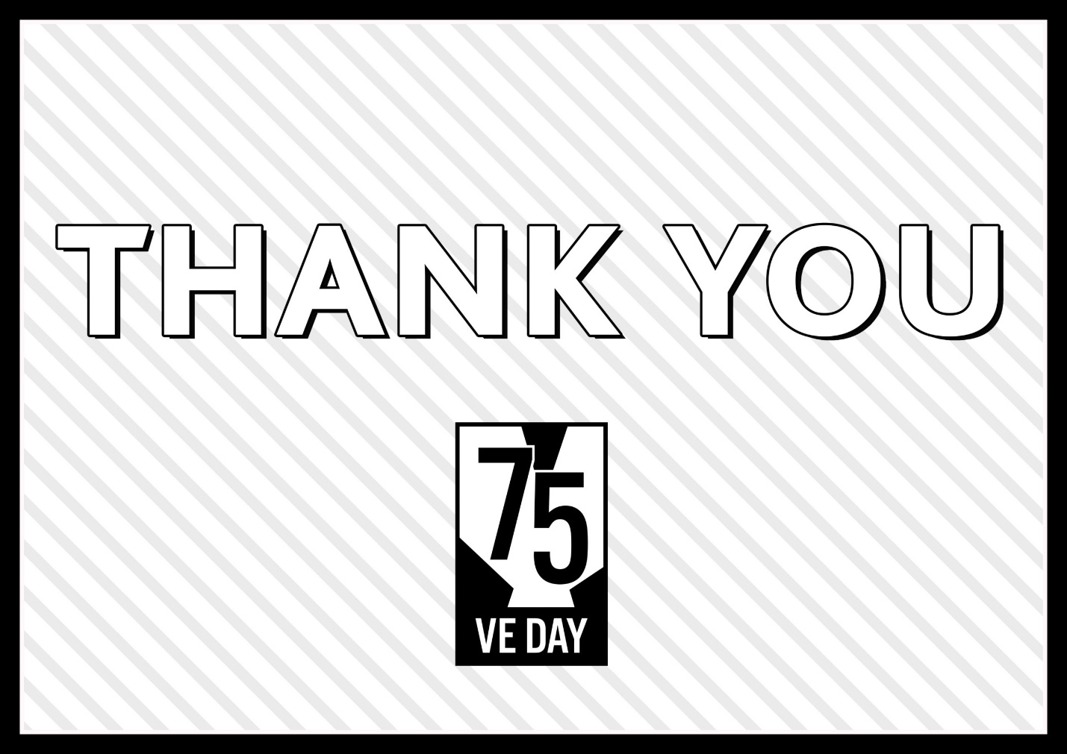

Listen to the Keep Calm and Carry On song https://youtu.be/HnuxWdesxI0
