Castle View Primary Academy Acting Headteacher: Huw Rose
Keswick Road, Lancaster, LA1 3LE huw.rose@cidari.co.uk
Friday Newsletter – 12th September 2025
Dear Parents and Carers,
It has been another wonderful and action-packed week at Castle View, with the children fully settled and embracing the new term.
The energy across the school has been fantastic. Our Key Stage 2 pupils in Years 3, 4, 5 and 6 have had a particularly exciting time, with an inspiring poetry workshop led by the visiting poet Louise Fazackerley, and the Year 5 and 6 children have also enjoyed their first school trip of the year to Leighton Hall.
We were also thrilled to launch our new Commando Joe's programme with 'Commando Amy'. This initiative is designed to build essential skills like resilience and respect, and the children are looking forward to their first 'missions' next week. This positive start is mirrored in our younger classes, where KS1 pupils are making incredible progress in their phonics and number work.
A brilliant week all round, setting a superb tone for the exciting term ahead.
Creative Choices and Clever Counting
In Reception, the children have made a fantastic start to their phonics journey. They are already working hard to recognise and write each sound using the correct letter formation. The children have also been practising writing their own names with great enthusiasm.
As part of our Marvellous Me topic, Reception have been learning about the parts of the body through songs and by building their very own Mr. Potato Heads. In Maths, they have been using their “magic wands” to practise counting carefully and accurately.
In Year 1 and Year 2, the children have been focusing on representing numbers to 20 and exploring tens and ones in Maths. We have also been very impressed with the creativity shown in Drawing Club this week, where the children produced imaginative writing and illustrations inspired by the book Would You Rather?
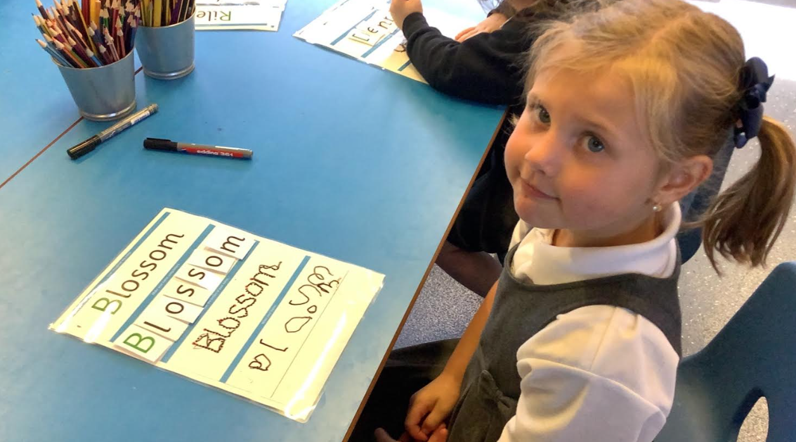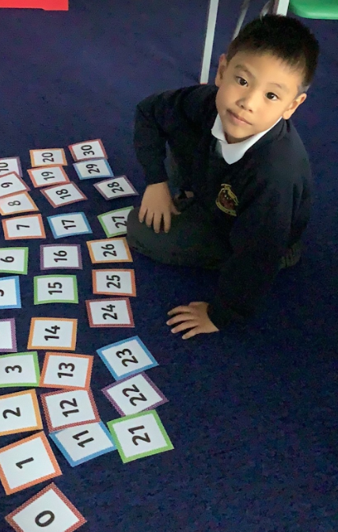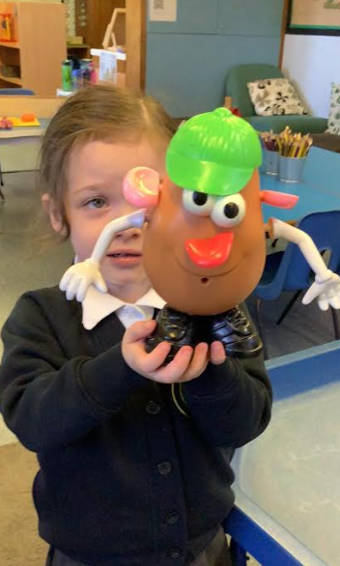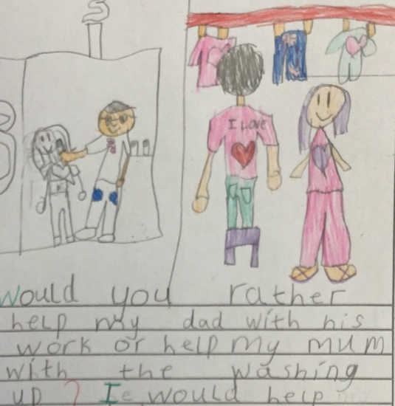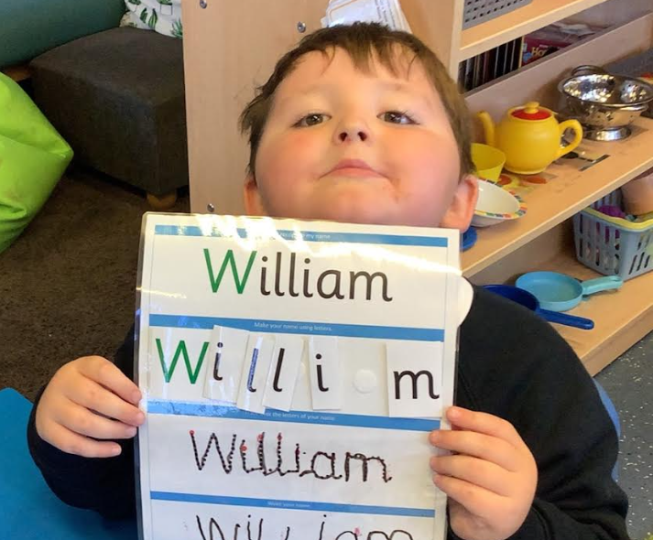
Superstars Certificates for outstanding work

The following children have all worked their socks off in class and have been awarded a certificate for their great attitude to learning:

Miss Spencer – Alex and Remee Mrs Hamer – Ruby H and Muhammad
Miss Mills – Leo and Lacey Mrs Robinson - Travis and Aron


Fantastic Behaviour Awards
Reception/1/2 – Penny Year 5 – Freddie
Year 3/4 – Cassidy Year 6 - Peter

Getting creative in Year 5

This week we started our Art topic looking at the work of William Morris. We found out that he used lots of patterns with flowers and birds in his work and was inspired by nature. He also was famous for making fabrics and furnishings with his wife. Some of his designs are still very popular today. We used view finders to study his work closely and were very pleased with our drawings.

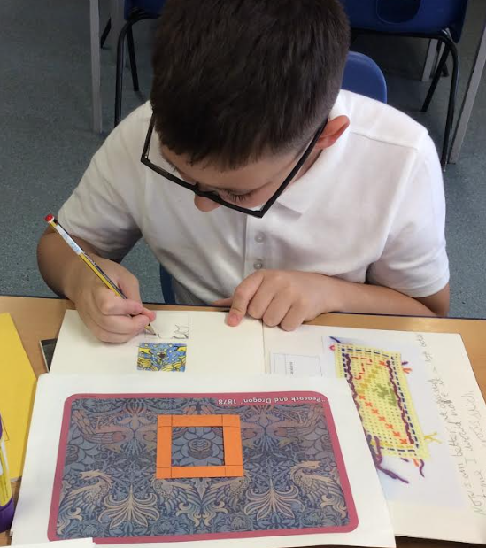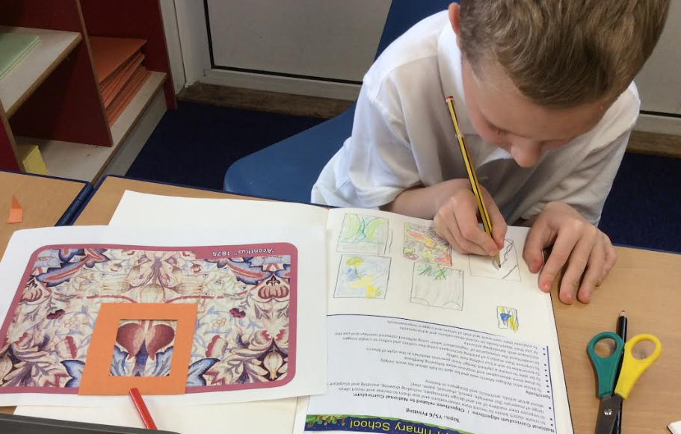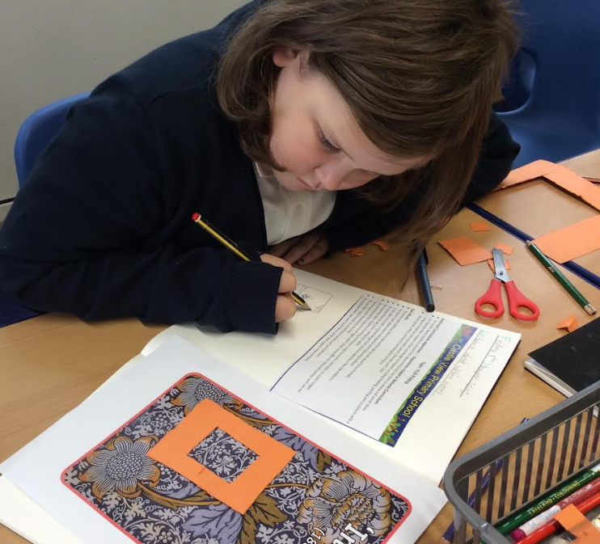

A Model Start!

Mrs Robinson’s modelling club got off to a fantastic start this week with children from Y1-Y6 working together to develop creative design ideas and practise their construction skills. We looked at size and stability in our models and began thinking about the materials we need for our future creations.

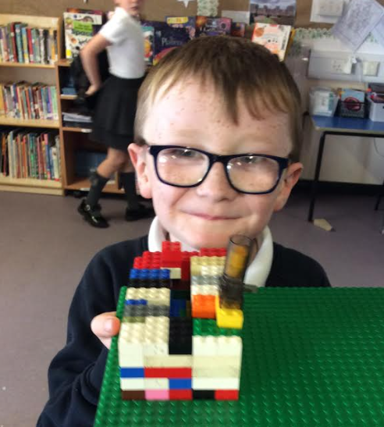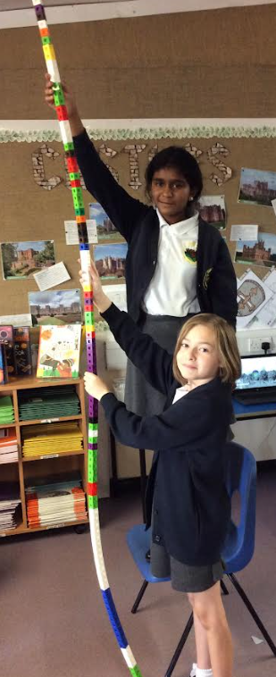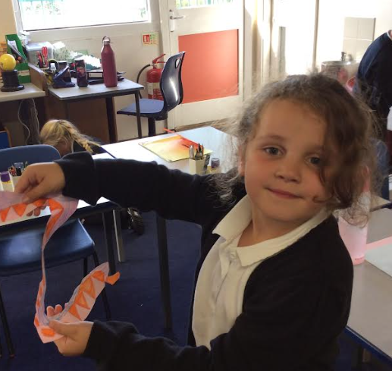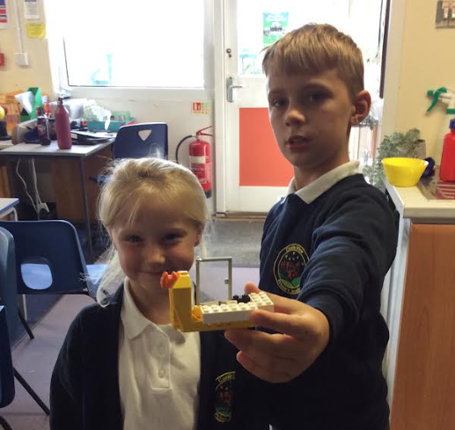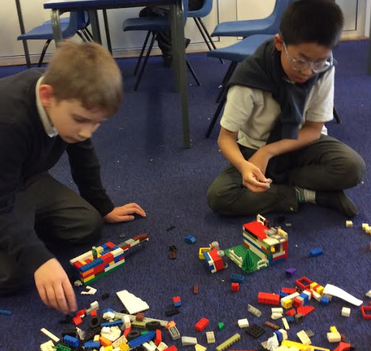

Visiting Poet - Louise Fazackerley
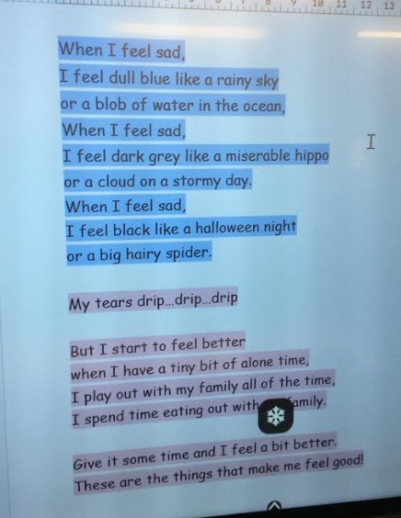
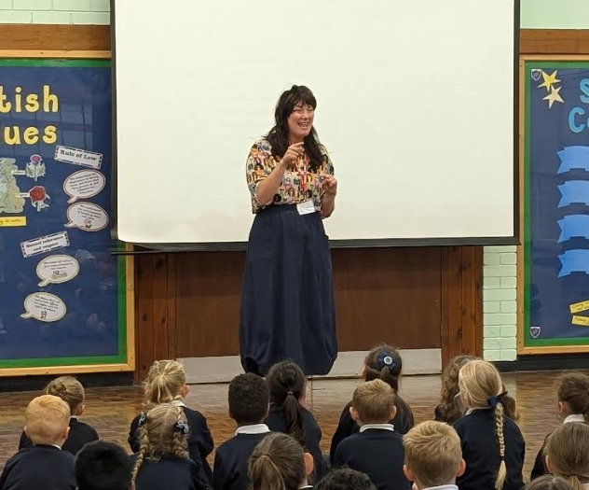
This week, we were visited by poet, Louise Fazackerley who came and performed in our assembly for the whole school. Louise also did workshops with Year 3/4 and Year 5 and Year 6. In Year 3/4 , Louise talked the children through her secrets to writing engaging poetry with actions! The class worked with Louise to make their own! They got stuck in and had some amazing ideas! The children loved working with Louise. It will certainly help with our work on poetry this year!
Harvest Festival
This will take place on Wednesday 1st October at 9am in the school hall. We are now collecting food items in tins and packets ready for the day. Please send any donations to your child's class. All parents are welcome to join us.
Leighton Hall - Year 5 and 6
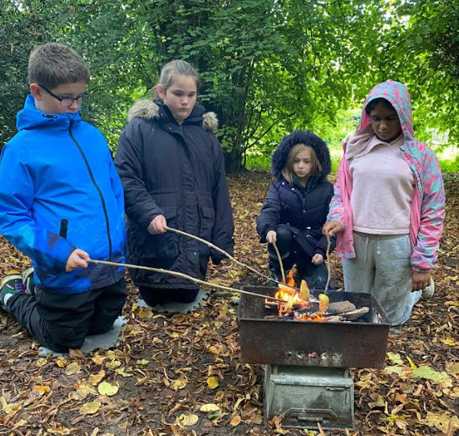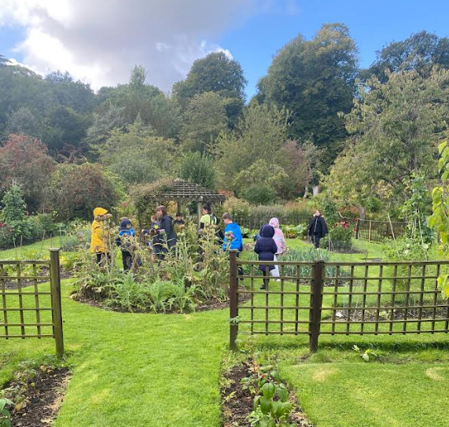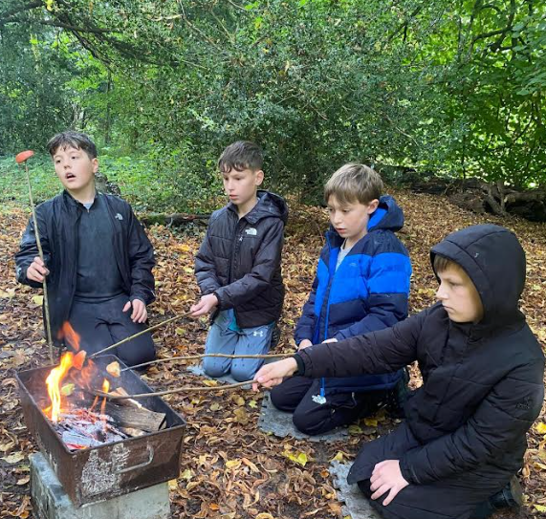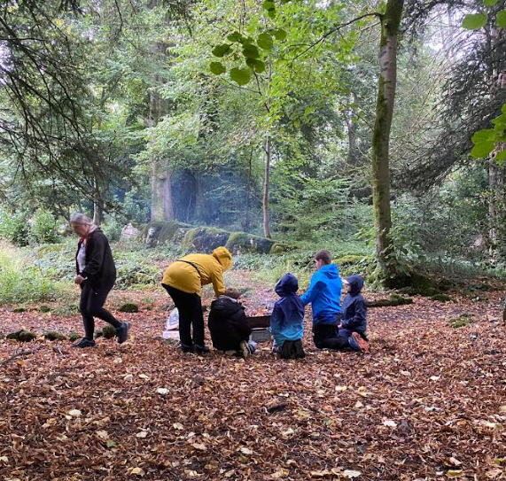

Attendance
You may remember that last academic year we had 8 children who had 100% attendance, 3 of whom had it the previous academic year too! These children have really set the standard for being in school every day on time and we are already hearing children talk about wanting to be part of this elite group at the end of this academic year which is very commendable. Please support your child by ensuring they are in school on time each day. If they are feeling slightly under the weather e.g. headache you can supply calpol for them to take during the day.
Coming to school every day makes a real difference to your child's learning journey. Every day missed adds up, meaning valuable learning time is lost. For instance, just one day off a week is nearly six weeks of learning missed across the school year! Let's work together to make the most of every learning opportunity.


Are you passionate about supporting the school, learning new skills and creating lasting memories? Then the Castle View PTA is the place for you. If you are interested, please do not hesitate to get in touch with the school office or speak to Mr Rose. The PTA will meet to discuss how they can support the school with events and raising money.
The first meeting will be: Wednesday 24th September
Location: Year 3/4 classroom Time: 3:15pm

Parent governor Vacancy
If you are passionate about making a difference and having a voice that contributes to shaping your child’s education, please apply for the Parent Governor role.
It is a deeply rewarding position. Meetings are once a half term. If you are interested, please come and speak to Mr Rose, who will be more than happy to discuss it further with you.
Dates to remember for the rest of the half term
- Friday 12th September - Y5 and Y6 trip to Leighton Hall
- Wednesday 24th September - Y6 Class Assembly
- Wednesday 1st October - Castle View Harvest Assembly
- Thursday 2nd October - National Poetry Day
- Tuesday 7th October - Y6 Heights and Weights
- Monday 13th October (2pm) - SEND Coffee Meeting with Mrs Barton
- Tuesday 14th October - School photo day
- Tuesday 14th October - Flu Immunisation - School Nurse Team
- Wednesday 22nd October - Halloween Disco
- Thursday 23rd October - School closes for half term
Best wishes,

H. Rose
Acting Headteacher

