Castle View Primary Academy Acting Headteacher: Huw Rose
Keswick Road, Lancaster, LA1 3LE huw.rose@cidari.co.uk
Friday Newsletter – 28th March 2025

This week, we have celebrated our wonderful Year 1/2 pupils who attended Lancaster Town Hall on Tuesday and took part in the Schools’ Singing Festival. It was a wonderful evening and the children represented Castle View magnificently. As well as our Maths and English lessons, our children have been getting very arty from making their own slippers, to collaging in KS2. We had a visit from some Morecambe FC footballers and the Lancaster Fire Brigade came in to speak to our Year 5/6 pupils. We’ve certainly had another busy week at Castle View.
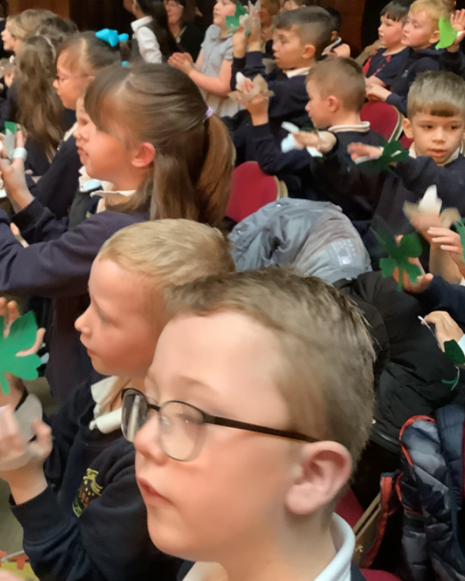
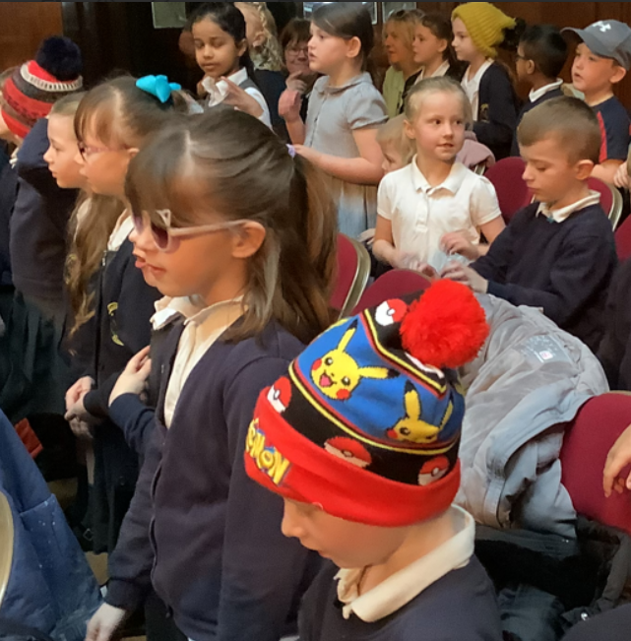
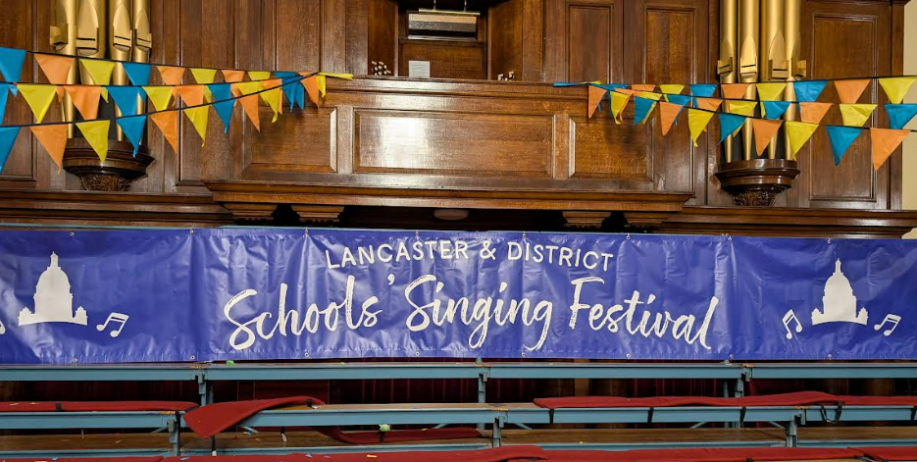
Mrs Walker's performers

This week, the children attended a music festival at the Town Hall in Lancaster. They sang their hearts out joining other schools in the district. Some children even came to the evening performance and gave an amazing event for their parents to watch. We are very proud of you all.

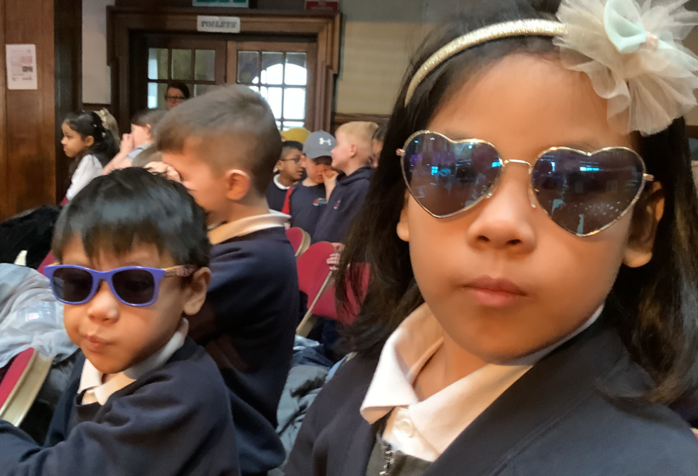

Y 3/4 - The work of David Hockney

Our continuing collage topic has allowed us to investigate the artist David Hockney. His work takes copies of the same picture and then reassembles them in an abstract way. The children worked very hard on their finished pieces and really enjoyed putting their own ideas together.

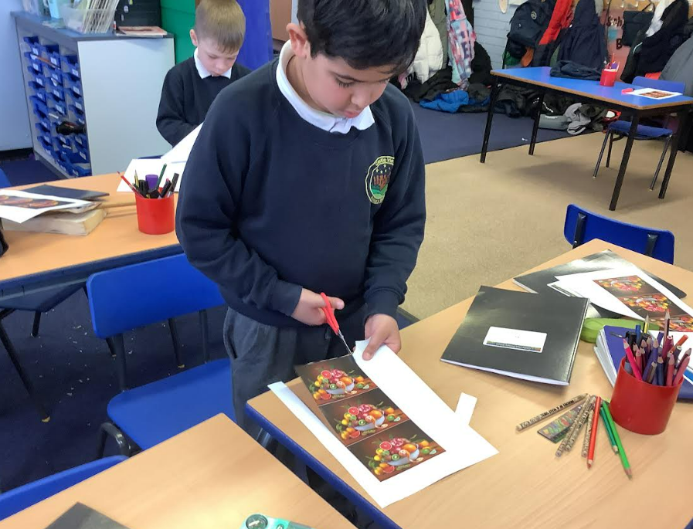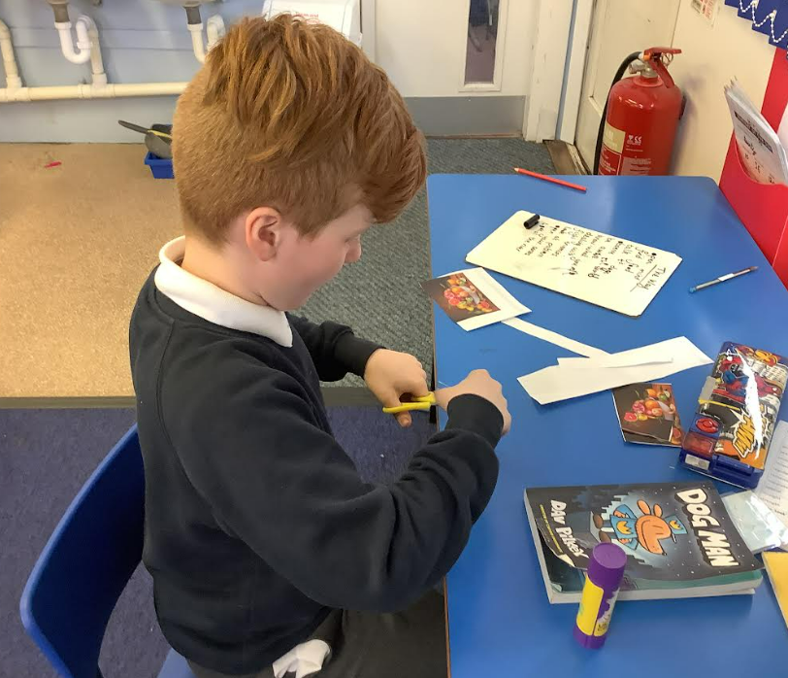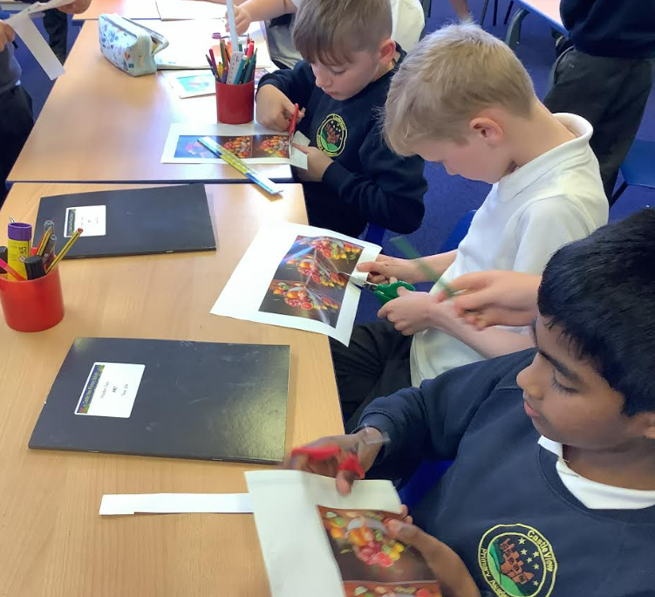

Superstars Certificates for outstanding work


The following children have all worked their socks off in class and have been awarded a certificate for their great attitude to learning:

Miss Spencer – Ivy and Penny Mrs Hamer – Freddie and Ruby
Mrs Walker – All of the Y1/2 class Mrs Stoves – George and Aron

Miss Spencer’s little elves
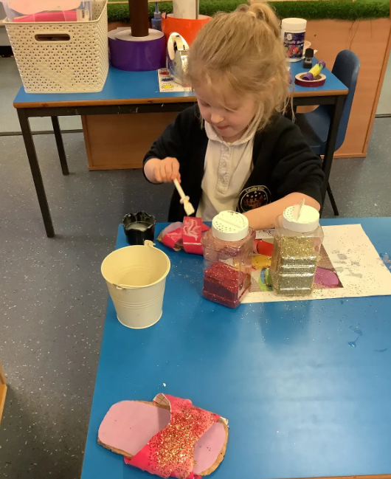
This week, our Reception class continued reading 'The Elves and the Shoemaker', designing and crafting their own unique slippers using a variety of materials. We also explored the traditional tale' Goldilocks and the Three Bears', the children did an outstanding job retelling and writing their own versions of the story. In Maths, we identified even and odd numbers, bringing them to life with imaginative “even” and “odd” monsters!


Fantastic Behaviour Awards

Reception – Ben Year 3/4 – Aaliyah
Year 1/2 – Ozzie Year 5/6 – Ellie

Mrs Stoves’ Y5/6 Artists
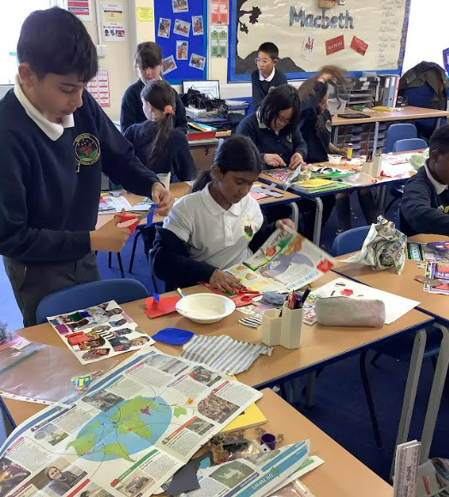
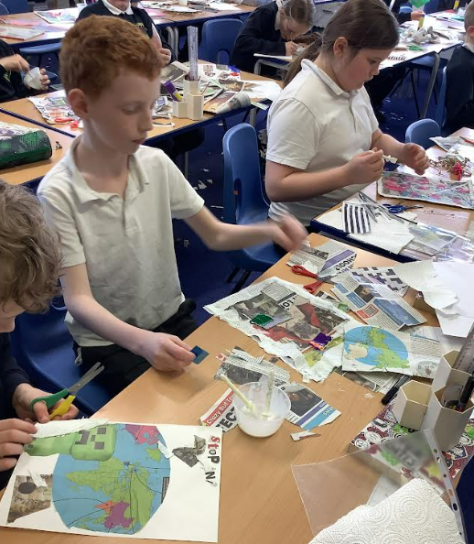
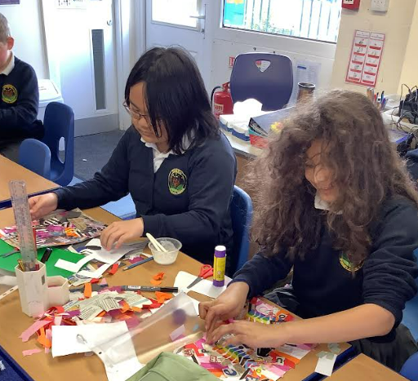

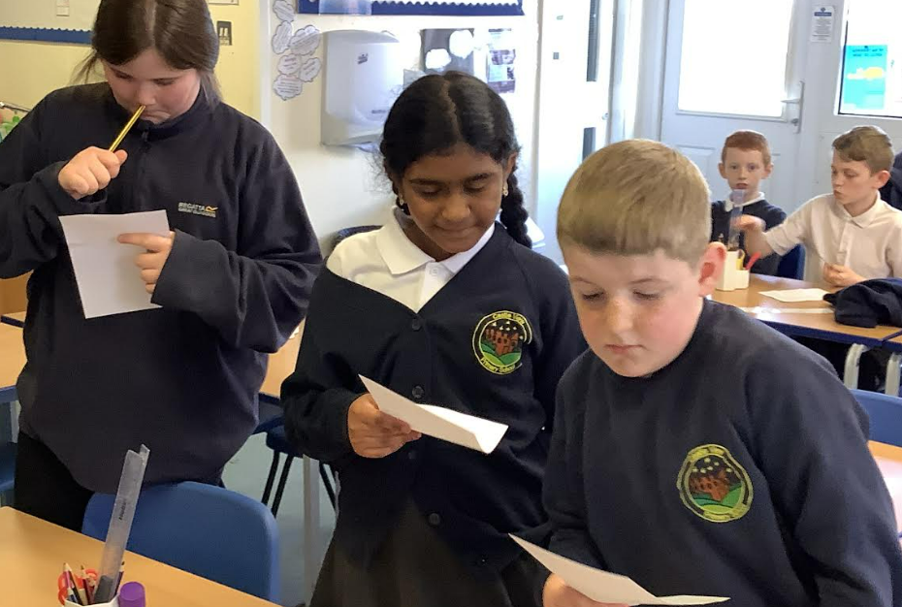
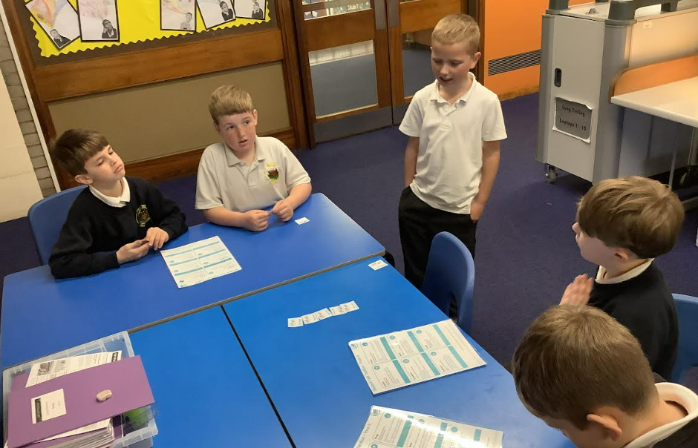

This week, Year 5/6 pupils have been completing that Activism Art project. During the half term, they have been choosing a social subject that they feel passionate about and creating a piece of activism art to promote that particular social movement.
As a school, we are beginning our journey towards improving our oracy skills. This is being led by Mrs Stoves. Our Year 5/6 pupils have been practising their speaking skills and learning how to speak within a group. Watch this space for more information.
Regular Readers The following children have read at home 7 times (or even more!) and we are so proud of them that we want to share their names with you!

Miss Spencer – Ivy, Rory
Mrs Walker – Dante, Kir, Keziah, Riley P, Jayden, Aram, Lacey F/W
Mrs Hamer – Ruby, Tyler, Lily, Michael, Haiden, Michele
Mrs Stoves – Hollie, Michalina, Mckenzie, Primrose, Daniel, Sarah, Ellie-Mae, James, Bella, Thaaranika, Marek

Well done children. As the children will tell you, reading is a super power!

Attendance
The winners of the best attendance prize this week are the children in Reception. Brilliant job!


We are celebrating all the fantastic things happening at Castle View and keeping you even more closely connected to your child's learning journey through X (formerly Twitter). You will be able to find us on X using the handle, @CastleViewAcad
Easter Competition
Remember, the deadline for the Easter Egg Competition is on Monday 31st March 2025. Parents and carers are invited to come and see the entries on Tuesday 1st April after school.
Dates to look out for:
- Monday 31st March - Deadline for Easter Egg entries - it’ll be very eggciting!
- Tuesday 1st April - Easter Egg competition for parents to view entries
- Wednesday 2nd April - Year 1/2 Class Assembly
- Thursday 3rd April - Easter disco for Reception/KS1 (3:45-4:30) and KS2 (4:45-5:45)
- Half term finishes on Friday 4th April
- School re-opens on Thursday 24th April

I hope you all have a lovely weekend.
Best wishes
H. Rose
Acting Headteacher

