Castle View Primary Academy Acting Headteacher: Huw Rose
Keswick Road, Lancaster, LA1 3LE huw.rose@cidari.co.uk
Friday Newsletter – 5th September 2025
Dear Parents and Carers,
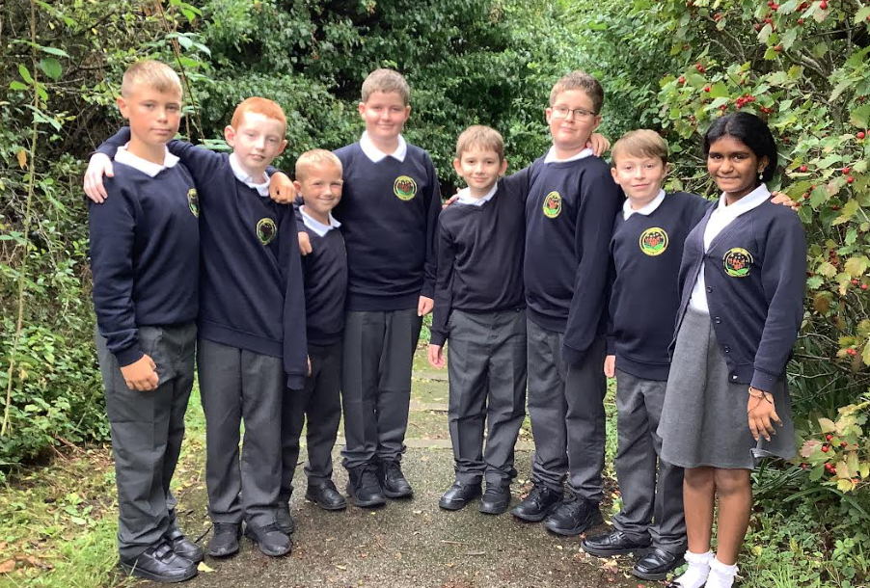
A very warm welcome back to the 2025/26 academic year at Castle View Primary Academy. It has been an absolute delight to see our returning children settle back into school life so brilliantly this week. I would also like to extend a particularly warm welcome to all the new children and families who have joined our school community; we are so pleased to have you with us.
As we begin the new term, you may notice a few minor changes around the school. These have been implemented to help improve both efficiency and effectiveness in our daily routines, with the ultimate aim of making Castle View an even more positive place for your children to come to learn and thrive.
We have certainly kicked off the year with a bang! Our children have already been taking part in a host of exciting activities across the school. This week we have been thrilled to announce our fantastic new House Captains and Vice House Captains (see photo) for the year and have successfully launched our brand new dinner time system.
And that is just the beginning! With all the incredibly exciting plans we have for the children, I am certain that the rest of this half-term, and indeed the year ahead, is going to be one not to forget.
Reaching New Heights in Year 5
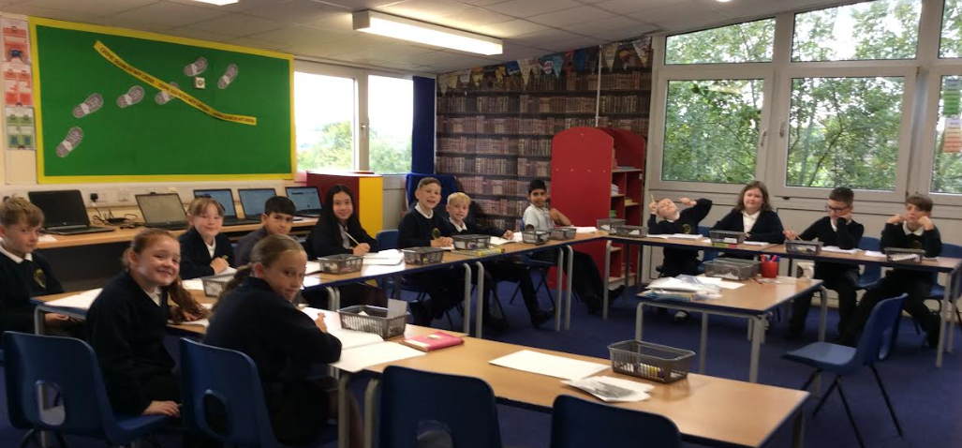
Year 5 have made a great start to the year and have begun with very positive attitudes towards learning. We are enjoying the move upstairs and as we are a small class we have been able to design how to use the space in the room. We now have our own laptop station and a creative area so we can develop our skills even further. Our first trip is Friday the 12th September and there are a few reply slips that need returning please.

Superstars Certificates for outstanding work

The following children have all worked their socks off in class and have been awarded a certificate for their great attitude to learning:

Miss Spencer – Ivy and Blossom Mrs Hamer – Klay and Ryan
Miss Mills – Riley and Iris Mrs Robinson - Kyle and Bella


Fantastic Behaviour Awards

Reception/1/2 – Tayo Year 5 – Teddy
Year 3/4 – Fahad Year 6 - Leo M

A-peeling Work in Year 6!

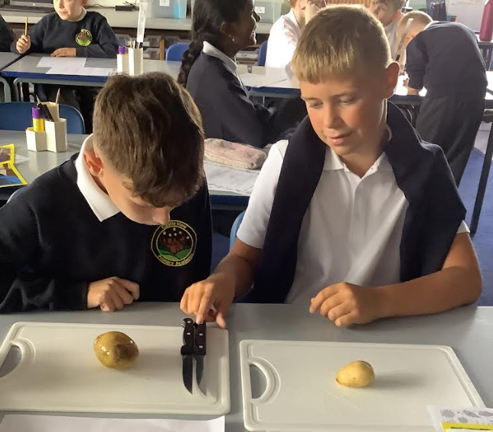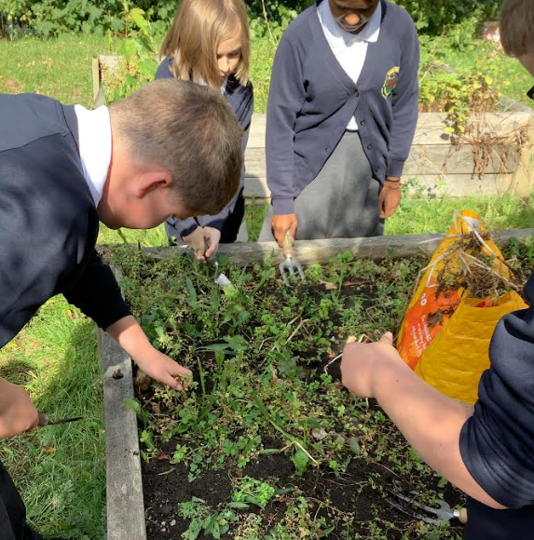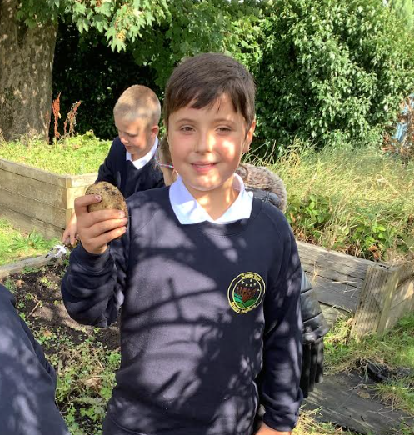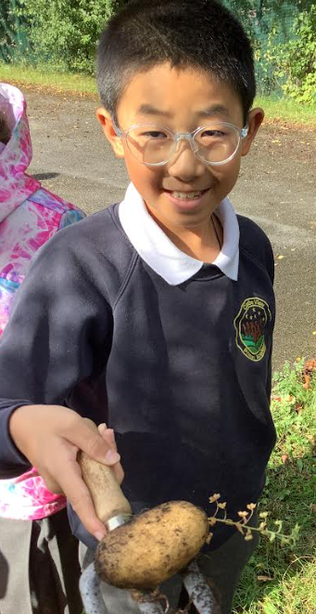

Y6 have been getting their hands dirty harvesting the potatoes they planted back in spring. The children were excited to wash the potatoes before carefully chopping them into bitesize portions that were then roasted in the oven. The children ate every last one and said our Castle View potatoes were 'delicious'.

An 'Apple-solutely' Brilliant Harvest in Year 3/4
Miss Mills' Year 3/4 class have had a wonderful time this week, heading out into the autumn sunshine to harvest the fruit from our school's many apple trees. They worked brilliantly as a team to carefully pick and count the crop, managing to gather a grand total of 184 apples! With such a fantastic haul, I think we can expect a few apple crumbles on the school menu. Anyone for apple sauce?
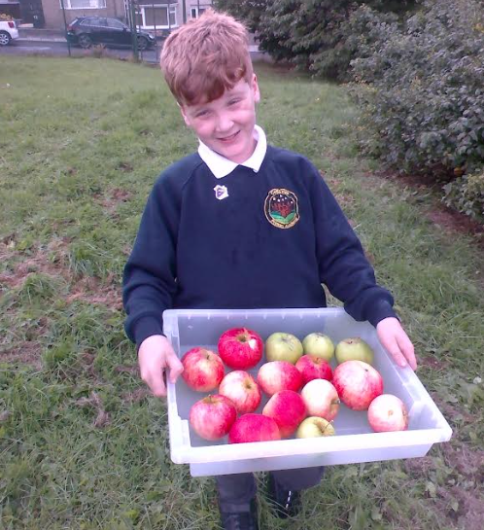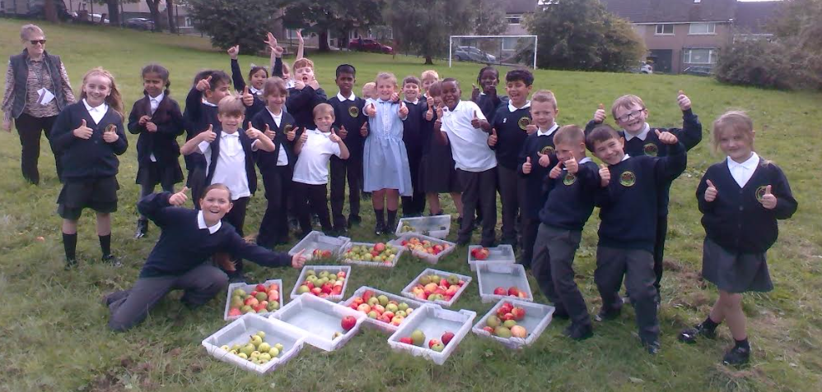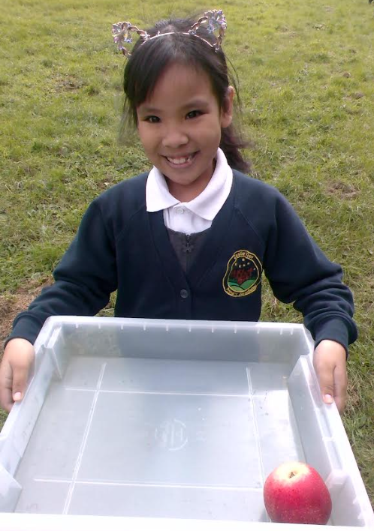

An Apple-solutely Fantastic Start!
What a fantastic start to the new school year we've had in the lower end of the school!
The children have been busy making new friends, and our Reception stars are already doing an amazing job getting to know the school routines — well done, everyone!
This week, as we've been settling into our new classes, we've been learning all about each other’s likes and dislikes. From favourite foods to fun hobbies, it's been great getting to know our classmates better. We’ve also been learning about our school value of being responsible. The children showed just how responsible they can be by helping to weed our play area — such great teamwork! Afterwards, they enjoyed picking apples from our trees for a well-deserved (and delicious!) snack. On top of all that, we've seen some truly amazing self-portraits and beautiful drawings of families — such creativity already! We can’t wait to see what the rest of the year brings. It’s going to be an exciting adventure!
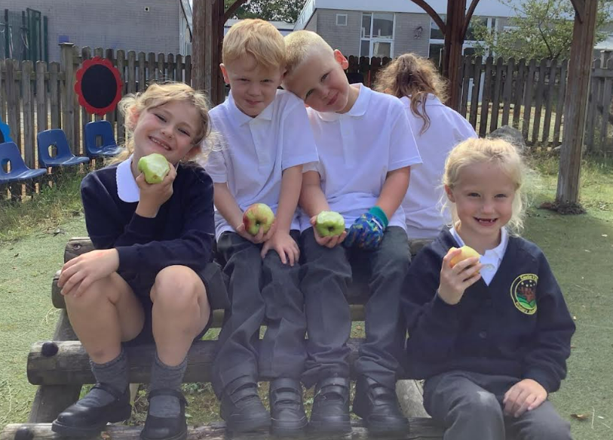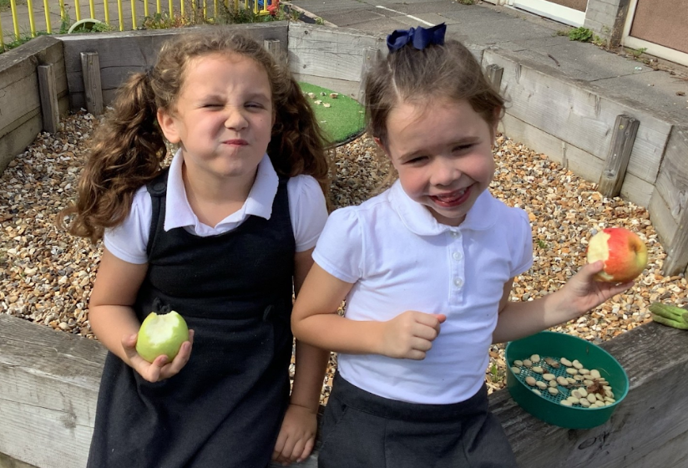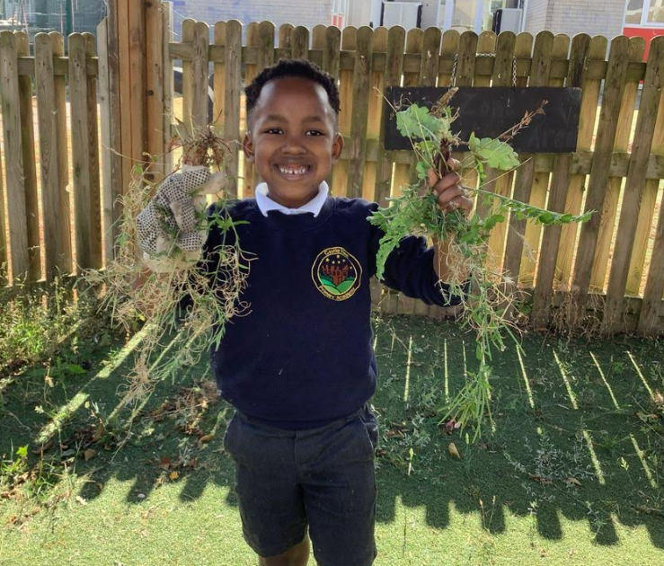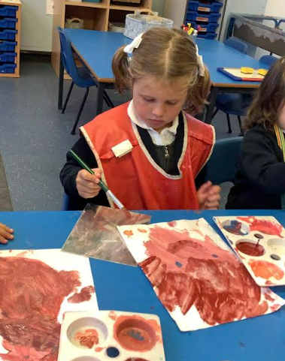

Poetry Visit
On Monday we will be visited by poet Louise Fazackerly. Louise will be leading workshops and performance poetry across the school. The children will then have the opportunity to perform at the Morecambe poetry festival on Saturday 13th September. More details will follow in a separate letter. Please look out for further information.
Harvest Festival
This will take place on Wednesday 1st October at 9am in the school hall. We are now collecting food items in tins and packets ready for the day. Please send any donations to your child's class. All parents are welcome to join us.
Attendance
You may remember that last academic year we had 8 children who had 100% attendance, 3 of whom had it the previous academic year too! These children have really set the standard for being in school every day on time and we are already hearing children talk about wanting to be part of this elite group at the end of this academic year which is very commendable. Please support your child by ensuring they are in school on time each day. If they are feeling slightly under the weather e.g. headache you can supply calpol for them to take during the day.

Coming to school every day makes a real difference to your child's learning journey. Every day missed adds up, meaning valuable learning time is lost. For instance, just one day off a week is nearly six weeks of learning missed across the school year! Let's work together to make the most of every learning opportunity.


We have an exciting opportunity for two parents to join our governing body as Parent Governors. This is a fantastic chance to play a vital role in shaping the future of Castle View, contributing to key decisions and strategic planning that directly impact our school community. If you're passionate about making a difference and would like to learn more about this rewarding role, please don't hesitate to speak to Mr. Rose for further information.
Dates to remember for the rest of the half term
- Friday 12th September - Y5 and Y6 trip to Leighton Hall
- Wednesday 24th September - Y6 Class Assembly
- Wednesday 1st October - Castle View Harvest Assembly
- Thursday 2nd October - National Poetry Day
- Tuesday 7th October - Y6 Heights and Weights
- Monday 13th October (2pm) - SEND Coffee Meeting with Mrs Barton
- Tuesday 14th October - School photo day
- Tuesday 14th October - Flu Immunisation - School Nurse Team
- Wednesday 22nd October - Halloween Disco
- Thursday 23rd October - School closes for half term
Best wishes
H. Rose
Acting Headteacher

