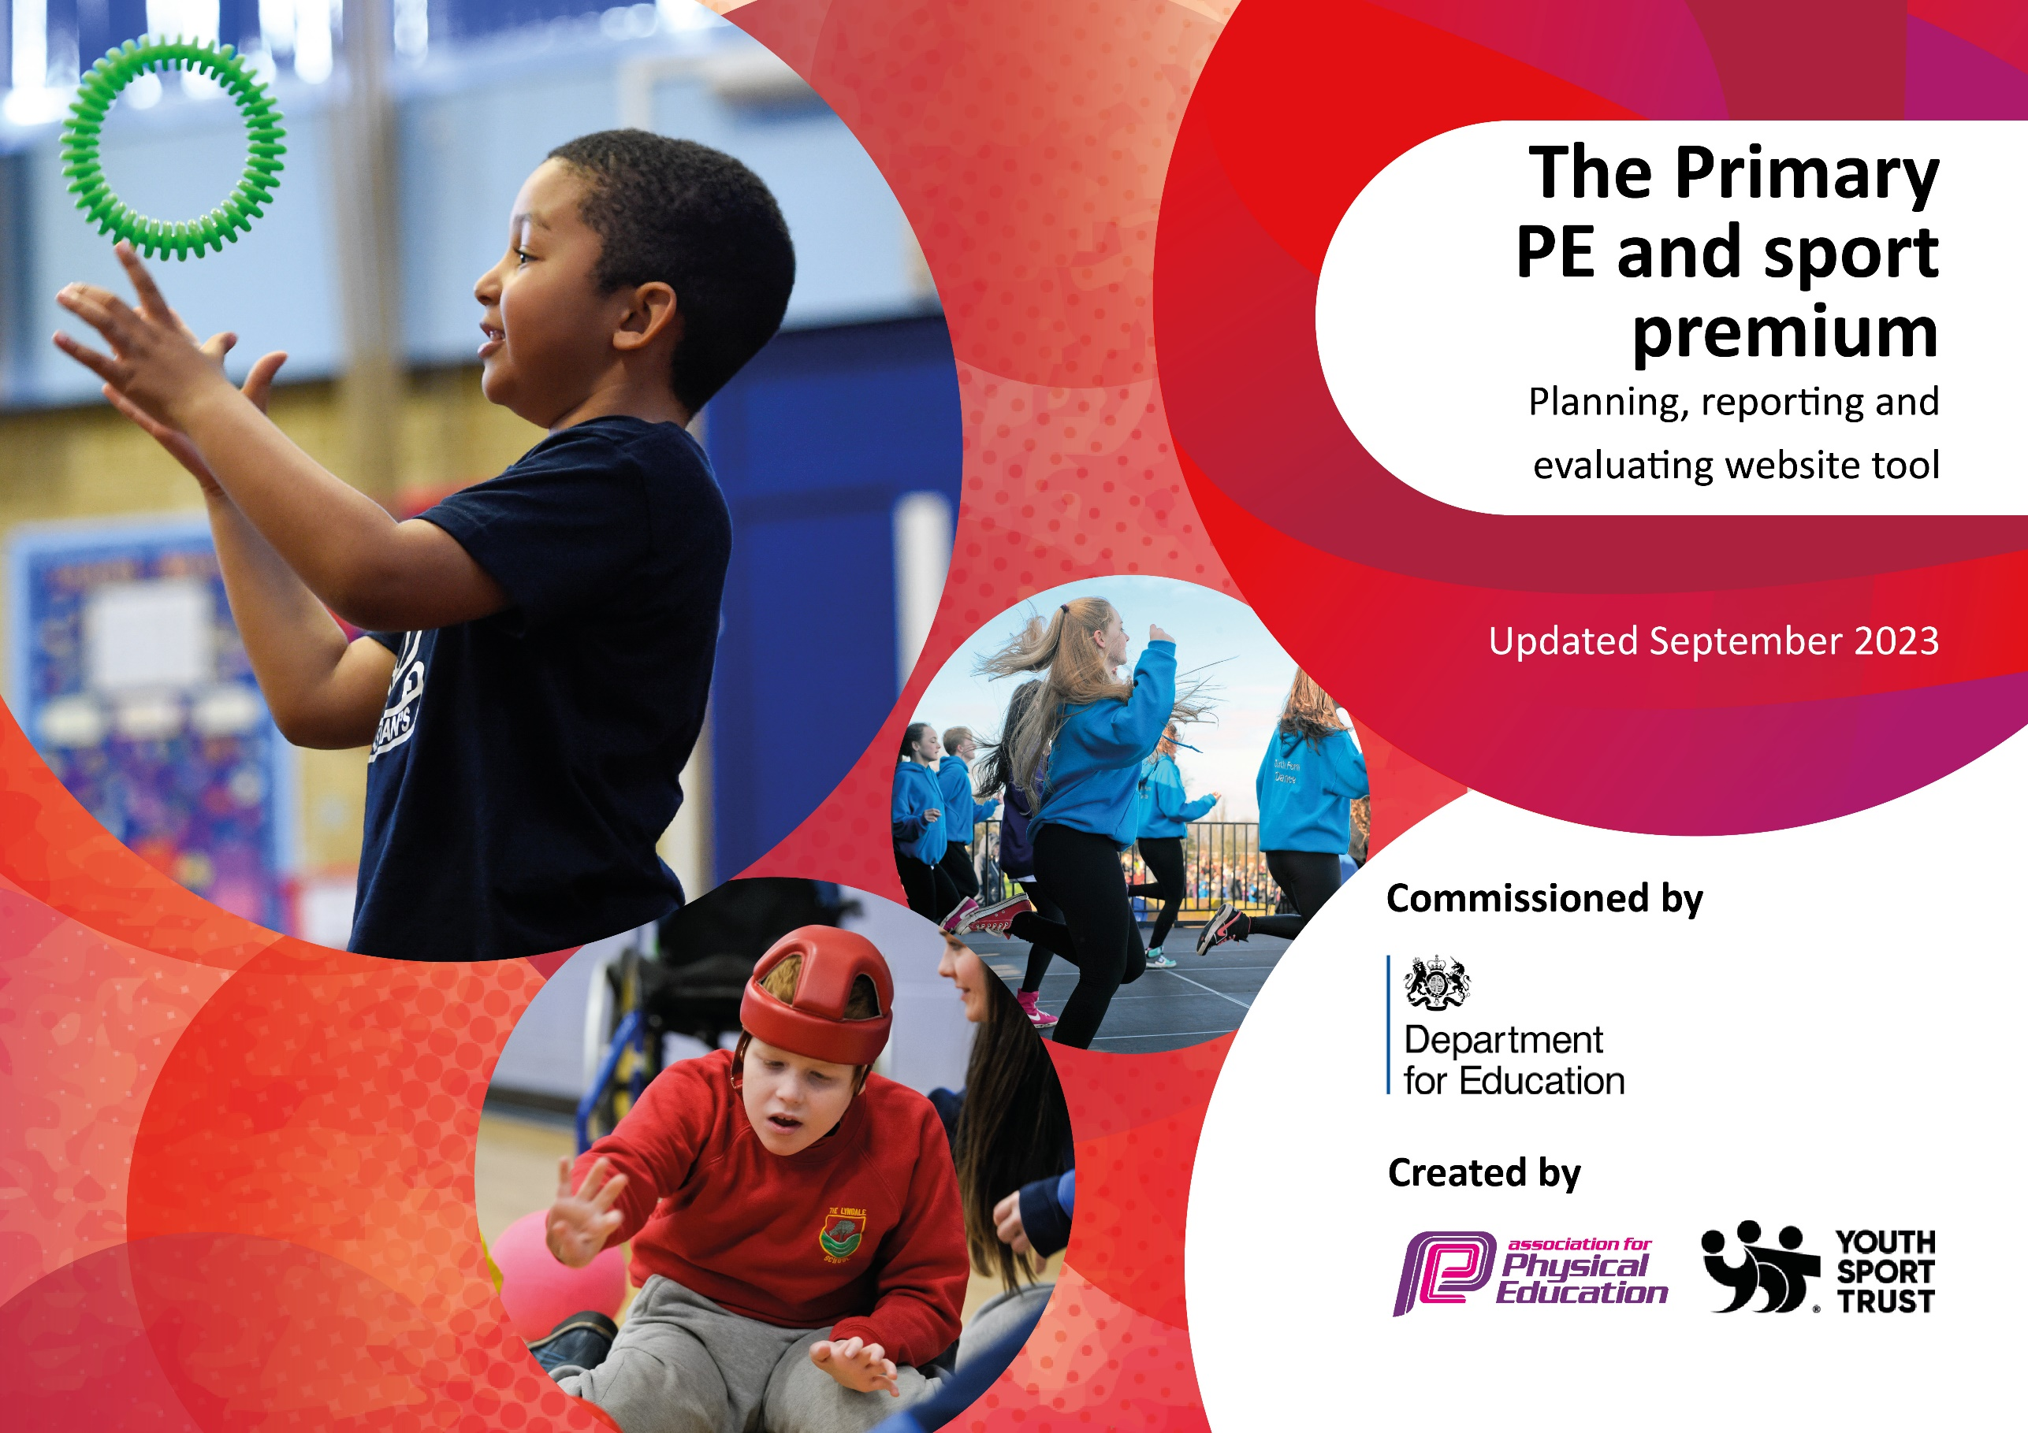

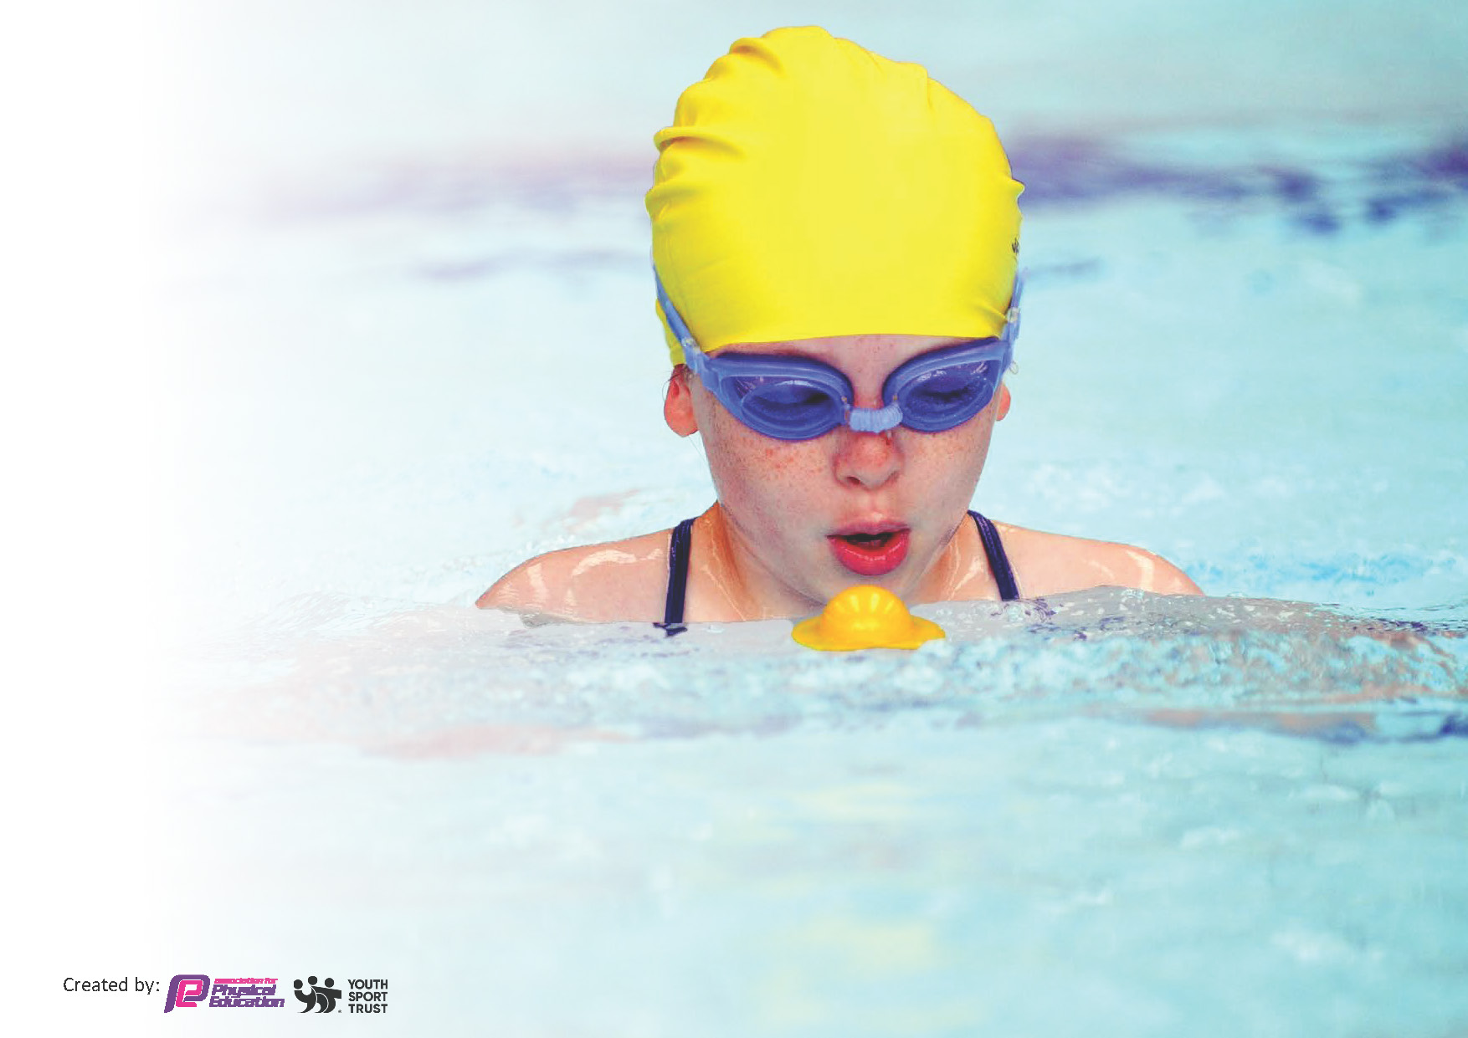
This template can be used for multiple purposes:
by:
- It enables schools to effectively plan their use of the Primary PE and sport premium
- It helps schools to meet the requirements (as set out in guidance) to publish information on their Primary PE and sport premium
- It will be an effective document to support Ofsted inspections enabling schools to evidence progress in Physical Education (PE) and evidence swimming attainment, which forms part of the PE National Curriculum. We would recommend schools consider
the Intent, Implementation and Impact of any spend, as examined within the Education Inspection Framework.

It is important that your grant is used effectively and based on school need.

Schools must use the funding to make additional and sustainable
improvements to the quality of the PE, School Sport and Physical Activity (PESSPA)
they offer. This means that you should use the Primary PE and sport premium to:

- Build capacity and capability within the school to ensure that improvements made now will benefit pupils joining the school in future years
- Develop or add to the PESSPA activities that your school already offers.

The Primary PE and sport premium should not be used to fund capital spend projects; the school’s core budget should fund these. Further detail on capital expenditure can be found in the updated Primary PE and sport premium guidance.

The Primary PE and sport premium guidance, outlines 5 key priorities that funding should be used towards. It is not

necessary that spending has to meet all the key priorities, you should select the priorities that you aim to use any funding towards.

Although completing this template is not a requirement for schools, schools are required to publish details of how they spend this funding. Schools must also outline what the impact this funding has had on pupils’ PE and sport participation and attainment and how any spending will be sustainable in the future. All funding must be spent by 31st July 2024.

The Department for Education has worked closely with the Association for Physical Education (afPE) and the Youth Sport Trust (YST) to develop this template and encourages schools to use it. This template is an effective way of meeting the reporting requirements of the Primary PE and sport premium.
Review of last year’s spend and key achievements (2022/2023)

We recommend you start by reflecting on the impact of current provision and reviewing your previous spend.

Activity/Action | Impact | Comments
All children to be encouraged to participate in 30 minutes of physical activity daily.

Children to consolidate the fundamental skills in KS1 to enable them to participate in games in KS2.

Improve parental support for sports and for parents to encourage their children to participate in physical activity outside of the school day.

Staff to be confident in using the PE app (Pe Passport) for planning, assessing and recording evidence.

Subject leader to be confident in the progression of PE planning.

Key priorities and Planning
This planning template will allow schools to accurately plan their spending.

Action – what are you planning to do | Who does this action impact? | Key indicator to meet | Impacts and how sustainability will be achieved? | Cost linked to the action
Introduce lunchtime sport sessions/activities for pupils.  After school Football Club  Afterschool Dance Club (Autumn and Summer)  Afterschool Hula Hoop Club  Membership of the School Sports Network (LHSSN) so that school can enter children into competitive sporting events.  Purchasing of PE equipment to replenish and increase children’s experience in PE. | Lunchtime supervisors, teaching staff, pupils  Key stage 2 children  Key Stage 2 children  Key Stage 1 and 2 children  Key Stage 1 and 2  Key Stage 1 and 2 | Key indicator 2 -The engagement of all pupils in regular physical activity  Key indicator 4: Broader experience of a range of sports and activities offered to all pupils.  Key indicator 5  Key indicator 5  Key indicator 2 – engagement of all pupils in regular physical activity  Key indicator 4 – Broader experience of a range of sports and activities offered to all pupils.  Key Indicator 2  Key Indicator 3 | More pupils meeting their daily physical activity goal, more pupils encouraged to take part in PE and Sport Activities.  Pupils are developing the necessary skills to  More pupils meeting their daily physical activity goal, more pupils encouraged to take part in Sport Activities. Hula hooping is a different type of exercise and offers an opportunity for all pupils to experience something different to the main sports.  An increase in confidence, knowledge and skills of all staff in teaching in PE and sport.  All pupils have access to high quality PE equipment. | FREE training (as part of the SSN membership, which cost £2150  £1000 – Lunchtime Activity equipment  £1900 (38 weeks)  £945 (27 weeks)  £2150  £5000

Key achievements 2023-2024
This template will be completed at the end of the academic year and will showcase the key achievements schools have made with their Primary PE and sport premium spending.

Activity/Action | Impact | Comments

Swimming Data
Meeting National Curriculum requirements for swimming and water safety.
Priority should always be given to ensuring that pupils can perform safe self-rescue even if they do not fully meet the first two requirements of the National Curriculum programme of study

Question | Stats: | Further context  Relative to local challenges
What percentage of your current Year 6 cohort can swim competently, confidently and proficiently over a distance of at least 25 metres? | 20% | 20% - Castle View Primary Academy has a very high level of mobility. This means some pupils have had fewer or no swimming lessons due to just starting.
What percentage of your current Year 6 cohort can use a range of strokes effectively [for example, front crawl, backstroke, and breaststroke]? | 20% | Even though your pupils may swim in another year please report on their attainment on leaving primary school at the end of the summer term 2024

What percentage of your current Year 6 cohort are able to perform safe self-rescue in different water-based situations? | 70% | All 21 pupils who took part in water safety and safe self rescue completed and were competent.
If your schools swimming data is below national expectation, you can choose to use the Primary PE and sport premium to provide additional top-up sessions for those pupils that did not meet National Curriculum  requirements after the completion of core lessons. Have you done this? | No
Have you provided CPD to improve the knowledge and confidence of staff to be able to teach swimming and water safety? | Yes | Miss Stoves and Miss Boardman attended

Signed off by:

Head Teacher: | Claire Bright
Subject Leader or the individual responsible for the Primary PE and sport premium: | Huw Rose
Governor:
Date: | September 2023

