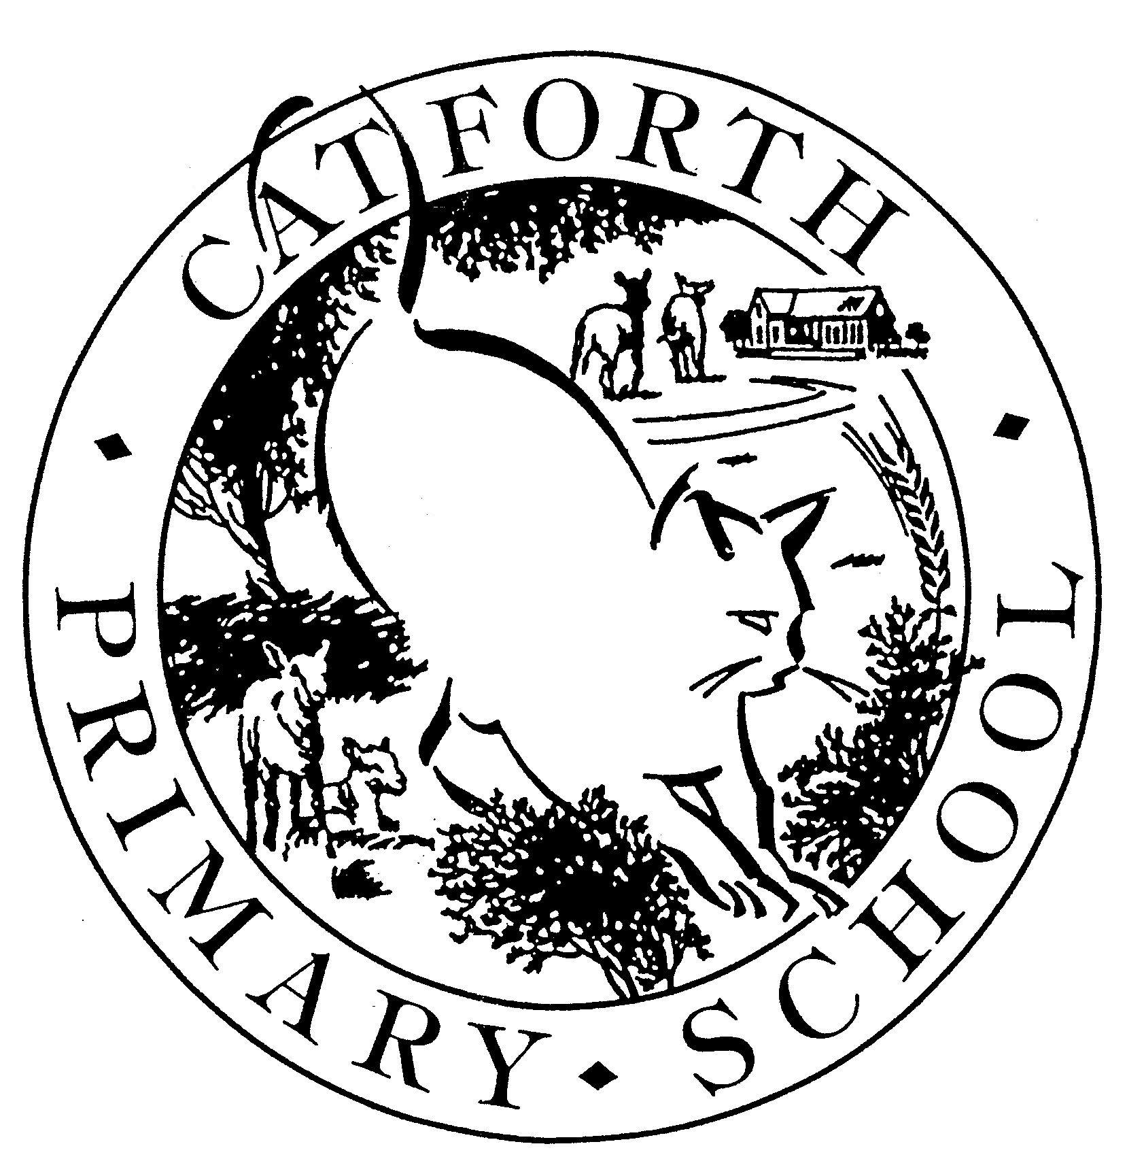
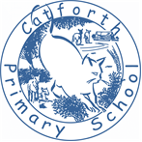
School Lane, Catforth, Preston PR4 0HL

CATFORTH PRIMARY SCHOOL
Headteacher: Mrs. J. Bainbridge Tel; 01772 690451
Website: www.catforthprimary.co.uk

ART
POLICY

ART POLICY

Contents

1 The Purpose of Art Policy
2 Aims
3 Curriculum and School Organisation
4 Art Curriculum Planning
5 Sketchbooks
6 Assessment
7 Special Educational Needs and Disabilities
8 Safety in Art
9 Monitoring and Review

The purpose of the Art policy

This policy outlines the teaching and learning of Art at Catforth Primary School.

Art, craft and design embody some of the highest forms of human creativity. A high-quality art and design education should engage, inspire and challenge pupils, equipping them with the knowledge and skills to experiment, invent and create their own works of art, craft and design. As pupils progress, they should be able to think critically and develop a more rigorous understanding of art and design. They should also know how art and design both reflect and shape our history, and contribute to the culture, creativity and wealth of our nation.
National Curriculum Purpose of Study

Aims/Intent

All children will have the opportunity to become Artists throughout their time at Catforth Primary School, to learn through Art as well as about Art. Our intention is to ensure that children feel excited, included and enabled in their individual creative journey. We aim to deliver a rich and exciting Art curriculum that meets the requirements of the National Curriculum, and builds upon foundational skills, knowledge and experiences laid during the Early Years Foundation Stage. Throughout their journey, children are encouraged to revisit important wider questions about Art; What is Art? How is Art made? What is Art for? Who is Art for?

During the Early Years Foundation Stage, we aim that pupils:

Build dexterity skills
- Explore materials and mark making in a playful way
- Use bodies and imaginations to inspire making
- Explore how they can reflect and share their views about what they have seen or made
- Explore how art enriches our lives

During Key Stage 1, we aim that pupils:
- Develop their creativity and imagination by exploring the visual, tactile and sensory qualities of materials and processes.
- Learn about the role of artists, craftspeople and designers from different times and cultures for differences and similarities.
- Begin to understand colour, shape, space, pattern and texture and use them to develop their ideas – try things out and change their mind.
- Experiment with a range of drawing media and explore ideas from first-hand observations.
- Use a simple graphics package to create images and effects.
- Review what they and others have done and say what they think and feel about it.

During Key Stage 2, we aim that pupils:
- Use their developing creativity and imagination to question and make thoughtful observations about starting points and select ideas in their work.
- Select and record from first hand observation, experience and imagination, and explore ideas for different purposes.
- Build on their skills and improve their control of materials, tools and techniques.
- Compare ideas, methods and approaches in their own and others’ work and say what they say and feel about them. Adapt their work and describe how they might develop it further.
- Explore the roles and purposes of artists, craftspeople and designers working in different times and cultures.
- Experiment with ways in which surface detail can be added to drawings.
- Use journals to collect and record visual information from different sources. Annotate work in journal.
- Draw for a sustained period of time
- Record, collect and present recorded visual information using digital cameras and video recorders. Use a graphics package to create images and effects.

It is our aim that by the time our children leave primary school they can feel as if they have found an area of the visual arts that is relevant and engaging to them – that might be through drawing, making or designing, or talking about art. We want them to feel enthused and excited about Art, and able to talk confidently about what Art means to them.

Curriculum and school organisation - Implementation
Art is taught as a weekly discrete lesson, with cross-curricular links throughout the unit. Art is embedded within our class topics and is incorporated into whole school themed/special days such as Roald Dahl day or World Mental Health Awareness Day.

To achieve our aims, our Art Curriculum is spilt into the following six themes, which are revisited each year;

Drawing and Sketchbooks,
Print, Colour and Collage,
Working in Three Dimensions (two units)
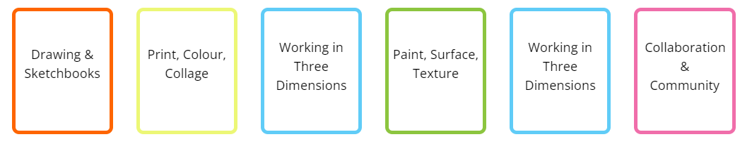
Paint, Surface and Texture,
Collaboration and Community

Within each theme, children follow a ‘pathway’ plan each half term, which leads them to develop knowledge and skills across range of disciplines. Each pathway makes links to Artists, ensuring children learn about and are inspired by a range of diverse crafts people and creative industries. Units also build in the opportunity for the children to reflect on their learning. At the end of each Art topic, children discuss their own and other people’s work, reflecting on their journey, with an eye to celebrating and further developing their skills. This also allows the children to practice their use of artistic and evaluative language and also reflect on their own progress within different mediums of Art.

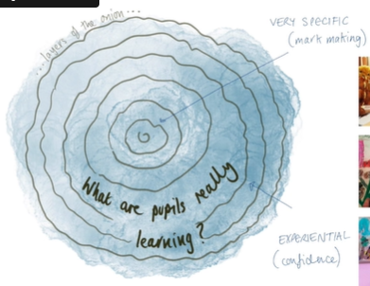
Our Art curriculum is carefully sequenced, in order to enable children at Catforth to build on their artistic skills and knowledge in the disciplines of drawing, printing, painting, collage, and sculpture from year to year. We see this process as a spiral curriculum – as opposed to linear - whereby children’s creative skills are revisited and built upon over time.

Planning
Foundation Stage
Artistic development is woven throughout our children’s journey during the Early Years Foundation Stage, particularly the areas of Physical Development, Expressive Art and Design and the Characteristics of Effective Learning.

Children explore the following areas.

What Can We See?

How Can We Explore Colour?

How Can We Build Worlds?

How Can We Explore Materials & Marks?

How Can We Explore 3d Materials?

How Can We Use Our Bodies To Make Art?

How Can We Use Our Imaginations?

Activities enable open-ended, playful exploration of materials, processes and ideas, which in turn nurture dexterity skills, promote an early understanding of visual literacy skills, and begin to build children’s confidence in their ability to make a personal, creative response to a stimuli.

Together these opportunities provide a foundation for pupils to develop skills further throughout Key Stage 1 and 2.

Key Stage 1 and 2
Our school uses the National Curriculum as the basis for the Foundation Subject of Art. Our medium-term plans give details of each unit of work for each term, supported through the Access Art Curriculum Pathways. They identify learning objectives and outcomes for each unit and ensure an appropriate balance and distribution of work across each term. The units planned are tailored to the mixed aged classes here at Catforth.

Programme of Study - National Curriculum at Key Stage 1
Pupils should be taught:
▪ to use a range of materials creatively to design and make products
▪ to use drawing, painting and sculpture to develop and share their ideas, experiences and imagination
▪ to develop a wide range of art and design techniques in using colour, pattern, texture, line, shape, form and space
▪ about the work of a range of artists, craft makers and designers, describing the differences and similarities between different practices and disciplines, and making links to their own work.

Programme of Study - National Curriculum at Key Stage 2
Pupils should be taught to develop their techniques, including their control and their use of materials, with creativity, experimentation and an increasing awareness of different kinds of art, craft and design.
Pupils should be taught:
▪ to create sketch books to record their observations and use them to review and revisit ideas
▪ to improve their mastery of art and design techniques, including drawing, painting and sculpture with a range of materials [for example, pencil, charcoal, paint, clay]
▪ about great artists, architects and designers in history.

Sketchbooks
Sketchbooks are an integral part of our learning journey at Catforth School. Introduced in Year One and continued until the end of Key Stage 2, they are used in both the stand alone drawing and sketchbook unit each year, and during other units throughout the year as a personal space for experimentation and reflection. Teachers model use of sketchbooks, and children are encouraged to look back and reflect on their work, identifying the initial stages of a process or prior learning as a reference point. Sketchbooks are used for:

• Exploring ideas, plans and designs
• Keeping a visual record of their observations made from a range of first-hand resources.
• Recording, exploring and storing visual and other information, such as notes and selected materials which can be used for reference
• Collecting materials, such as fabric designs, patterns, colour schemes, which they feel may be an inspiration for future work
• Critical evaluations of artists’ work, styles and techniques
• Comparing ideas, methods and approaches in their own and others’ work and saying what they feel and think about them.
• Adapting their work according to their views and describing how they might develop it further.
• Annotating their own and artist’s, crafts people’s and designer’s work in a sketch book.

In EYFS, children’s creative and artistic development maybe evidenced through Tapestry, displays, floor books and examples, and on Class Dojo.

Assessment
Assessment of Art is holistic and ongoing thoughout. It most frequently takes place through conversation with children, both individually or as a group and includes reflection and discussion about children’s own work and that of their peers. Through assessment we aim to support children to grow. We recognise Art as a unique subject and the delicate nature of assessing emerging creativity. Our assessment of Art is therefore gentle but meaningful. Children’s growth (or progression) in each discipline can be seen as a result of repeated exposure to media, concepts, explicit teaching of skills and techniques, together with supported reflection whilst leaving space for different types of success.

Teachers may choose to create a ‘wall of reflection’ a space to add ideas, vocabulary and other content as a unit progresses. ‘I can’ statements used for each unit provide a starting point for discussion.

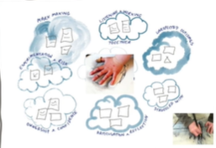
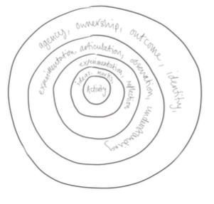

Special Educational Needs and Disabilities

Art and design is an essential means of creative expression that can boost self-esteem and give learners the agency needed to develop and communicate their personal ideas, observations, and creations. It lends learners opportunities to develop both individually and collaboratively, the latter highlighting the importance of working together for a common purpose to demonstrate to learners that their contribution is important. Thereby art and design connects learners to the wider world in ways that other subject areas cannot. NASEN 2022
.

We recognise the unique capacity for Art to engage all children in creative expression. When planning their lessons, teachers ensure learning will be accessible to all by considering the individual barriers to learning some children may face and planning how to address these. The SEND teacher handbook has useful guidance in this area. See appendix 1.

Safety in Art
The safety of the children is the responsibility of the class teacher. The Design Technology Association risk assessments are available on the staff server and are used by teachers before activities are carried out. The children are made aware of the safe use and correct procedure involved when using tools and equipment in a learning environment and how to follow proper procedures. The children build up a range of skills when using equipment to reduce unnecessary risk.

Monitoring and Review
The monitoring of children's work and of the quality of teaching in Art is the responsibility of the Art subject leader. The work of the subject leader also involves supporting colleagues in the teaching of Art, being informed about current developments in the subject, and providing a strategic lead and direction for the subject in the school. The Art subject leader gives the headteacher an annual report in which she evaluates the strengths and weaknesses in the subject and indicates areas for further improvement. The Art subject leader has specially-allocated, regular management time in order to review evidence of the children's work and undertake lesson observations of Art teaching across the school.



