English Policy

The heart of the wise makes his speech judicious and adds persuasiveness to his lips. Gracious words are like a honeycomb, sweetness to the soul and health to the body.
Proverbs 16:23-24

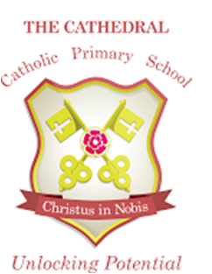

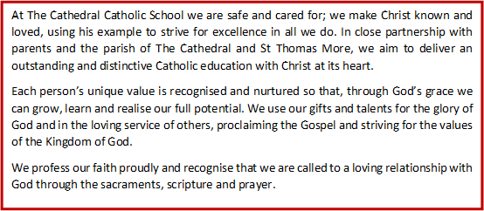

This policy was developed as part of a consultation process involving pupils, staff, parents and Governors of The Cathedral Catholic Primary School, based on best practice advice from Lancashire County Council.
This policy should be read in conjunction with the following documents:
- Teaching and Learning Policy
- Marking and Feedback Policy
- Handwriting Policy (Appendix A)
- Assessment Policy
- Inclusion Policies

English Subject Statement

To develop our pupils as speakers and listeners we:
- Give them opportunities to express their ideas to a range of audiences
- Give them opportunities to take part in group discussion and drama activities
- Encourage them to listen and respond appropriately to others.
- Help them to understand the need to adapt their speech for different situations
- Give them opportunities to evaluate and reflect on their own speech
- Encourage them to use the vocabulary and grammar of Standard English.
To develop our children as readers we:
- Place a high importance on the teaching of phonics as the foundation of learning to read. In Reception and KS1 a discrete Letters and Sounds lesson is taught daily.
- Teach Phonics to KS2 children who still require the support
- Teach them to read accurately and fluently using a range of strategies both at school and at home
- Help them to understand and respond to what they read using inference and deduction where appropriate
- Encourage them to read a wide range of fiction and non-fiction books, including classic fiction
- Encourage them to read independently and with enjoyment
- Teach them to seek information and learn from what they read.
- Encourage them to use their reading skills as an integral part of their learning across the curriculum
- Read regularly to children so as to model good practice in reading (class reader)
To develop our children as writers we:
- Teach them to write effectively for a range of purposes and readers, adapting their vocabulary
- Encourage them to write with interest commitment and enjoyment
- Show them how to write in a variety of forms such as stories, poems, reports and letters through good quality teacher modelling
- Teach grammar warm up sessions, modelling the correct use of terminology
- Teach spelling as part of English concentrating on rules and patterns of words
- Show them how to evaluate and improve their own writing
- Teach children how to punctuate to make meaning clear to the reader
- Give them the knowledge and strategies to become confident and accurate spellers
- Teach them a fluent and legible style of handwriting, promoting an understanding of how to present work appropriate

Planning and Organisation of English
All classes across the school have a daily English lesson which is planned using the National Curriculum in order to achieve our school aims for English. The Early Years Foundation Stage framework is used by Foundation Stage practitioners leading on to National Curriculum English objectives for the rest of the school. English should be linked to cross curricular themes wherever possible.
English in EYFS
Children begin to develop the skills they need for English at the beginning of the EYFS. Reception children have a daily phonics session working through The Cathedral Letters and Sounds. Once the whole class has started in Reception, children begin phase 2 phonics. They begin to form letters from day 1 and blend sounds together from week 2. These sessions are delivered as whole class session each morning and additionally there is a boost session each afternoon. Writing takes palce in small goups to ensure children receive more personalised learning. Children begin to take home phonetically decodable reading books as soon as they begin to blend the phonemes. Children only take home books that have phonemes in that they have previously been taught to blend. The children are encouraged to apply their phonics to their reading and writing skills. There are numerous opportunities inside and outside for the children to practise and develop their literacy skills through fun, exciting continuous provision activities.

English in Key Stage 1
Teachers plan daily English lessons using the Lancashire Units which last approximately one hour. Children participate in guided writing sessions within the English lesson, but guided reading takes place outside the English lesson. Handwriting is also taught discretely and linked to spelling.

English in Key Stage 2
Teachers plan English lessons using the Lancashire Units which last approximately one hour for five days a week. Spelling is taught as a discrete lesson and grammar skills are taught throughout the school, with each year group having a specific number of allocated skills to teach. English is also encouraged across the curriculum and links are made with other subjects where appropriate. English lessons are supplemented by a discrete 30 minute daily guided reading session. Children who are not secure in their phonic knowledge when they leave KS1 are assessed to see if other strategies may work better for them. They may continue with Phonics and use Bounce Back phonics programme or they may move onto precision teaching to recognise whole words. Handwriting is also taught discretely.

Oracy at The Cathedral

At Cathedral we believe that correct spoken language is fundamental to learning. From the first days in school, speaking and listening play a large part in a child’s progress in all curriculum areas and teachers plan to develop these skills in a wide variety of ways. We aim to develop and encourage fluent speakers, who can confidently articulate their ideas in a wide range of situations.
Pupils should have a range of planned oracy experiences, which include:
- drama;
- talking partners;
- Talk 4 writing/ preparation for writing;
- listening to stories;
- reading sessions;
- visiting speakers;
- giving and receiving instructions;
- paired/collaborative work;
- problem solving in maths;
- presentation of learning;
- plan, do review sessions.

It should also be recognised that there are opportunities for children to develop their oracy skills outside of the curriculum, including:
- assemblies
- celebration of the word
- student council and other pupil voice activities;
- extra-curricular and year group productions;
- Nativity performances

Children with additional needs are encouraged to take full and active part in spoken
language activities at a level appropriate for their needs. Targets are usually set by the class
teacher, following the advice of our SENDCo, which are then worked on individually or in
small groups. Some of our children have input from a speech therapist, and we welcome the
expertise they bring to the school. Our EYFS teachers use the Wellcom toolkit to develop our
pupils’ oracy skills from the start of their school journey.
As a school we have a large number of pupils who have English as an additional language.
Their experiences and knowledge provide us with a rich resource on which to draw for the
benefit of the whole school. Visual prompts and signs written in the child’s first language may
be used to develop vocabulary and encourage participation for early English speakers.
Our experienced TAs and pastoral team work with individuals or groups of children
specifically in the areas of speaking, listening and collaboration. Sometimes this may be to
address a SEND issue, at other times it may be to encourage social skills.

Phonics at The Cathedral

We plan, deliver and assess phonics using The Cathedral Letters and Sounds. This is our own SSP based on the original structure of Letters and Sounds. The teaching of phonics occurs in the same order as the original document, however we have our own resources to teach the programme as advised by our local reading hub.
At the beginning of Reception, children will begin phase 2 and work through phase 3 and 4. Year 1 will begin phase 5 and Year 2 will begin phase 6. This is the minimum expectation and groups often work at a faster pace than this.

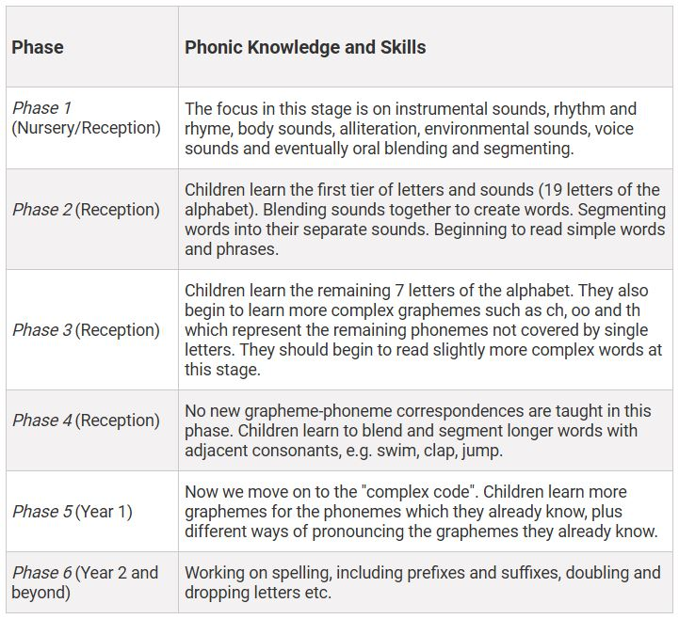

Phonics is taught discreetly to each year group on a daily basis with the emphasis being on ‘keep up not catch up’. All children are exposed to the phonemes and graphemes for each year group. Any children who struggle to retain this knowledge or blend sounds move have additional interventions to help them keep up. It is anticipated that the children will stay together and be taught as one large group however children who are identified as having a specific learning need may be put in a small group with an adult and move at a slightly slower pace. At the beginning of each year children will be assessed using Phonics Tracker. The tracker is updated during assessment week and the English leader will identify any children who are struggling with their phonics and recommend support and intervention as necessary. Daily interventions take place for children not meeting YGE. Fast track phonics is used for Year 2 who didn’t pass the Phonic screening in addition to whole class phonics. Bounce back phonics/precision teaching is used in KS2.

Recording of phonics
The children record their phonics learning in a red phonics skills book. Some lessons are additionally recorded in English skills books. Phonics activities occur during guided reading sessions and in continuous provisions (R and Year 1). Children are encouraged to use their phonics to spell unknown words throughout all lessons.

Spelling in Rec/ Y1
Tricky words are taught throughout the early years at school and children practise whole word recognition through flash cards and displays. Tricky words are displayed on blue cards and phonetically decodable word are displayed in yellow to help children differentiate.

Spelling in Y2-6
Years 2-6 follow the National Curriculum spelling programme. Purple Mash is used as the tool for delivering this. Children are assessed on spelling in different ways, either through quizzes, dictation or games. They are given focussed words to practice each week and these spelling patterns are then brought into English lessons in warm up or during the guided reading carousel.

Reading at The Cathedral

Children are encouraged to bring in their reading books every day and place their books in either the red or blue boxes (The red box means ‘I read my book last night’ and the blue box means ‘I didn’t read last night’). This helps the adults to know who may need additional support that day. Children who have not read are then listened to in school.
Learning to read begins as soon as the children in Reception are all in school. Once the children begin to learn Letters and Sounds in the third week of reception, they will be taught to blend the sounds into words. Our early reading books are phonically decodable up to phase 5 of their phonics. In Reception and Y1 children will bring 2 different books home each week. They will bring a practice book home every day and this book will only contain phonemes that they have previously been taught in class. Their second book will be their library book which is to share with their families and will be read to them (see below)
We use 'Big Cat: Letters and sounds' books for our guided reading books and Songbirds and Rigby Star and Big Cat books for our practice books. All are phonetically decodable and have been sorted into the order that phonemes are delivered.
Once in Y2 or when they have moved onto phase 6 of Letters and Sounds, the children then move onto other reading schemes such as Oxford Reading Tree and Project X. The children in Y2-Y6 again take home practice books and library books. The children progress through coloured book band levels which cover early stories and poems to more challenging stories and texts. The reading commitment ladder explains our expectations of reading at home and shows the importance we place on this most essential and important skill.
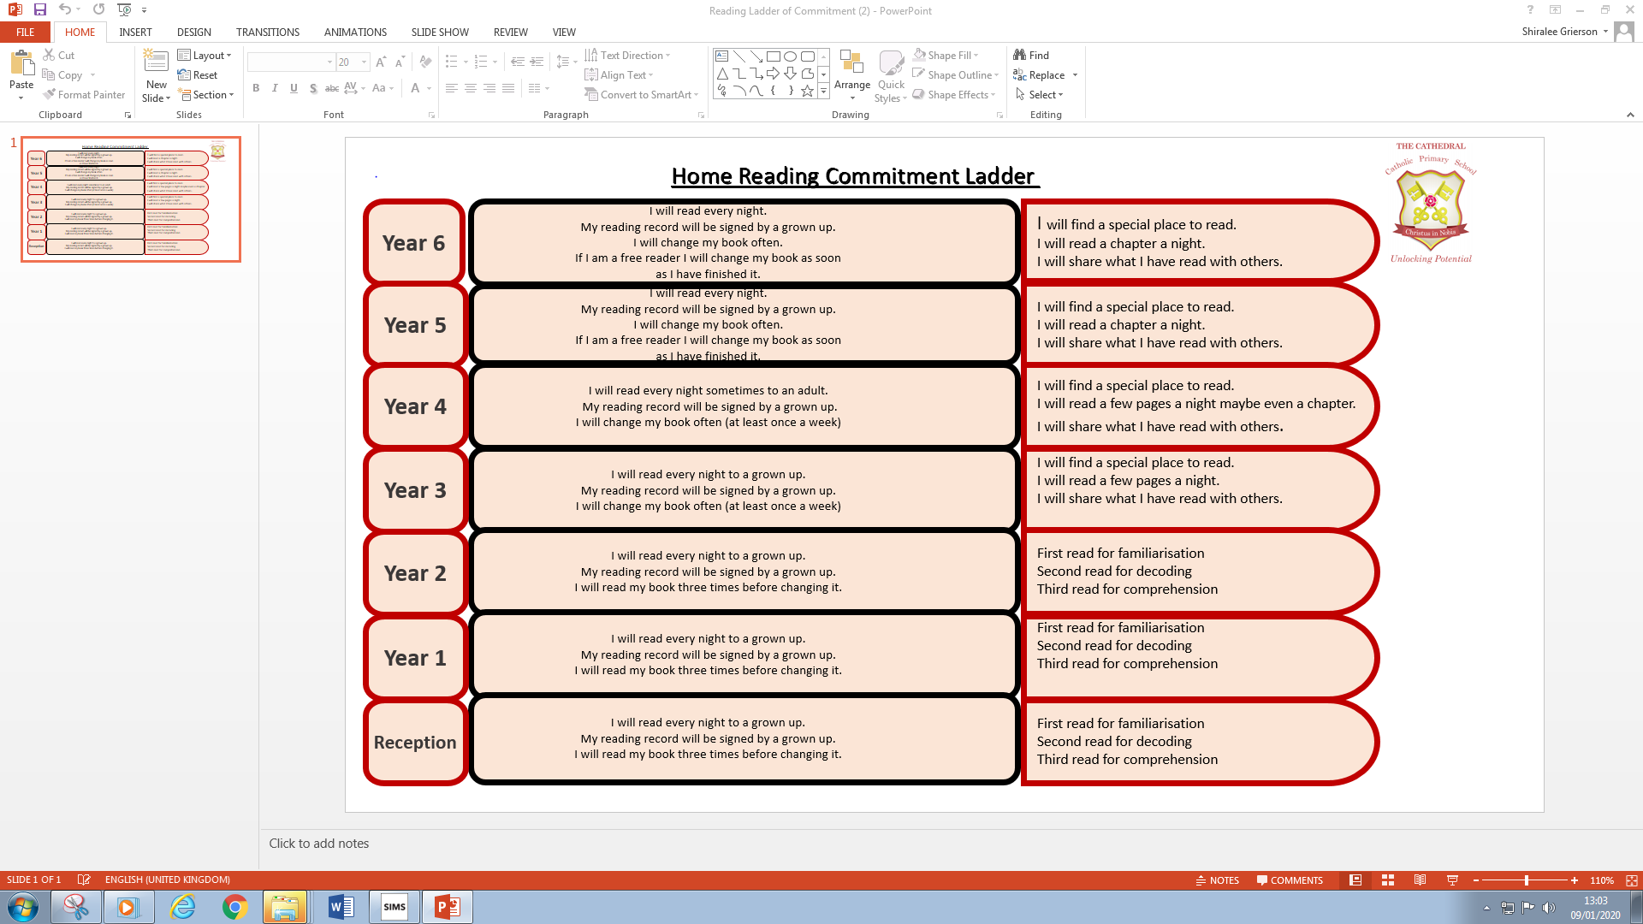

Home reading commitment ladder EYFS/KS1
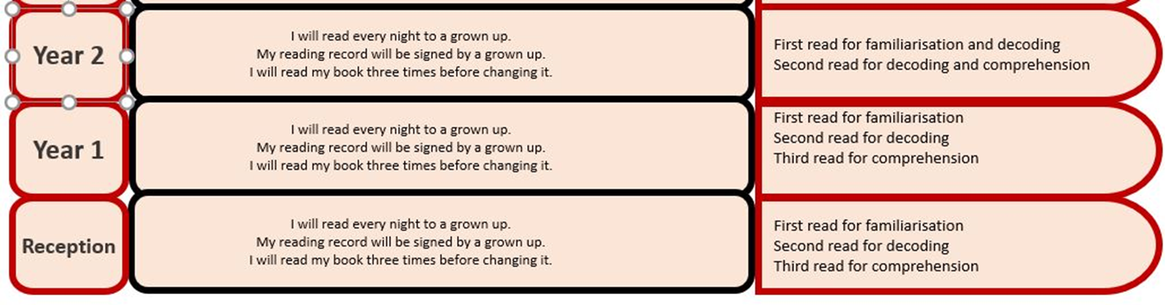
Reading for pleasure
In addition to guided reading and individual home reading, all children from Reception onwards become members of our school library. They are given a ‘Reader ID number’ each to identify themselves on the library system (Reading Cloud) and will have at least one session per week in either our class or school libraries. During this time they can browse books and choose a book to take home and read for pleasure with their families. This book might be one that they want to read for themselves or have an adult read to them and may vary in difficulty. The whole point in that they read for pleasure whether alone or with a sibling or adult. This book can be changed whenever they have library time.
Adults read to children at the end of every day. Rec and Y1 have a class set of books each half term. Y2-Y6 read the class novels. The books may link with the learning or class or may be one of the recommended reads for their yeaars group.

Guided reading
The aim of every guided reading session is to encourage and extend independent reading skills. Groups of children work together on the same text. These texts are selected to match the reading ability of the group; challenging but not so difficult as to disrupt the flow of reading. A range of fiction, non-fiction, poetry and plays should be chosen throughout each term. The teacher or teaching assistant leads the session, guiding the children to focus on words, sentences and understanding the whole text. While working with the group the adult gives focused attention to individuals and sessions follow the structure of: introduction, strategy check, independent reading and returning and responding to the text.

Writing at The Cathedral

Within English lessons and across the curriculum, children must complete 8-10 pieces of independent/ extended writing. At the end of each English unit there should be 2 outcomes – Outcome 1 will be scaffolded and Outcome 2 will be independent. Outcome 3 will be cross curricular later on in the half term or term.

- Independent means not heavily modelled or scaffolded but can have planning time, discussion time, access to dictionaries, working walls, helpful word mats and books.
- Opportunities for independent writing should be evident in Phase 1, 2 and 3 including short writing opportunities.
- Children should be given opportunities to write for an extended period of time to develop stamina and application of skills.
- Marking ladders to be used from Year 1 upwards for Outcome 1 - 3.
- GPS to be included in English planning and as warm up.
- Spelling to be included in planning and follow 5 times in a 2 week unit.
- Use vocabulary books to encourage looking for own spelling mistakes.
- At the end of each half term children will take part in a whole school write. This is a piece of writing (often outcome 3) which will be kept in each child’s Writing Portfolio and taken with them throughout their school journey.
Each year group uses the Lancashire Unit of Work overviews (that have been moved around and adjusted within the year group to fit with cross curricular themes) to ensure they receive a broad and balanced English curriculum, being exposed to a range of texts: narrative, non-fiction and poetry. Progression is ensured by teaching using the yearly objectives set out in the National Curriculum.
English is at the heart of the whole school curriculum. Skills, knowledge and understanding gained in English lessons are planned for and revisited during lessons in other subjects to allow children the opportunity to practise and apply.
Teachers take opportunities to teach other subject areas in English lessons, whilst still ensuring that the Year Group Expectations skills are being taught within that lesson. Work in non-fiction texts is a particularly effective way of ensuring coverage of Foundation subject content when it is linked to topics e.g. Science, History and Geography.

English at home
All children will be given opportunities to work at home with parents/carers. The nature of this work will vary according to the year group they are in.
All children will take a reading book home and should read every day. As children get older, they may have written comprehensions, research or other types of English homework to complete.

Assessment, Recording and Reporting
Assessment opportunities should be planned for within lessons and used to inform planning, monitor standards and feed back to pupils, parents, teachers and governors.

Planning for English at Cathedral

Teachers in EYFS plan following the guidelines set out in the Development Matters and Birth to 5 Matters. They plan to cover all 7 areas of learning. Teachers produce weekly plans for adult led sessions and continuous provision activities. Teachers plan to cover development statements from Development Matters and Birth to 5 Matters, which are appropriate to the development of the children in their class/group.
Teachers in Years 1-6 plan following the guidelines laid out in the National Curriculum and the Lancashire plans. Chevron lists are written with Independent writing opportunities evident. They plan each unit of work following the phased approach. Objectives from National Curriculum are clearly recorded in planning, as are the different phases, final outcomes, use of Talk for writing, use of ICT and differentiation. Units of work usually last between 2 and 4 weeks, but teachers produce weekly plans, which should then be retained for evaluation and scrutiny. Separate plans are created for guided reading sessions.
Each class display and discuss Non-Negotiables for Writing. These are taken from the National Curriculum expectations and are reiterated regularly so the children clearly understand how they are expected to write and display their work and what skills should always be evident in a piece of writing.

Reading and writing assessments
Formative assessments in reading and writing occur using the Key Learning in Primary Schools (KLIPS). Additionally to this, a piece of independent writing will be assessed each term by teachers for each child. The writing is assessed using the KLIPS documents and summative judgements from all reading and writing assessments are entered onto the school’s tracking system termly.
Reading assessments: as well as guided read annotations, teachers collect a variety of evidence from across the curriculum which can also add to their teacher assessments. The range of evidence includes: shared reading activities; research based tasks; class novel contributions; drama and role play work with reference to character or setting and home school reading commitment. These should also be listed in a class file alongside the KLIPs.

EYFS
Formative assessment using Development Matters, Birth to 5 Matters and the Early Learning Goals occur through observations and engaging with children. Observations are collated on focus children (2 from each key person group) weekly and any wow moments of other children are also recorded. These observations are collated into a class floor book and kept in a file. Weekly team meetings are had to discuss next steps for each child and ensure these are actioned and that all children make progress.

Statutory National Assessments
Children in the EYFS are assessed using the Early Learning Goals at the end of Reception year. These results are published to parents and nationally. The Phonics Screening Check is administered at the end of Year One and attainment details are published to parents and nationally. Any child who does not obtain the national pass mark is required to re-sit the test at the end of Year Two.
Optional Standard Assessment Tests take place in Year Two and help to inform teacher assessments which aare reported to parents. In Year six, children are tested in reading, spelling, grammar and punctuation. Attainment details are published to parents and nationally.

Moderation
Regular moderation of reading and writing occurs in Staff Meetings and at Senior Leadership Team meetings (SLT). Teachers and leaders moderate work using the KLIPS and exemplar pieces of work (both externally and internally)
Planning should indicate any additional provision needed for children with SEN or specific PPG needs. This provision may be adult support, modified texts or additional resources to enable children to access the English curriculum.
Intervention in speaking, listening, phonics, reading and writing is also provided throughout school. These vary depending on the year group.

Resources
Resources are kept centrally and in the classroom. English teaching is enhanced through the use of ICT in the form of laptops, PCs and tablets in each classroom. Teachers are able to request additional resources through the Subject Leader and these will be granted according to school requirements and budget.

Professional development and training
Staff professional development is organised in line with school priorities. Training in phonics, speaking, listening, reading and writing occurs regularly in staff meetings and INSET events. External courses or internal 1:1 support is also arranged for individuals where the need arises eg. When a teacher moves year group.

Health and Safety
As with all the National Curriculum, any English activities undertaken that might be considered a risk to children (such as food tasting) should be risk assessed to ensure any potential hazards can be managed effectively.

Roles and Responsibilities
The class teacher will:
- Plan and deliver English, Guided Reading and Phonics lessons in accordance with the details within this policy
- Assess phonics, speaking and listening, reading and writing in accordance with the details within this policy
- Ensure that every child is heard reading regularly both at home and at school
The English subject leader in school will:
- Maintain an overview of English teaching and be aware of strengths and areas for development
- Take a strategic lead in subject review and development
- Support and advise colleagues
- Provide a model of good practice
- Keep abreast of new initiatives and disseminate appropriate information to relevant staff.
- Undertake regular monitoring of progress and standards in line with our Monitoring and Assessment policy
- Provide or organise staff professional development in line with school priorities
- Allocate available funding to areas of most need and manage resources throughout the school
- Write and evaluate an annual action plan for the subject which will become part of the school improvement plan.
Monitoring and Evaluation
It is the responsibility of the Subject Leader and the Head teacher to undertake regular and systematic monitoring and evaluation across the whole school, in line with our Monitoring and Assessment policy.
Monitoring will take place through:
- Classroom observation
- Planning scrutiny
- Scrutiny of work done in English and other work across the curriculum
- Pupil questionnaires
- Learning walks
- Discussions with staff about English successes and where they feel improvements need to be made
- Analysis of termly assessments and end of Key Stage SAT results.

Inclusion
Vision
‘There is neither Jew nor Greek, there is neither slave nor free, there is no male and female, for you are all one in Christ Jesus.’ Galatians 3:28

The Cathedral Catholic Primary School is founded on faith in Jesus Christ and the life of the school is centred on his presence. At The Cathedral Catholic Primary School, every member of the school family is regarded as being of equal worth and importance. We endeavour to make sure each class teacher and subject leader understands the meaning of the word inclusion, which recognises differences, meets the needs of individuals and takes positive action, so that everyone has the opportunity to meet their full potential across the curriculum.

SEN
We want all children to have access to the English Curriculum so that they can succeed and make progress. There are many approaches to giving support in English, some of which are detailed below:
- Ensure tasks are adapted and scaffolded to enable SEN children to achieve e.g when writing a letter provide a writing frame with key vocabulary and sentence openers.
- Use a variety of ICT resources during the ‘think it-say it-write it-read it’ process e.g. talking tin lids/talking postcards. Children can use these to record sentences before they write.
- Provide collaborative tasks. Ask what role each pupil has taken in the collaborative writing task. Could they work equally well if they changed roles next time?
- Use paired talk before and during activities such as shared reading/ writing. This gives pupils the opportunity to reflect on and discuss ideas, before offering them in these contexts.
- Introduce key vocabulary explicitly and ensure this includes verbs as well as nouns – for example, as well as teaching rhythm and symbolism in readiness for writing a literary critical essay, also introduce the common verbs used to develop literary comment, such as depicts, conveys, suggests, evokes etc

Please refer to Inclusion policy for further information.

Able, Gifted and Talented
We recognise the importance of providing challenge for those children who are able and gifted in English in order to ensure continued progression and maintain motivation in the subject.
- Challenging extension activities are offered in class and homework projects allow all pupils to succeed at their own level.
- Open questions are used to facilitate higher-order thinking.
- Children are encouraged to make connections in their learning eg. Use ICT to design and create a leaflet from a non-chronological report they have written.
English as an Additional Language
We recognise the importance of providing a rich language based curriculum so that EAL children make progress and can access all aspects of the curriculum. There are many approaches to providing support, some of which are outlined below:
- We use actions, non-verbal gestures, images and simple words to convey messages and meaning.
- Through drama, we explore non-verbal as well as verbal communication, and make use of drama techniques, such as mime, mirroring or tableau (which require no words).
- Plan, teach and display relevant vocabulary (with images if necessary) Vocabulary will need explicitly teaching before a new genre is introduced.
- We think carefully about planning in ability/mixed ability groups of differing sizes. We are careful to ensure EAL children work in smaller groups if appropriate and can listen and converse with children who are excellent English speakers.

Pupil Premium
We recognise the importance of providing rich opportunities for those children who are entitled to Pupil Premium to ensure continued progression and motivation. There are many approaches to providing support, some of which are outlined below:
- Provide opportunities to enrich the curriculum with visits to stimulate enthusiasm, motivation and give first-hand experience.
- Provide rich resources in class and the upper and lower school libraries such as beautifully illustrated stories, electronic stories and listening stations for accessing stories independently.
- Invite in theatre companies to perform drama/stories to Key Stages.

Mobility
We recognise the importance of welcoming all children to The Cathedral Primary School regardless how long the children remain in school. There are many approaches to providing support for Mobile children in English some of which are outlined below:
- Use a visual timetable to help the child feel secure and confident around the school and know what to expect, and when.
- Before new learning begins, revisit prior learning and explain how the new learning fits into this so that the child understands the context of what they are learning.

Appendix A – Handwriting
The correct formation of all letters needs to become quite automatic and may require a lot of practice. At The Cathedral Catholic Primary School we believe that neat, well-formed handwriting and presentation of written work helps to raise standards, as the pupils take pride in and have a sense of ownership of their work. As a school we are adopting Nelson Thornes method of handwriting.
There are four main purposes to this policy:
- To establish an entitlement for all pupils
- To establish expectations for teachers of this subject
- To promote consistency across the school
- To state the school’s approaches to this subject in order to promote public and parents’ and carers’ understanding of the curriculum
Aims:
- To raise standards in writing across the school
- To have a consistent approach across EYFS, Key Stage One and Two when teaching handwriting throughout the school.
For pupils to:
- Achieve a neat, legible style with correctly formed letters in line with school handwriting.
- Develop flow and speed, so that eventually they are able to produce the letters automatically and in their independent writing.
Handwriting is taught daily through short, focused sessions and is linked with spelling, grammar or phonics objectives. Teaching generally occurs outside Literacy lessons, although shared and guided writing also provides additional opportunities for the modelling and monitoring of handwriting.
Teaching and Learning
Handwriting is a skill which needs to be taught explicitly. Since handwriting is essentially a movement skill, correct modelling of the agreed style by the teacher is very important; it is not sufficient to require pupils to copy models from a published scheme or worksheet. Consistency in the attitudes displayed, the methods employed and the models provided is the key to effective learning. A mixture of whole class, small group and individual teaching is planned.
The role of the teacher:
To follow the school policy to help each child develop legible and fluent handwriting
To provide direct teaching and accurate modelling
To provide resources and an environment that promotes good handwriting
To observe pupils, monitor progress and determine targets for development
To deliver intervention to any child who falls behind age expectation in this area

EYFS
In the pre-communicative stage pupils are encouraged to mark make and these experiments are recognised and praised as an important stage in the child’s understanding that marks convey meaning. Pupils are given the opportunity to experiment with a range of mark making materials and implements; a multi-sensory approach is used to help pupils feel the movement in the hand and the upper arm.
The emphasis at this stage is with movement rather than neatness. Letter formation (starting at the right entry point and then moving in the right direction) learned at this early stage becomes automatic and has a profound influence on later fluency and legibility. Pupils are to be taught to use lead-in and lead out strokes, following agreed policy, as soon as they are ready for letter formation. (For agreed letter formation please see Nelson Thornes). To aid movement, close attention is given to pencil grip, correct posture, the positioning of the paper and the organisation of the writing space. Teachers are vigilant to ensure that bad habits do not become ingrained and that the specific needs of left-handed pupils (for example, additional tracking and tracing of letters at the pre-writing stage) and those with special educational needs are met.
Strategy for Implementation - Continuity and Progression (Dependent on ability not age/ year band of child)

Key Stage 1
Building on the EYFS, pupils at Key Stage 1 develop a legible style and use the handwriting in Year One). This is achieved in Year 1 by developing a comfortable and efficient pencil grip and by practising handwriting in conjunction with spelling and independent writing as well as in discrete subject teaching. Correct letter orientation, formation and proportion are taught daily in line with the schools agreed handwriting style. This continues in Year 2, moving towards joining the letters within a word by the end of Year Two.

Key Stage Two
The target for children in Key Stage Two is to produce a fluent, consistently formed style of fully joined handwriting with equal spacing between the letters and words. Children will have regular handwriting sessions and practice using appropriate prepared resources, in the agreed handwriting style.
Children in Year Three, Year Four and Year Five will write with pencils until the class teacher assesses that they are joining competently and consistently. They will then be given a handwriting pen.
In Year Six children most children will use a handwriting pen. They work hard to earn a gel pen or fountain pen. Pencils will be used in Maths, or for drawing and completion of diagrams.
All children in Key Stage Two will practise their letter formation at all times. The vast majority of pupils are able to write legibly and fluently with most children writing using cursive joins by the end of Year Four as stated in National Curriculum guidelines. However, some pupils need more support and a specific individual or group programme is drawn up in consultation with the SENCO. Thicker triangular pencils, pencil grips and wider lines will be used by children experiencing problems writing alongside other activities to develop their fine motor skills.

Left handed writers
We make appropriate provision for left handed children: paper should be positioned to the left for right handed pupils and to the right for left handed pupils and slanted to suit the individual in either case; pencils should not be held too close to the point as this can interrupt pupils’ line of vision; pupils should be positioned so that they can place their paper to their left side; left-handed pupils should sit to the left of a right-handed child, so that they are not competing for space; extra practice with left-to-right exercises may well be necessary before pupils write left-to-right automatically.

