John 1:1 “In the beginning was the Word, and the Word was with God, and the Word was God.”

History Policy

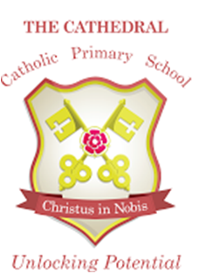

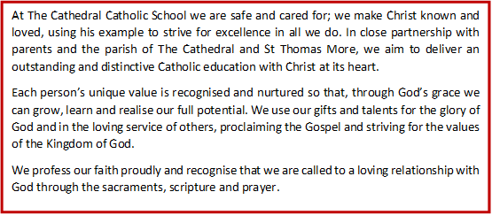

Our Vision
At The Cathedral Primary School we want all of our children to have an understanding of our past and how History will shape their future. Our History curriculum will be full of topics which foster awe and wonder and drive children to ask the question` why.’ The History topics will help children to gain an understanding of the complexity of people’s lives and the process of change; as well as helping them to recognise their own identity and face the challenges of their time.Through a positive caring environment, we provide the opportunity for every child to reach their full potential. We embrace Catholic values and ensure all children are ready for their next steps.

In context
At The Cathedral Catholic Primary School we are committed to providing all children with learning opportunities to engage in history.
History is about real people who lived, and real events which happened in the past. History is concerned with sequence, time and chronology and is the study of evidence about the past; it gives us a sense of identity, set within our social, political, cultural and economic relationships. History fires the children’s curiosity about the past in Britain and the wider world and plays an essential part in preparing us for living and working in the contemporary world.
Pupils consider how the past influences the present, what past societies were like, how these societies organised their politics, and what beliefs and cultures influenced people’s actions. As they do this, children develop a chronological framework for their knowledge of significant events and people. They see the diversity of human experience, and understand more about themselves as individuals and members of society. What they learn can influence their decisions about personal choices, attitudes and values.
In history, children find evidence, weigh it up and reach their own conclusions. To do this they need to be able to research, sift through evidence, and argue for their point of view – skills that are prized in adult life.

Aims
the aims of history are:
- To instil in the children a curiosity and understanding of events, places and people in a variety of times and environments.
- To develop an interest in the past and an appreciation of human achievements and aspirations.
- To understand the values of our society.
- To learn about the major issues and events in the history of our own country and of the world and how these events may have influenced one another.
- To develop a knowledge of chronology within which the children can organise their understanding of the past.
- To understand how the past was different from the present and that people of other times and places may have had different values and attitudes from ours.
- To understand the nature of evidence by emphasising the process of enquiry and by developing the range of skills required to interpret primary and secondary source materials.
- To distinguish between historical facts and the interpretation of those facts.
- To understand that events have a multiplicity of causes and that historical explanation is provisional, debatable and sometimes controversial.

The Curriculum

Early Years
History is taught in Reception as an integral part of the topic work through child-initiated and adult led activities. The children are given the opportunity to find out about past and present events in their own lives, and those of their families and other people they know. In the Foundation stage history makes a significant contribution to developing a child’s understanding of the world through activities such as looking at pictures of famous people in history or discovering the meaning of new and old in relation to their own lives.

Key Stage 1
During Key Stage 1, pupils learn about people’s lives and lifestyles. They find out about significant men, women, children and events from the recent and more distant past in Britain and the wider world. They listen, and respond to stories and use sources of information to help them ask and answer questions. They learn how the past is different from the present.

Key Stage 2

During Key Stage 2 pupils learn about significant people, events and places from both recent and more distant past. They learn about change and continuity in their own area, in Britain and in other parts of the world. They look at history in a variety of ways, for example from political, economic, technological and scientific, social, religious, cultural or aesthetic perspectives. They use different sources of information to help them investigate the past both in depth and in overview, using dates and historical vocabulary to describe events, people and developments. They also learn that the past can be represented and interpreted in different ways.

Teaching and Learning
We use a variety of teaching and learning styles in history lessons. Our principal aim is to develop the children’s knowledge, skills and understanding in history and we use a variety of teaching and learning styles in our history lessons. We believe children learn best when:

- They have access to, and are able to handle artefacts.
- They go on visits to museums and other places of interest.
- They have access to secondary sources such as book, maps, and photographs.
- Visitor talks about personal experiences of the past
- They listen and interact with stories from the past
- They use drama and dance to act out historical events
- They are shown, or use independently, resources from the internet and videos.
- They are able to use non-fiction books for research.
- They are provided with opportunities to work independently or collaboratively to ask as well as answer historical questions.

We recognise the fact that we have children of differing ability in all our classes, and so we provide suitable learning opportunities for all children by matching the challenge of the task to the ability of the child. We achieve this through a range of strategies which are differentiated by task, expected outcome and/or support from peers or adults

Cross Curricular Links

As a school we use the Lancashire plans which highlight the cross curricular links in all topics. Here are a few examples:

English- History develops the skills of reading, writing, speaking and listening. Where appropriate, links are made to English unit of work e.g. the use of historical texts. Cross curricular writing is expected and gives children a purpose to their writing.

Maths - Children learn to use numbers when developing a sense of chronology through activities such as creating time-lines and through sequencing events in their own lives. Children learn to interpret information presented in graphical or diagrammatic form. For example, Venn diagrams can be used to compare and contrast aspects of History.

Personal, Social and Health Education (PSHE) and Citizenship - They discover how to be active citizens in a democratic society by learning how laws are made and changed, and they learn how to recognise and challenge stereotypes, and to appreciate that racism is a harmful aspect of society. They learn how society is made up of people from different cultures and they start to develop tolerance and respect for others.

Computing - enhances our teaching of History, wherever appropriate, in all key stages. The children use ICT in a variety of ways, such as word processing, finding information on the Internet and presenting information through PowerPoint. They can make creative use of the digital camera to record photographic images. They could further the use of email to gather information from sources in other countries.

History Curriculum Planning

We follow the Lancashire Scheme of work over a two year cycle which includes all skills and knowledge for the National Curriculum. We use these as the basis for our chevron list, which gives weekly objectives for the unit of work for each term. The class teacher keeps daily plans in their planning file. We ensure that there are opportunities for children of all abilities to develop their skills and knowledge in each unit, and we plan progression into the schemes of work, so that the children are increasingly challenged as they move through the school.

Health and Safety

When planning fieldwork, teachers must complete a risk assessment prior to the trip. Teachers should refer to the school’s Health and Safety Policy.

Resources

We have a range of books and interactive boards to access the internet as a class. Visits are planned to enhance learning and give hands on activity. People with an interest, or expertise, in a particular topic or area of history could be invited into school to work with the children. These might be parents, grandparents, other family members, neighbours or representatives of the local community.

Display
History is displayed as a celebration of their success and to support their learning during the topic. When History is the lead subject it is expected that History work will be displayed. Refer to the Display policy for further details.

Marking and Feedback

Feedback is given to the children as soon as possible, and marking work will be guided by the school’s Marking Policy.

Inclusions /Equal Opportunities
Vision
‘There is neither Jew nor Greek, there is neither slave nor free, there is no male and female, for you are all one in Christ Jesus.’ Galatians 3:28
The Cathedral Catholic Primary School is founded on faith in Jesus Christ, and the life of the school is centred on His presence. At The Cathedral Catholic Primary School, every member of the school family is regarded as being of equal worth and importance. We endeavour to make sure each class teacher and subject leader understands the meaning of the word inclusion, which recognises differences, meets the needs of individuals and takes positive action, so that everyone has the opportunity to meet their full potential across the curriculum.
All children will be given access to History irrespective of race, gender, creed, level of ability or nationality. Mutual respect and tolerance for all cultures will be promoted through the study of History. This corresponds with the school’s curriculum policy of providing a broad and balanced education to all children. Through our History teaching we provide learning opportunities that enable all pupils to make good progress. We take all reasonable steps to achieve this.

SEN -We continually strive to ensure that those pupils with special educational needs are supported appropriately and have full access to the curriculum. We do this through promoting the use of visual, audible and kinaesthetic resources and learning activities.

AGT – We aim to challenge those children who are able, gifted and talented to ensure they make good progress. We strive to ensure that AGT children are given opportunities to apply historical skills and encourage children to take risks where appropriate. For example research and present a small project on a chosen topic, challenge them to find out more than the teacher knows. Use more open ended questions are provide them with a mysterious artefact – what do you think it is? Why?

EAL - We strive to ensure all EAL have access to the History curriculum through the use of differentiation including: word banks, pictures, Key vocabulary cards in their home language, books in their home language and use of support staff.

Mobile – we strive to provide a rich and balanced curriculum for all mobile children. We ensure they have the same entitlement regardless of time in school.

It is the responsibility of all teachers to ensure that all pupils, irrespective of gender, ability, including gifted pupils, ethnicity and social circumstance, have access to the curriculum and make the greatest progress possible.

Assessment and Recording

At The Cathedral Catholic Primary School, assessment is an integral part of the teaching process. Assessment is used to inform planning and to facilitate differentiation. The assessment of children’s work is on-going to ensure that understanding is being achieved and that progress is being made.

Monitoring

Monitoring takes place regularly through sampling children’s work, and teacher planning, pupil discussions, through a book scrutiny and lesson observations. This is timetabled on the Monitoring schedule and linked to the Monitoring Policy.

Roles and Responsibilities

The History subject leader will be responsible for:

•Feedback to the governors on monitoring undertaken by the subject co-ordinator.
•Reviewing and updating the History policy and scheme of work.
•Monitoring the teaching and learning of history on a regular basis.
•Purchasing history resources.
•Offering support and advice on possible teaching activities to all staff.

Teachers will be responsible for:

•Including effective history teaching activities in their short and medium term planning.
•Assessment and levelling of pupils in accordance with school assessment policy.
•Informing the History Subject Leader of any resources required for their particular class.

The Head Teacher will be responsible for:

•Supporting the History co-ordinator.
•Allocating the budget.

The subject is led a subject leader and each year time is set aside to review standards and monitor curriculum provision and ensure training and resources are up to date.

Professional development and training
The subject leader attends local conferences and subject update courses when available and then reports back to school in staff training. The teachers are able to attend courses to update their subject knowledge and learn new and exciting ways to teach the topics.

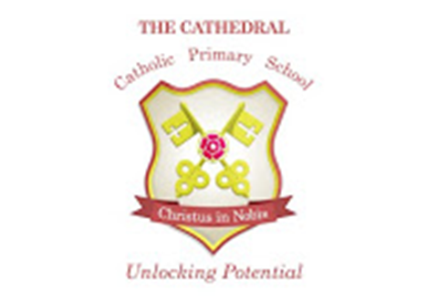

HISTORY POLICY
January 2018
This Policy is based on best practice advice from Lancashire County Council.
The implementation of this policy will be monitored by Mrs Nicola Holt in consultation with the Leadership Team and a nominated Governor.
This policy will be reviewed as appropriate by The Senior Leadership Team
Intended Policy Review Date – January 2020

Approved by ______________________________ (Headteacher)

Date: ______________________________

Approved by ______________________________ (Governor)

Date: ______________________________

