Religious Education Policy
“Go, therefore, make disciples of all nations.
And look, I am with you always; yes, to the end of time.” (Matthew 28:19-20)

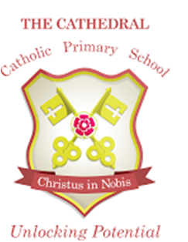

“Unlocking potential together in faith and love.”

At The Cathedral Catholic Primary School, we celebrate that each person is unique and loved by God. With Christ at the centre of all we do, we strive to unlock each child’s potential to become the person they are created to be. Inspired by St Peter’s example, we are working together to build a community built on love, faith, forgiveness and service.

Context
As a Catholic school, religious education is at the heart of our curriculum as we strive to proclaim and live the Christian values taught by Jesus Christ, within the Catholic tradition. This permeates every aspect of our school life. With parents and Parish, we hope to lead children to a greater understanding of who God is and to celebrating with deeper faith and understanding, the liturgy of the Church.

Intent
Our subject specific aims for the teaching of religious education are to enable all children to:

- grow in understanding of who God is for us as a Catholic community;
- grow in knowledge and understanding of Jesus’ life and teachings;
- gain a deeper knowledge and understanding of the Catholic tradition and the liturgy of the Church;
- recognise and appreciate the spiritual and religious dimensions of life through feelings of awe, wonder, delight and joy;
- examine their own religious feelings, views and responses.

Content
Religious education is an ENRICHING SUBJECT, a subject at the heart of life, which all children should enjoy. As a Catholic school we offer religious education as an important contribution to faith development of pupils. It may also be received by some pupils as evangelisation or catechesis.

The content of the Religious Education curriculum is provided in the Revised Religious Education Curriculum Directory of the Bishops’ Conference of England and Wales (RECD).

At The Cathedral School, the requirements of the religious education curriculum are currently met through our own personalised curriculum which uses a combination of “Come and See”, “The Way, The Truth and the Life” programme, the Caritas scheme, CAFOD units of work and a wide range of resources to stimulate, engage and challenge pupils. These include relevant videos, music, posters, stories and use of the Bible. We use “Come and See” to set whole school topics and the Diocese of Lancaster RE Curriculum Framework to ensure full coverage of the RECD.

The scheme covers many aspects of the Catechism of the Catholic Church. In addition, the publication, 'Fit for Mission? Schools' (November 2007) is used to ensure that we are handing on to our pupils the important truths of our faith that have been identified as essential to the promotion of a Catholic ethos in our school.

All Sacramental Preparation takes place in the parish. However, work done in religious education does help the children to grow in their knowledge and understanding of the sacraments of the Catholic Church and supplements work carried out at home and in the parish in preparing children to receive the sacraments.

Teaching and Learning
Religious education in the Catholic school is a core subject and is given the careful planning and preparation time that is employed to other core subjects. It is allocated 10% of the teaching week (2 hours in Key Stage 1 and 2 ½ hours in Key Stage 2). This 10% is split over several lessons each week so that children are frequently being brought back to the religious purpose of our school.

Teachers are encouraged to use a wide range of creative teaching strategies to deliver religious education so that children enjoy the subject and are engaged in their learning. The topics covered are those suggested in the scheme and are enriched by using a range of visual and audio resources. Children are encouraged to participate in lessons through paired work, group work, class discussion and drama. Where possible, links are made to other subject areas, particularly English.

Staff Professional Development
We are committed to ensuring ongoing staff development in religious education so that all teaching staff grow in understanding of the Catholic faith we promote. The subject leader attends Diocesan meetings and provides feedback and updates to staff through staff meetings. The subject leader provides relevant information for appropriate occasions in order to support the development of teacher knowledge and understanding, for example, information about the Church's liturgical year, information about the Sacraments to support individual teachers in their planning and teaching. Newly qualified teachers and teachers new to Catholic Education attend Diocesan training sessions for teaching R.E. in a Catholic School.

Planning
The school has adopted the topic plan provided by ‘Come and See’ (See Appendix One). The Diocese of Lancaster RE Curriculum Framework identifies key learning for each year group (based on the RECD) and we have allocated the key learning statements to the different topics covered over the year. Teachers use these as the starting point for planning and use resources from ‘Come and See’ and ‘The Way, the Truth and the Life’ to support teaching and learning.

Learning objectives are also informed by age-related standards which provide the framework for assessment in religious education. Learning objectives, teaching activities and differentiated pupil activities are outlined on medium term plans, which are produced for each topic.

We acknowledge the importance of using a wide range of teaching and learning strategies and resources in the delivery of religious education in order to fully engage pupils in their learning in this subject. These are reflected in teachers’ planning.

In the autumn term, two weeks are allocated to teaching of other faiths, using ‘Come and See’ resources. Because of the proportion of families who practise Islam, we usually focus our learning on aspects of Muslim beliefs.

Assessment
Assessment in religious education is based on age-related standards in three attainment targets:

- Attainment target 1: Knowledge and understanding of religion (Learning about religion)
- Attainment target 2: Engagement and Response (Learning from religion)
- Attainment target 3: Analysis and Evaluation

Age-related standards provide a description of what is expected of almost all pupils by the time they reach the end of a particular age phase. These age phases are:

• 3-5
• 5-7
• 7-11
• 11-14
• 14-16
• 16-19

On entry in Reception Class, the class teacher carries out a baseline assessment, based on 10 standards from the 3-5 phase.

Most RE lessons should show evidence of learning within the age-related standards for a given phase. The standards for the relevant phase are inside the cover of pupil RE books. Teachers record learning by dating the relevant standards as they are addressed. During termly assessment week, teachers make a judgement of attainment for each pupil, based on their progress within the phase. This is recorded as entering (E), developing (D) and secure (S). As each phase covers two years, a child is expected to be working on each of these for two terms. Children who are working on age-related standards below a given phase are recorded as PP (pre-phase).

A staff moderation meeting takes place termly to monitor and evaluate attainment in R.E. across school.

External cluster and diocesan moderation meetings also take place during the year.

Records of Progress
Records of termly assessments are kept on the server. The subject leader collects these to track and monitor pupil progress across school. Pupils who are not making expected progress are highlighted to the class teacher who is expected to plan and provide further support or scaffolding during RE lessons to help pupils make accelerated progress.

Reporting to parents
Annual pupil reports focus on each child’s progress in relation to the topics covered, age-related standards and their attitudes to learning in religious education. In addition, pupil progress in religious education is reported to parents termly through written progress reports and on parents’ evening meetings.

Resources
These are outlined in Appendix Two.

Inclusion
Vision
The Cathedral Catholic Primary School is founded on faith in Jesus Christ, and the life of the school is centred on His presence. At The Cathedral Catholic Primary School, every member of the school family is regarded as being of equal worth and importance. We endeavour to make sure each class teacher and subject leader understands the meaning of the word inclusion, which recognises differences, meets the needs of individuals and takes positive action, so that everyone has the opportunity to meet their full potential across the curriculum.
‘There is neither Jew nor Greek, there is neither slave nor free, there is no male and female, for you are all one in Christ Jesus.’ Galatians 3:28

SEN
We recognise the importance of ensuring all children can access the RE Curriculum and can succeed and make progress. There are many approaches to giving support in RE, some of which are detailed below:
- Use of multisensory approaches e.g. use of drama and roleplay music and puppets when retelling Bible stories, visits to places of worship.
- Ensure the task is differentiated and scaffolded to support the learning of lower attaining pupils, e.g when writing a diary entry for the Good Samaritan provide a diary entry writing frame with key vocabulary and sentence openers.
- Use a variety of resources, for example talking tins, to record a child’s verbal learning. These could be transcribed at a later date.
- Use of good-quality artefacts allows pupils to understand aspects of the different faiths. Artefacts can be used to develop pupils’ observation skills and use of language.
- Use Talk for Write e.g. when learning about stories or when learning about actions and symbols in a Sacrament.

Refer to the SEN policy for further information.

Able, Gifted and Talented
We recognise the importance of providing challenge for those children who are able and gifted in RE in order to ensure continued progression and maintain motivation in the subject. There are many approaches to providing challenge, some of which are outlined below:
- Provide open ended activities which allow children to apply learning across topics and attainment targets.
- Promote creative thinking through higher order questioning e.g rather than retelling the story of the parable of the sower, children could explain what believers learn from this parable. How can we apply it to our life? Why did Jesus tell parables?
- Be creative in letting children make links with others subjects e.g using ICT recording when hot seating a character about their reasons for keeping Sunday holy.
- Allow the opportunity to select work for themselves; pupils can choose an appropriate level of challenge. e.g children could be given a range of starting points, materials or processes that they choose from.

English as an Additional Language
We recognise the importance of providing a rich, language based RE curriculum so that children with EAL make progress and can access all aspects of the RE curriculum. There are many approaches to providing support, some of which are outline below:
- Plan, teach and display vocabulary used in RE lessons with pictures alongside if necessary. Refer to this vocabulary when teaching and model how to use the words. Give children the chance to repeat the words with their peers.
- Ensure teachers or teaching assistants make time to work with children with EAL before the RE lesson to discuss important RE vocabulary, concepts and/or processes, where appropriate.
- Present information in a variety of ways to help children with EAL understand e.g. watch a clip of a Bible story, read a simple story board version, put actions to the story, highlight key vocabulary.

Pupil Premium
We recognise the importance of providing rich opportunities for those children who are entitled to Pupil Premium to ensure continued progression and motivation. There are many approaches to providing support, some of which are outlined below:
- Provide opportunities to enrich the curriculum with visits to places of worship and use of visitors to bring alive the Catholic Faith.
- Provide rich resources in class and the library such as beautifully illustrated Bibles and other religious books to broaden children’s understanding and experience of our faith.

Mobility
We recognise the importance of welcoming all children to The Cathedral Primary School regardless of how long the children remain in school. Our school is a place of refuge where children feel safe and part of our school family. There are many approaches to providing support for mobile children in RE some of which are outlined below:
- Ensure children feel safe and secure when discussing issues in RE. “Teacher support and peer acceptance have a positive influence on attitudes toward school among children who experience more school mobility” (Gruman, Harachi, Abbott, Catalano, & Fleming, 2008) For example when discussing moral issues ensure peers are supportive of others’ comments.
- Spend time chatting with pupils about prior learning in RE, their understanding of key concepts, their thoughts on moral issues and anything they would like to learn in RE.

Homework
This can be given to enable children to reflect on the work done in class.

Role of the Subject Leader
The role of the Subject Leader is to:
- provide a strategic lead and direction for the subject;
- support and offer advice to colleagues on issues related to the subject;
- monitor pupil progress in that subject area;
- provide efficient resource management for the subject;
- keep up to date with developments in their subject, at both national and local level;
- review the way the subject is taught in the school and plan for improvement linked to whole-school objectives;
- review the curriculum plans for their subject, ensure that there is full coverage of the agreed curriculum and that progression is planned into schemes of work.

Review and Development
Religious education is subject to constant review in light of Diocesan Guidelines and current teaching practice. This involves the whole staff to ensure that necessary changes are made and development implemented.

This policy statement should be read in conjunction with the School’s overall Teaching and Learning Policy Statement.
APPENDIX ONE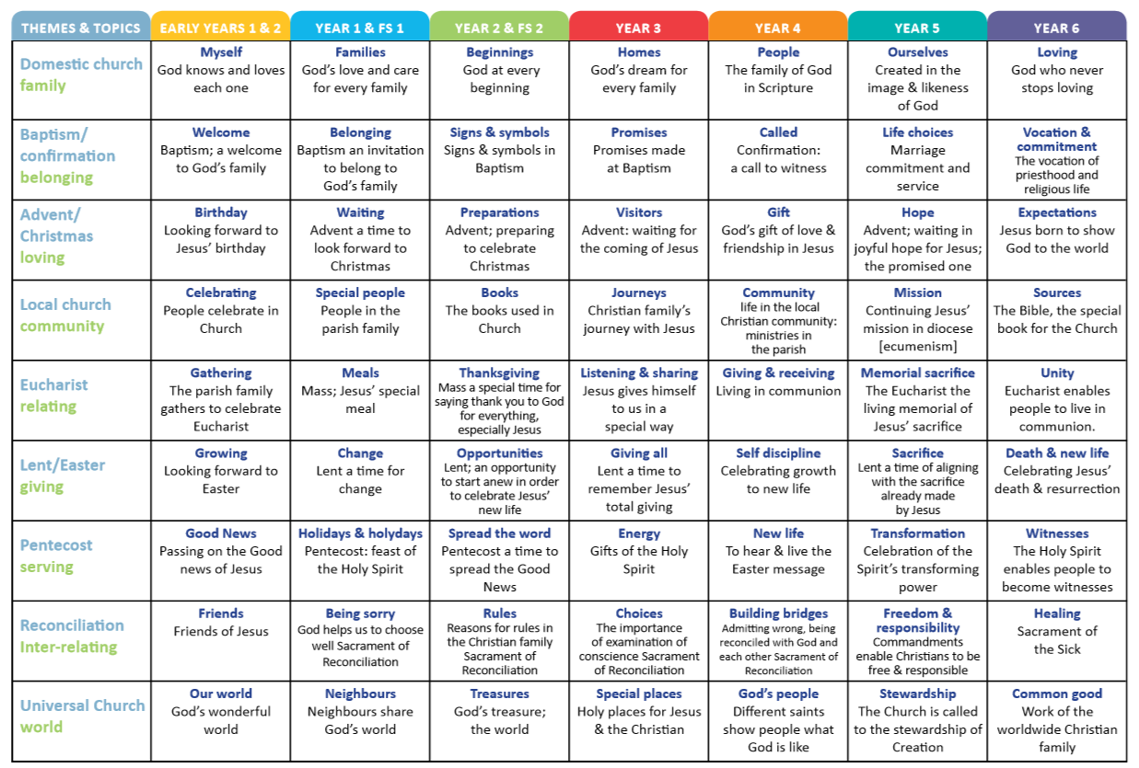
APPENDIX TWO

RELIGIOUS EDUCATION AND PRAYER AND LITURGY RESOURCES

 | Religious Education | Prayer and Liturgy
General – KS1 | - Class set of Bibles  - CTS books 'Faith for children' and 'Praying with the Saints'.  - Variety of books to support teacher understanding. | The following are available for use in any class:  Candles  Cloths for worship tables  Posters showing scenes from Jesus’ life  Bibles  Music – instrumental and songs  Meditation books  Crucifix in every classroom  Statues of Mary  Statue of Jesus and Mary  Stones  Children’s liturgy books for Key Stage 1 and 2
Reception | - Foundation Stage and year 1 resources for “The Way, the Truth, the Life” series  - Come and See resources
Year 1 | - Year 1 pupil and teacher resources for “The Way, the Truth, the Life” series  - Come and See resources
Year 2 | - Year 2 pupil and teacher resources for “The Way, the Truth, the Life” series  - Come and See resources
General – KS2 | - Youth Catechism (YouCat)  - Class set of Catholic Children’s Bibles  - Posters showing the life of Christ and Stations of the Cross  - Guided meditation book  - CTS books: 'Praying the Rosary', 'Prayers around the Crib', 'The Way of the Cross'.  - Class set of illustrated catechisms  - 101 Saints and Special People  - Books to support teacher and pupil spiritual development
Year 3 | - Year 3 pupil and teacher resources for “The Way, the Truth, the Life” series  - Caritas document  - Come and See resources
Year 4 | - Year 4 pupil and teacher resources for “The Way, the Truth, the Life” series  - Caritas document  - Come and See resources
Year 5 | - Year 5 pupil and teacher resources for “The Way, the Truth, the Life” series  - Caritas document  - Come and See resources
Year 6 | - Year 6 pupil and teacher resources for “The Way, the Truth, the Life” series  - Caritas document  - Come and See resources

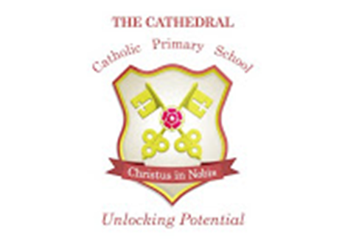

RE POLICY
April 2022

This Policy is based on best practice advice from the Lancaster Diocese.
The implementation of this policy will be monitored by Mrs Nicola Holt in consultation with the Leadership Team and a nominated Governor.

This policy will be reviewed as appropriate by The Senior Leadership Team

Intended Policy Review Date – April 2024

Approved by ______________________________ (Headteacher)

Date: ______________________________

Approved by ______________________________ (Governor)

Date: ______________________________

