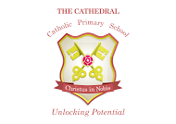
SEC 2021
School was closed for a 1/3 of the year due to COVID
Reception
- GLD- 52% ( 14 /27)
Year 1
- Phonics screening – 90%
Year 2
- Year 2 phonics – 7 children resat the test and 1 passed. The 6 children who did not pass include 5 SEN children, 1 PA who has missed a lot of phonics. These children will receive IDL in Year 3 and intensive reading intervention.

 | EXP | GDS
Reading | 65% | 12%
Writing | 62% | 12%
Maths | 65% | 12%
RWM | 58% | 8%

Year 6
Attainment
 | EXP+ | HS
Reading | 87% | 40%
Writing | 83% | 33%
Maths | 80% | 27%
GPS | 67% | 27%
RWM | 73% | 23%

