The Cathedral Catholic Pupil premium strategy statement 2022-2023

This statement details our school’s use of pupil premium (and recovery premium for the 2021 to 2022 academic year) funding to help improve the attainment of our disadvantaged pupils.

It outlines our pupil premium strategy, how we intend to spend the funding in this academic year and the effect that last year’s spending of pupil premium had within our school.

School overview
Detail | Data
School name | The Cathedral Catholic Primary School
Number of pupils in school | 204
Proportion (%) of pupil premium eligible pupils | 43 %
Academic year/years that our current pupil premium strategy plan covers (3 year plans are recommended) | Specifically 2022-2023
Date this statement was published
Date on which it will be reviewed | December 2022
Statement authorised by | Nicola Holt
Pupil premium lead | Nicola Holt
Governor / Trustee lead

Funding overview
Detail | Amount
Pupil premium funding allocation this academic year | £103 115
Recovery premium funding allocation this academic year | £ 13 450
Pupil premium funding carried forward from previous years (enter £0 if not applicable) | £0
Total budget for this academic year  If your school is an academy in a trust that pools this funding, state the amount available to your school this academic year | £116 565

Part A: Pupil premium strategy plan

Statement of intent
All members of staff, governors and teaching assistants accept responsibility for “socially disadvantaged “ pupils and are committed to meeting their pastoral social and academic needs within the school environment. At The Cathedral Catholic Primary School we are committed to closing the gap between vulnerable pupils and the pupil premium forms a vital part of that process.
Mission Statement
“Unlocking potential together in faith and love.”

“Go, therefore, make disciples of all nations.
And look, I am with you always; yes, to the end of time.” (Matthew 28:19-20)

OUR MISSION:
At The Cathedral Catholic Primary School, we celebrate that each person is unique and loved by God. With Christ at the centre of all we do, we strive to unlock each child’s potential to become the person they are created to be. Inspired by St Peter’s example, we are working together to build a community built on love, faith, forgiveness and service.
OUR AIMS:
We are a school where:
- The teachings of Christ and the Church are embedded in every aspect of school life, so that the love of God is proclaimed in all words and actions.
- Prayer and celebration of Sacraments unite us in praising God, deepen our faith and help us to grow to become more like Christ.
- Children are educated with the highest standards of learning and behaviour so every child can unlock their full potential.
- Learning is creative, inspiring, challenging and fun so that a lifelong love for learning is fostered.
- Children are inspired and supported to develop interests and skills both in and outside school.
- Everyone is safe, supported, valued and happy.
- Positive relationships are modelled by all adults. Children are taught how to build positive relationships and how to manage differences peacefully.
- We work collaboratively with families, parish, outside agencies and the wider community to share God’s love with all.
- We share appreciation of the wonders of God’s creation and we work together to look after the world we live in.

Contextual and demographic information for The Cathedral Catholic Primary School
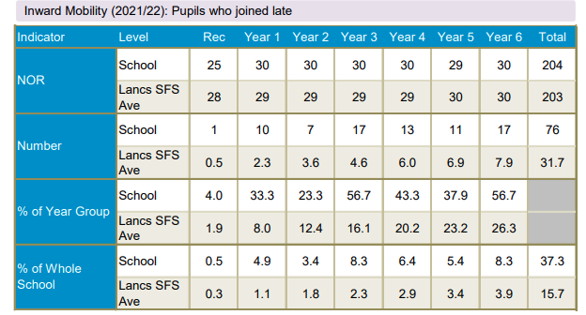
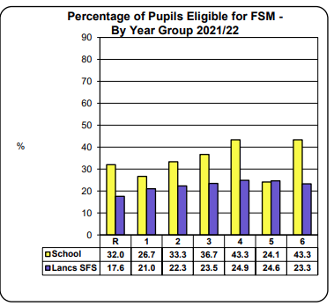

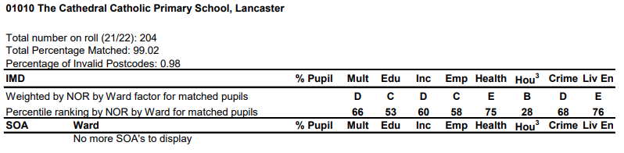

Challenges

This details the key challenges to achievement that we have identified among our disadvantaged pupils.
Challenge number | Detail of challenge
1 | Attainment and progress  Low levels on entry of PP pupils particularly in communication & understanding, reading and writing  Writing across all year groups for PP children is lower than other groups due to loss of learning during COVID  EEF research (2022) shows that: ‘COVID-19-related disruption has negatively impacted the attainment of all pupils, particularly those from disadvantaged backgrounds. There is evidence that the attainment gap between disadvantaged students and their classmates has grown. There is some evidence that in primary schools, younger year groups (Key Stage 1 pupils) have been the most significantly affected’  KS2 data  KS2 data All pupils Disadvantaged pupils = 11 37%  School National Difference School National Difference  Reading 90% 74% +16 73% 62% +11%  Writing 70% 69% +1 55% 55% =  Maths 90% 71% +19 73% 56% +17%  RWM 63% 59% +4 45% 43% +2  GLD in Reception for PP pupils was 33% achieved, much lower than the 64% by the whole cohort.
2 | Attendance of disadvantaged pupils is lower than that of non-disadvantaged pupils. Low attendance would impact on academic achievement (disadvantaged - 92% compared with others 95%)
3 | Parental engagement across school is sporadic especially in home reading and homework for disadvantaged pupils, thus decoding skills may be below age related expectation and writing expectations are lower in this area.
4 | Social and emotional support and wellbeing  Children in school require significant amounts of social and emotional support; this can be more apparent for disadvantaged pupils as they lack some of the opportunities and life experiences than many children who are less disadvantaged can access. This has been further exacerbated by the Covid pandemic and in the current challenging economic climate, when many resources are limited for families and they struggle with managing the basics for day to day, including access to healthy food, nutrition and emotional support. Pupils were not able to freely interact with one another during Covid pandemic restrictions, impacting on physical development, sleep and general routines at home.  Social skills have been impacted, particularly in younger children who have not had the sustained opportunity to develop these skills in the early years of their education; children are lacking resilience, stamina, independence and confidence and this impacts on the need for additional adult support in school significantly. Many children have had negative experiences of lockdown which impacts on learning behaviours.

Intended outcomes
This explains the outcomes we are aiming for by the end of our current strategy plan, and how we will measure whether they have been achieved.
Intended outcome | Success criteria
- Improve writing results for disadvantaged pupils | KS2 and KS1 writing results for PP pupils are above national average and GLD for PP improves this year
2 .Improve attendance of disadvantaged children in school and reduce persistent absenteeism | Disadvantaged children attendance is at least in line with others and with national average. Measures in place show an improvement in attendance for disadvantaged pupils classified with persistent absenteeism
- Improve parental engagement for PP children | Parents of PP pupils will become more engaged through attendance at school events, communication with them on the playground and in school workshops and PP children are present at clubs and events.
- Pupils to access additional support and intervention in a universal and targeted way to continue to strengthen wellbeing, social skills and to maintain good progress | Pupils are observed in lessons to show good learning habits and make good progress in lessons; they are engaged and motivated to tackle work and enjoy challenges and problem solving; strategies to support pupils who struggle are effective in helping them develop a range of social, emotional and wellbeing skills and strategies Early help is identified quickly, and a range of well managed strategies are in place to support pupils both academically and socially

Activity in this academic year

Evidence suggests that pupil premium spending is most effective when schools use a tiered approach, targeting spending across 3 areas, with a particular focus on teaching.
Read the Education Endowment Foundation’s (EEF) pupil premium guide for information about the tiered approach to spending.
- Teaching Investing in high-quality teaching, for example:
• training and professional development for teachers
• support for teachers early in their careers

- Targeted academic support Additional support for some pupils focussed on their specific needs, for example:
• one-to-one tuition
• small group tuition
• speech and language therapy

- Wider approaches Support for non-academic issues that impact success in school, such as attendance, behaviour and social and emotional challenges, for example:
• school breakfast clubs
• counselling to support emotional health and wellbeing
• help with the cost of educational trips or visits
• development of pupil leadership and self- esteem.

Teaching (for example, CPD, recruitment and retention) Budgeted cost: £18 660
Intended outcome | Activity | Cost | Evidence that supports this approach | Challenge number(s) addressed
Quality first teaching is prioritized, so that children are able to make accelerated progress from below average starting points on entry. | Additional TA in YR to support QFT in writing’ and support emotional development | £11,295 + 20% on costs = £13 660 | EEF pupil premium guide | All
 | Redesign English units to encourage more speaking and listening and develop a love for writing | Supply costs to release Key Stages to plan curriculum redesign = £2000
 | CPD for writing across school including EFYS writing and Quality mark | £3000 professional development courses

Targeted academic support (for example, tutoring, one-to-one support structured interventions) Budgeted cost: £52 528
Intended outcome | Activity | Cost | Evidence that supports this approach | Challenge number(s) addressed
Attainment data at end of KS2 show that PPG children are in line with national for writing and enter secondary school with their national attainment gap having been narrowed towards national average thus setting up for future success. | HLTA and TA2 to work with small group and 1-1 with PPG children as part of school led interventions | £17 000 | EEF pupil premium guidance | 1
Attainment data at the end of KS1 shows that PPG children are in line with national for writing and have a love writing for writing ready for KS2 | TA2 to work with small groups on talk for writing. | £15 000 | EEF pupil premium guidance | 1
Pupils with SEN are provided with specific, appropriate provision to meet their needs, based on a thorough and accurate assessment of strengths and delivery of proven intervention strategies, by teachers who are trained and informed in these specified needs | Provision of a specific nurture class. | All SLA educational psychologist £5,060  SENCO time to lead and manage SEN provision , ensuring high quality teaching for identified pupils £12,890 + 20% on costs = £15468

Wider strategies (for example, related to attendance, behaviour, wellbeing)
Budgeted cost: £ 45 133
Intended outcome | Activity | Cost | Evidence that supports this approach | Challenge number(s) addressed
Children with social and emotional or mental health barriers to learning are identified and provided with targetted support (including support for parents e.g. triple P) to increase their capacity to engage with learning, leading to increased progress. | Provision of a learning mentor to undertake Boxall profiling and deliver appropriate intervention according to Boxall profile and responsive pastoral support | £11,513 +20% on costs £13,815 | EEF pupil premium guide | 4
 | Play therapist employed for one day a week to work with the most vunerable children. | £6000 +20% on costs £6120
Children are provided with food to enable them to focus and engage in lessons – impacting on raised attainment. | Subscription to Magic breakfast club | £2000 | EEF pupil premium guide | 4
 | Breakfast club places | £2000 | EEF pupil premium guide
Raise attendance levels for all pupils, in particular disadvantaged | Pastoral team, office staff and head teacher to monitor attendance daily using a wide range of strategies | £11 500 | EEF pupil premium guide | 2
Raise levels of pupil aspiration; develop a growth mindset, engage with arts based enrichment activities – thus impacting on raised achievement through increased knowledge and cultural capital. | Enrichment activity and subsidy on school trips, inc Y6 residential, whole school theatre visit, ice skating, uniforms for all children and half price visits for all PP children. | £12 000 | EEF pupil premium guide | 4,2
Increase parental engagement | Parental workshops, PTA fundraisers back up and running including cultural food night and Reception stay and play. | £744 | EEF pupil premium guidance | 3

Service pupil premium funding (optional)
For schools that receive this funding, you may wish to provide the following information:
Measure | Details
How did you spend your service pupil premium allocation last academic year?
What was the impact of that spending on service pupil premium eligible pupils?

