COMPLAINTS POLICY
Therefore I will not restrain my mouth; I will speak in the anguish of my spirit; I will complain in the bitterness of my soul.
Job 7:11

At The Cathedral Catholic School we are safe and cared for; we make Christ known and loved, using his example to strive for excellence in all we do.
In close partnership with parents and the parish of The Cathedral and St Thomas More, we aim to deliver an outstanding and distinctive Catholic education with Christ at its heart. Each person’s unique value is recognised and nurtured so that, through God’s grace we can grow, learn and realise our full potential.
We use our gifts and talents for the glory of God and in the loving service of others, proclaiming the Gospel and striving for the values of the Kingdom of God.
We profess our faith proudly and recognise that we are called to a loving relationship with God through the sacraments, scripture and prayer.

Introduction
The Education Act 2002 (Section 29) requires all maintained schools and maintained nursery schools to have a procedure for dealing with complaints relating to the school, that are not covered by other statutory complaints procedures. In respect of complaints regarding community facilities/ events or extended services that hire the school premises, schools must ensure that all these organisations have their own complaints procedures in place and that they are up to date. In the light of lessons learned, from feedback received from Lancashire Schools and their Governing Bodies following a complaint; the advice from Legal Services and the launch of the “DfE Best Practice Advice for School Complaints Procedures” in 2016; Lancashire County Council (LCC) has now revised its Model Policy and Procedures. This is now commended to schools. Schools are reminded that in respect of complaints regarding governors, the Complaints Policy is used. It is important that complaints are resolved as soon as possible. Therefore schools, should have in place arrangements for the acknowledgement, investigation process and response. Guidance for schools and governing bodies is contained in the Appendices. The Appendices are for school use only and must not be published as part of the school’s approved Policy and Procedures. The revised Model Policy and Complaint Form may be adopted by the Governing Body as it stands or it may be modified. However, the approved Governors Policy must be published on the school’s website with all the necessary school references added.

In summary:
To adhere to this model Policy and Procedures, all Governing Bodies must:
• Have a School Complaints Policy.
• Have the Complaints Policy available via the school’s website and, if requested, in a printed copy.
• Establish a Complaints Review Committee who may be required to review any formal complaints.

The terms of reference and membership of the committee should be reviewed annually. In addition, all Schools should maintain a Register of Complaints.

Complaints Record
The School should retain copies of all correspondence about concerns and complaints. These should be classed as confidential. Note: The parent /child have a legal right to receive a copy of the child’s school records. The School should maintain a written record of all formal complaints, how they were dealt with and the outcome in a Complaints Register. This Register will be required at an Ofsted Inspection. The Governing Body should be informed, in general terms only, of all formal complaints at the next full Governing Body meeting. This enables the Governing Body to establish if there were any lesson learned from the process.
Serious Allegations or Complaints
If the allegations refer to criminal activity which may require the involvement of the Police, the Headteacher should inform the Chair of Governors and seek the advice of the County Council (and the Diocesan/Church Authority, if appropriate). If the allegations relate to financial or accounting irregularities involving misuse of public funds, or assets, or any circumstances which may suggest irregularities affecting cash, stores, property, remuneration or allowances; the Headteacher should inform the Chair of Governors and seek the advice of a representative of the Schools’ HR Team and/or Director of Governance, Finance and Public Services to enable the complaint to be investigated under the procedures normally applied for suspected financial irregularities. The Scheme for Financing Schools requires the Local Authority to be notified immediately of all such irregularities. If the allegations relate to the abuse of children, the Headteacher should seek the advice of the Authority’s School Safeguarding Team, a representative of the Schools’ HR Team and/ or the Director of Governance, Finance and Public Services and/or other agencies such as Children’s Social Care. Serious allegations of this nature must be referred under Child Protection Procedures to Children’s Social Care. Reference should also be made to the separate procedure “Staff Facing Allegations of Physical/Sexual Abuse”. In all the above, consideration would need to be given to the possible suspension* from duty, on full pay, of any member of staff concerned in accordance with the School’s Disciplinary and Dismissal Procedure. Investigations at school level and the stages set out in this procedure are unlikely to proceed where external agencies are involved. Subsequently, an internal school investigation and other procedures (e.g. Disciplinary) may be involved. *Note: Suspension is a precautionary measure and is not a disciplinary sanction.
Unreasonable complaints
The school should seek advice from Governor Services and Legal Adviser, prior to taking the decision not to progress the complaint further. The school should not stop responding to a complaint because an individual is viewed as difficult to deal with or asks complex questions. The school may refuse to respond to the subject matter but not the correspondent. The DfE provide additional guidance (pages 10 – 13) of Best Practice Advice for School Complaints Procedures (January 2016).
1. Introduction and Scope
The policy of this School is to work in partnership with parents/carers and the wider community. We try hard to do our best for all our pupils/students. Your views help us plan for the future. We like to know when things are going well. We also want parents/carers to tell us about their worries, concerns or complaints as soon as possible. It is much easier for the school to sort out a recent problem than something that happened some time ago.

Our commitment to you
• We will deal with your concern or complaint in a professional manner.
• It will be looked into thoroughly, fairly and as quickly as possible.
• We will keep you up-to-date with what we are doing.
• We will apologise if the school has made a mistake.
• We will tell you what we are going to do to put things right.
What to do first
If you have a concern about anything we do you can tell us by telephone, in person or in writing. If any of these are difficult for you, a friend or advocate can speak to the school on your behalf. Most concerns or complaints will be sorted out quickly either by putting things right or by explaining the School’s actions to you.
Try to go to the member of staff involved or your child’s class teacher who will either deal with your issue or pass you on to someone who is more able to help.
Please remember that the beginning or end of the school day can be a very busy time. If you talk to a teacher at these times, for practical reasons, it may not be possible to sort things out there and then. Be prepared for them to make an appointment to see you/to ring you at a more convenient time.
In considering concerns or complaints, the School will ensure that they are dealt with effectively and with fairness to all parties. Where possible, complaints will be resolved informally. Where a complaint has not been resolved informally, then the formal procedures set out in section “6(ii)” will be followed. Where your concern or complaint is considered sufficiently complex or serious, the school may choose to investigate formally from the outset.

2. What is a concern or a complaint?
(a) A concern or a complaint is defined as:
• An expression of dissatisfaction about the conduct/operation of the School.
• The conduct of, actions or lack of actions by a member of staff/the Governing Body/an individual governor
• Unacceptable delay in dealing with a matter or the unreasonable treatment of a pupil or other person.
(b) Concerns or complaints relating to any of the following are not covered by these
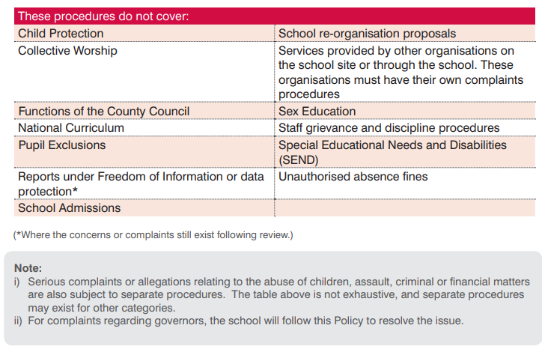
3. Anonymous Complaints
The School will always give serious consideration to concerns and complaints that are brought to its attention. However, anonymous complaints will not normally be considered.
4. Unreasonable Complaints
There is a right to raise a complaint against a school and an expectation that the individual will exhaust the School’s procedures. If the individual contacts the school again with the same issue, this could be seen as unreasonable and the school may choose not to respond.
5. Making a complaint
The school expects that the majority of complaints to be made within three months of the incident being complained of. The school will consider complaints beyond this time frame in exceptional circumstances only. Dependent on the type of complaint, the following table is a guide to whom it should be referred to:
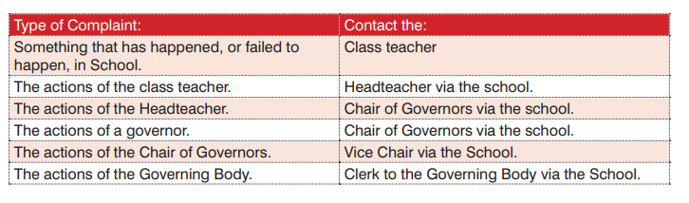

The School /Governing Body would in most cases hope to resolve concerns and complaints at an informal stage, but the procedures allow for formal consideration of a complaint and a review stage if matters cannot be resolved. The School is committed to dealing with complaints as speedily as possible and would plan to complete each stage within 20 school days. From time to time, it may not be possible to complete the process in that timescale. Where it is not possible, the complainant will be informed of any delays. Where complaints are made against an individual member of the school staff or governor, the individual will be informed of the complaint at the earliest opportunity and certainly before any investigation commences.
6. The Complaint Procedures
(i) Informal Stage
The school will seek to resolve complaints informally by email, telephone call, brief meeting as appropriate. If the complaint is unable to be resolved at this stage, the school will ask you to put your concerns or complaint in writing and the ‘Formal Stage’ - Paragraph 6(ii) of the procedures will commence from the date that the letter is received by the school. If the school has not heard from you by 20 school days, it will assume that you do not want to take things any further and the complaint will be closed.
For concerns regarding the Headteacher, the complainant should put the complaint in a sealed envelope marked ‘private and confidential’ and addressed to the Chair of Governors via the School. Under the Data Protection Regulations, the school is not permitted to provide the personal details of the Chair of Governors, but the School will forward the envelope to the Chair as soon as possible.

(ii) Formal Stage
This stage will commence when the:
• Informal complaint has not been resolved to the satisfaction of the complainant.
Or • Complainant has indicated they wish to go straight to the formal stage.
Or • School feels that the complaint is inappropriate for an informal resolution.
The Headteacher will: Note: If the complaint is regarding the Headteacher or a governor, this will be investigated the Chair of Governors, or nominated governor if the Chair has previously been involved. • Following receipt of the written complaint, formally acknowledge receipt of the complaint and ensure the complainant receives an up to date copy of the School’s Complaint Policy and Procedures. It should be clarified what the complainant feels would put things right if it not clear in the correspondence. (Note: It is acceptable for someone else to write the complaint on behalf of the complainant)
• Seek advice, as appropriate. (Dependent on the nature of the complaint, this could include: the School’s Adviser; Clerk to the Governing Body; Legal Services; Schools’ HR Team; Finance Officer or Pupil Access Officer.)
• Inform the member of staff (or governor) if the complaint concerns them and provide them with a copy of the complaint and School’s Policy and Procedures.
• Arrange and complete a full investigation of the complaint.
• Prepare a report following the investigation; consider what actions need to be taken and whether it be substantiated or unsubstantiated.
• Advise the complainant, in writing, of the outcome of the investigation.
• Should the complaint remain unresolved:
If the Headteacher/Chair has undertaken the investigation, the complainant can request a review to the Complaints Review Committee. The request must be received within 20 school days of the notification and set out the grounds as to which matters remain unresolved. Note: If the Clerk to the Review Committee does not hear from the complainant within

Complaints Policy
November 2020

This Policy is based on best practice advice from Lancashire County Council.
The implementation of this policy will be monitored by Mrs Holt in consultation with the Leadership Team and a nominated Governor.
This policy will be reviewed as appropriate by The Senior Leadership Team
Intended Policy Review Date – November 2020

Approved by ______________________________ (Headteacher)
Date: ______________________________
Approved by ____________________________ ( Chair of Governors)
Date: _____________________
Approved by ______________________________ (Governor)
Date: ______________________________

