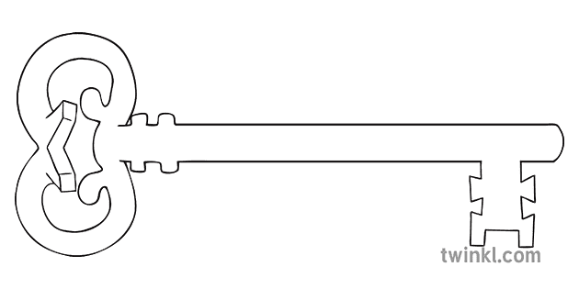

**Maths**

As mathematicians, we are going to learn how to measure objects using rulers, plus we will deepen our understanding of addition and subtraction. We’ll be finding halves and quarters, describing positions and directions, and learning how to tell the time!

**Curriculum Enrichment**

Spring Walk

Trip to Wildlife Oasis

**Year 1**

**Spring 2 Term 2024**

Growth and Green Fingers

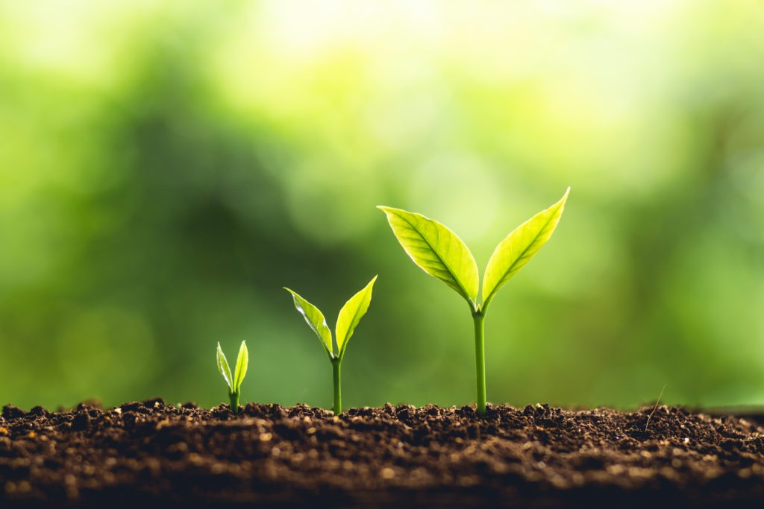

**PE**

As athletes, we will be learning the fundamental movement skills of throwing, catching and kicking. We will explore the ways we can kick different objects with accuracy. Building our skill set to use tactics in a simple game.

**Design & Technology**

As designers ,we will research different foods where they come from and those foods that are healthy and those that are treats. After researching we will esign a healthy pizza that appeals to their own tastes by trying different pizza toppings and creating a food vocabulary linked to these foods.

**Science**

As scientists, we will be researching, planting and growing plants. We will Identify and name a variety of common wild and garden plants.

We will also, identify and describe the basic structure of a variety of common flowering plants.

**PSHE**

As caring community members, we will be learning about feelings and emotions. This involves discovering all the different emotions we might have, why we might feel like that, and how to cope with them.

**Computing**

As computer scientists, we are going to learn some simple coding! This involves creating a clear instruction so the computer knows what to do. We will create our own computer games with different characters and backgrounds.

**RE**

As theologians, we will be learning about Lent and the Easter story. We will read many pieces of Scripture, from how Jesus spent 40 days in the desert, to the events of Good Friday. The children will discuss what they will give up for Lent, and what they could do to help others.

**Geography**

As geographers, we will be learning some fieldwork skills. We will explore our school grounds and follow maps, plus draw our own! We will learn what North and South mean, plus we will learn other directional language such as near and far.

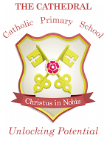

Unlocking potential together

in faith and love.

**English**

As readers and writers, we will be letter writing, writing a set of instructions and learning a traditional rhyme.

Throughout the term we will be reading lots of different stories from the Peter Rabbit collection.