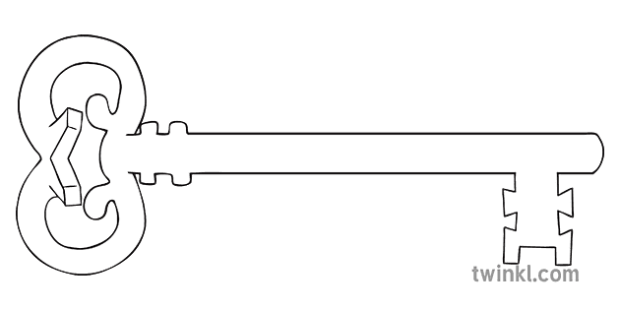

**Maths**

As mathematicians, we are going to learn how to measure objects using rulers, plus we will deepen our understanding of addition and subtraction. We’ll be finding halves and quarters, describing positions and directions, and learning how to tell the time!

**Curriculum Enrichment**

Spring Walk

**Year 1**

**Spring 2 Term 2025**

Growth and Green Fingers

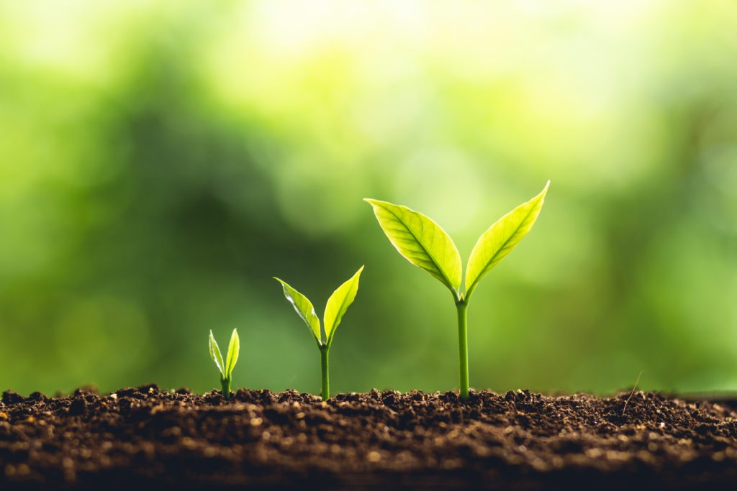

**PE**

As athletes, we are going to enjoy learning some core kicking skills, plus we will be learning catching and balancing skills.

**Design & Technology**

As designers, we are going to be designing our own foods and cooking them to taste for ourselves. Delicious! What toppings will you have?

**Science**

As scientists, we are looking at Plants this half term. We will be identifying different types of plants, the structure of plants, and how they grow. Why don’t you get some seeds to plant at home?

**PSHE**

As caring community members, we will be learning about feelings and emotions. This involves discovering all the different emotions we might have, why we might feel like that, and how to cope with them.

**Computing**

As computer scientists, we are going to learn some simple coding! This involves creating a clear instruction so the computer knows what to do. We will create our own computer games with different characters and backgrounds.

**RE**

As theologians, we will be learning about Lent and the Easter story. We will read many pieces of Scripture, from how Jesus spent 40 days in the desert, to the events of Good Friday. The children will discuss what they will give up for Lent, and what they could do to help others.

**Geography**

As geographers, we will be learning some fieldwork skills. We will explore our school grounds and follow maps, plus draw our own! We will learn what North and South mean, plus we will learn other directional language such as near and far.



Unlocking potential together

in faith and love.

**English**

As readers and writers, we are going to read Peter Rabbit and write our own versions, plus learn how to write instructions for growing a plant, and we will be listening to and writing our own rhymes about gardens.