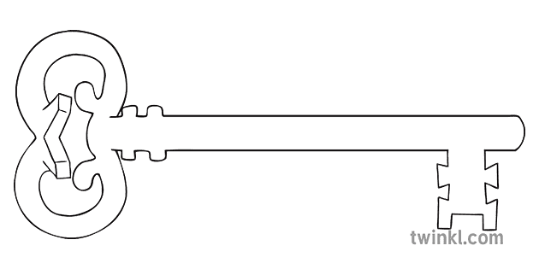

**Maths**

As mathematicians, we will do lots of retrieval of skills we have already learnt. We will learn the time, measuring objects and looking/comparing different shapes (2D and 3D).

We will deepen our understanding by using our maths skills to solve problems.

**Curriculum Enrichment**

Toy Day

Enterprise Week

**Year 1**

**Summer 2 Term 2025**

Robots

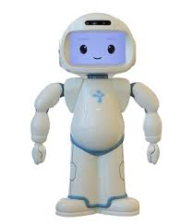

**PE**

As athletes, we will practice our athletics skills (running, throwing, jumping). We are also going to be learning fundamental movement skills throwing over and under arm.

**Art**

As artists, we will be studying the wonderful art work of Barbara Hepworth, using her work as an inspiration to sculpt our own shapes. Our final product will be creating a sculpture out of soap.

**Science**

As scientists, we will be exploring different materials, looking the different categories of materials and what materials suit different jobs the best. We will investigate the best material to make a perfect eye mask for a robot to help him sleep.

**PSHE**

As caring community members, we will be focusing on healthy relationships – learning about secrets, appropriate touch, plus listening and playing co-operatively with others. Moreover, the children will be taking part in HRE week which focuses on families.

**Computing**

As computer scientists, we are going to recap over everything we have learnt about this year on Purple Mash. Get ready to revisit pictograms, e-books, coding and spreadsheets!

**RE**

As theologians, we will be starting our final topic this year. We will learn about what it means to be a Christian and be a part of the Church family, plus learning a little about Jewish traditions.

**History**

As Historians, we will be delving into the history of toys. But first, we must consider - what are our favourite toys now? Why do we like them? Then we will think about how they are different to toys from long ago. We will be exploring a selection of old toys first hand and comparing them to our current toys.

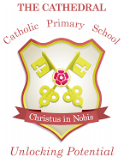

Unlocking potential together

in faith and love.

**English**

As readers and writers, we are very excited to be practising all the skills we have used this year in writing a fantasy story based upon the story ‘NoBot the Robot’. We will also write a recount.