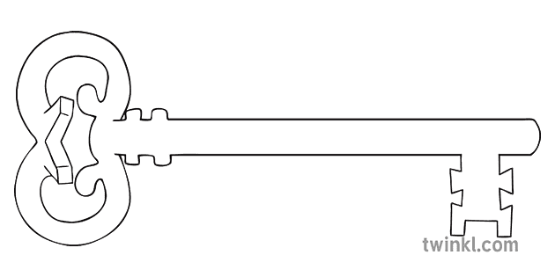

**Maths**

As mathematicians, we will start by finishing our Subtraction topic. Then we will look at sequences and sorting, followed by 2D and 3D shapes, Fractions, Money and Time.

**Curriculum Enrichment**

Great Fire of London workshop

**Year 1**

**Autumn 2 Term 2023**

Fire, Fire!

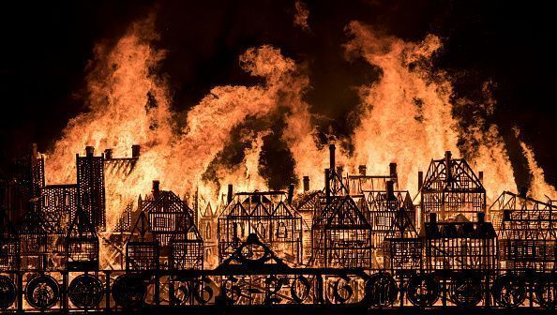

**PE**

As gymnasts, we are practising our balances, rolls, jumps and learning how to put them all into a sequence.

**Art**

As artists, we will be working on our painting skills. This involves using thick and thin brushes, mixing primary colours to make secondary colours, plus combining materials and tools in order to create different effects.

**Science**

As scientists, we are looking at different materials this term. This involves looking at various objects and considering how they are different. What are they made out of? Can you describe the material? Is it smooth or rough? Soft or hard? It is important to be able to tell the difference between an object and the material from which it is made.

**PSHE**

As caring community members, we will be learning about our Rights and Responsibilities this term. We will understand the needs of ourselves and others, plus we will learn about the people in our community and who can help us.

**Computing**

As computer scientists, we will be learning how to use Pictograms on Purple Mash. This will show us how to display data collected from the class in a clear way that can be analysed easily.

**RE**

As theologians, we are starting our new topic called Prophecy and Promise, which covers our learning up until Christmas. We will learn what Angel Gabriel asked Mary to do, and what happened at Christmas.

**History**

As historians, we will be considering an event from long ago – The Great Fire of London! When was it? Where? How did it happen? And who was Samuel Pepys? We’ll be discovering the answers to these questions and more.

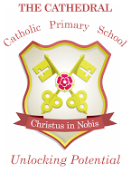

Unlocking potential together

in faith and love.

**English**

As readers and writers, we will be reading a family-favourite story about a dragon, and we will write our own versions of it!

Then, we will explore Fire-related rhymes and poems, creating actions, choosing our favourites, and completing our own poem about Bonfire Night.

Then,