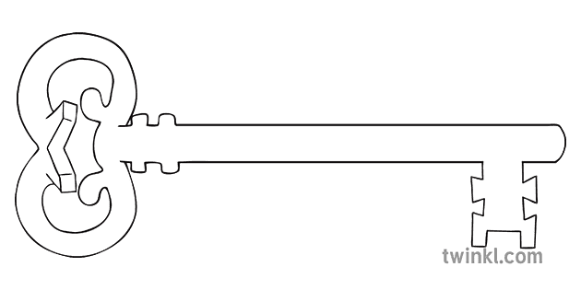

**Maths**

As mathematicians, we are going to continue trialling the new Red Rose maths scheme. We will begin learning how to tell the time, and continue developing our understanding of Place Value, Addition and Subtraction, Measurement, Fractions and Geometry.

**Curriculum Enrichment**

Visit to Williamson Park

**Year 1**

**Summer 1 Term 2023**

The Great Outdoors

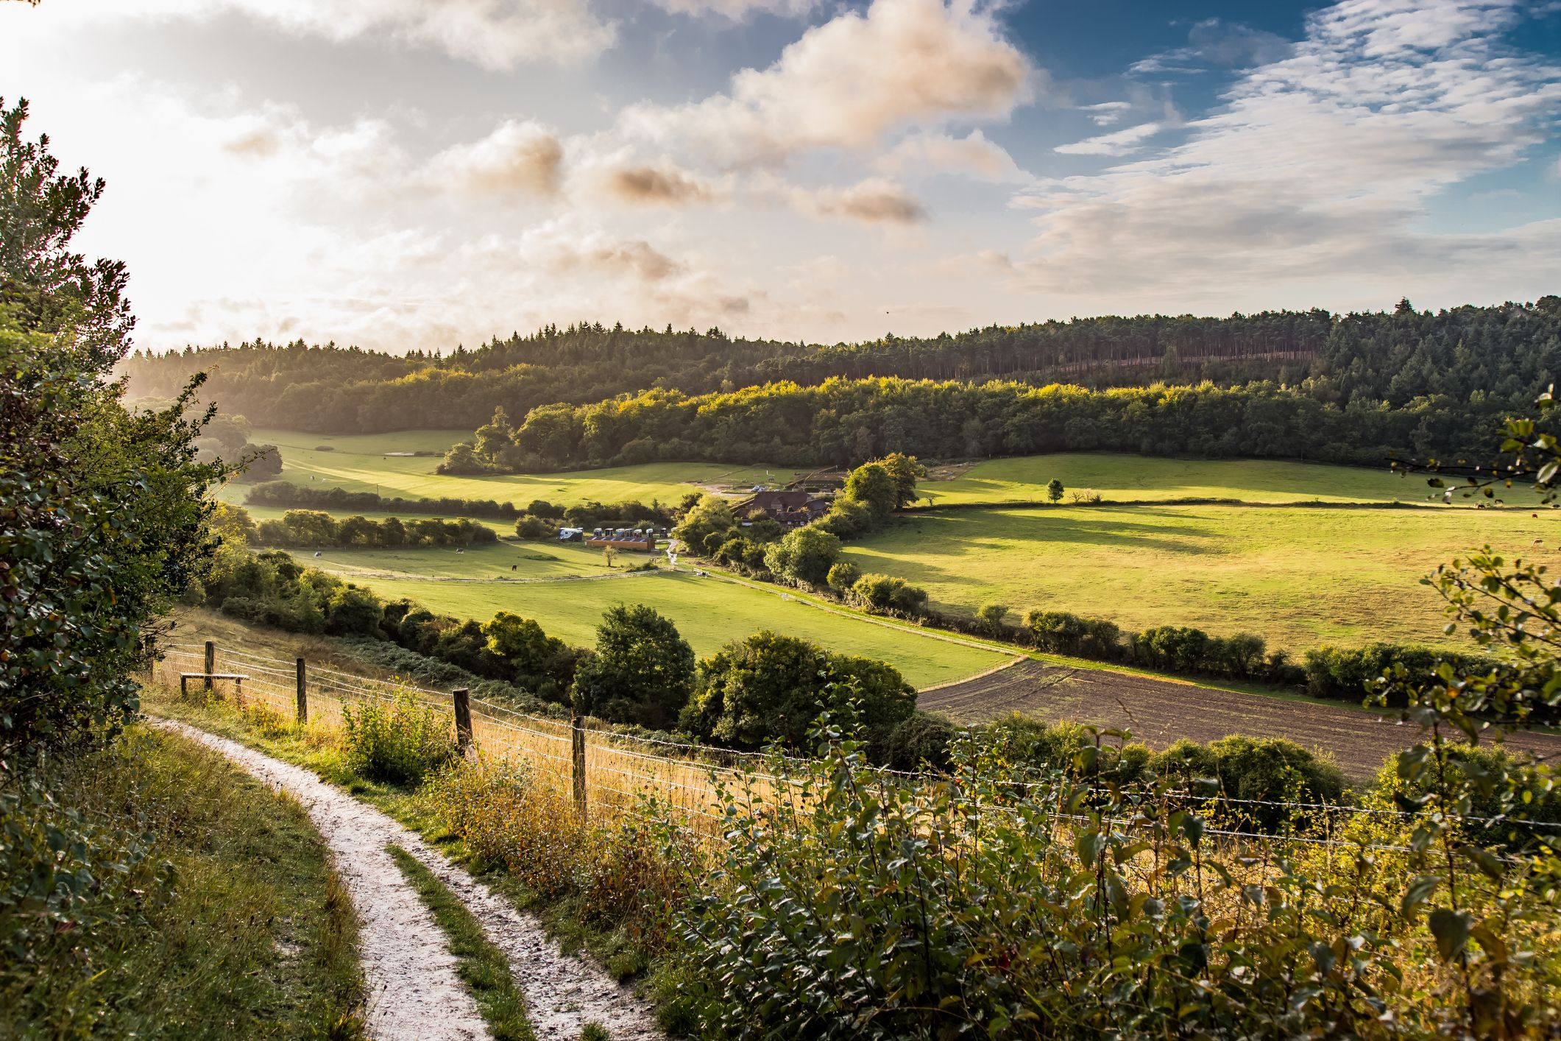

**PE**

As athletes, we are going to have fun perfecting our underarm and overarm throwing, and using these in games!

**Art**

As artists, we will be creating our own collages using a variety of different materials that we will learn to manipulate in a way that looks pleasing!

**Science**

As scientists, we are revisiting the Animals topic this half term. We will be identifying various animals and grouping them. What makes animals different? We will also be learning what the terms Herbivore, Omnivore and Carnivore mean!

**PSHE**

As caring community members, we will be learning about what is or is not safe. This includes learning about medicines, what to do if we are worried, and how to ensure our privacy in different contexts.

**Computing**

As computer scientists, we are going to explore spreadsheets! What are rows and columns? What is a cell? How do we enter data? We will be learning this and more.

**RE**

As theologians, we will continue learning about the Easter story. Then, we will learn about what happened after Jesus rose from the dead, and the story of Pentecost.

**Geography**

As geographers, we will be developing our knowledge of the United Kingdom. What countries are here? What are their capital cities? We will also be identifying natural and manmade features in the United Kingdom.

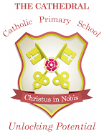

Unlocking potential together

in faith and love.

**English**

As readers and writers, we are going to write a narrative based on the Percy the Park Keeper series. Then, we will create a non-fiction booklet about Williamson Park using all the features we already know – titles, subtitles, information, labels and pictures.