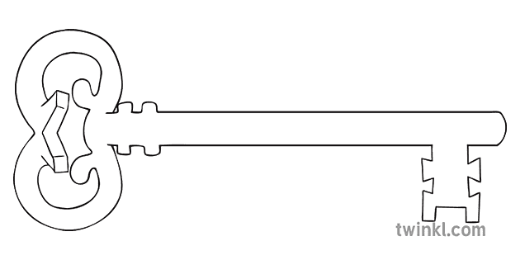

**Maths**

As mathematicians, we are going to learn how to measure objects using rulers, plus we will deepen our understanding of addition and subtraction. We’ll be finding halves and quarters, describing positions and directions, and learning how to tell the time!

**Curriculum Enrichment**

Spring Walk to Williamsons Park

Art Exhibition

Sports Day

**Year 1**

**Summer 1 Term 2024**

The Great Outdoors

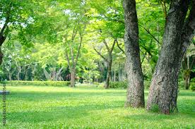

**PE**

As athletes, we will be learning from an expert as we are lucky enough to welcome Dan the PE expert into our PE lessons. Dan will be teaching us different ways of throwing and developing our skills in games.

**Art**

As artists, we will use a combination of materials that are cut, torn and glued. We will mix materials to create texture to create a very exciting end product based on the outdoors!

**Science**

As scientists, we will identify and name a variety of common animals including some fish, some amphibians, some reptiles, some birds and some mammals. We will also name a variety of common animals that are carnivores, herbivores and omnivores.

**PSHE**

As caring community members, we will be learning about what is or is not safe. This includes learning about medicines, what to do if we are worried, and how to ensure our privacy in different contexts.

**Computing**

As computer scientists, we are going to explore spreadsheets! What are rows and columns? What is a cell? How do we enter data? We will be learning this and more.

**RE**

As theologians, we will find out what happened after Jesus died on the cross. We will listen to stories such as The Road to Emmaus, and discuss the events of Pentecost and the Ascension.

**Geography**

As geographers, we will be learning about the land, seas and coast in and around our United Kingdom. We will learn the names of the four countries in the UK, and we will be taking a close look at our local coast line. What do you know about Morecambe?

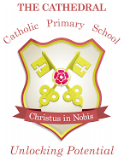

Unlocking potential together

in faith and love.

**English**

As readers and writers, we will be writing a story based in a familiar setting (a park) and we will be writing an information page based upon Williamsons Park.

Throughout the term we will be reading lots of different stories from Nick Butterworth series ‘Percy the Park Keeper’ collection.