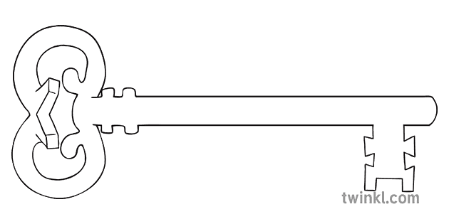

**Maths**

As mathematicians we will work on our number and place value knowledge focusing on tens and ones. We will have a focus on 2D and 3D shape, counting money and finish off the half term with the fundamentals of multiplication and division.

**Curriculum Enrichment**

Wildlife Oasis

**Year 1**

**Spring Term 2025**

Penguins, Possums and Pigs

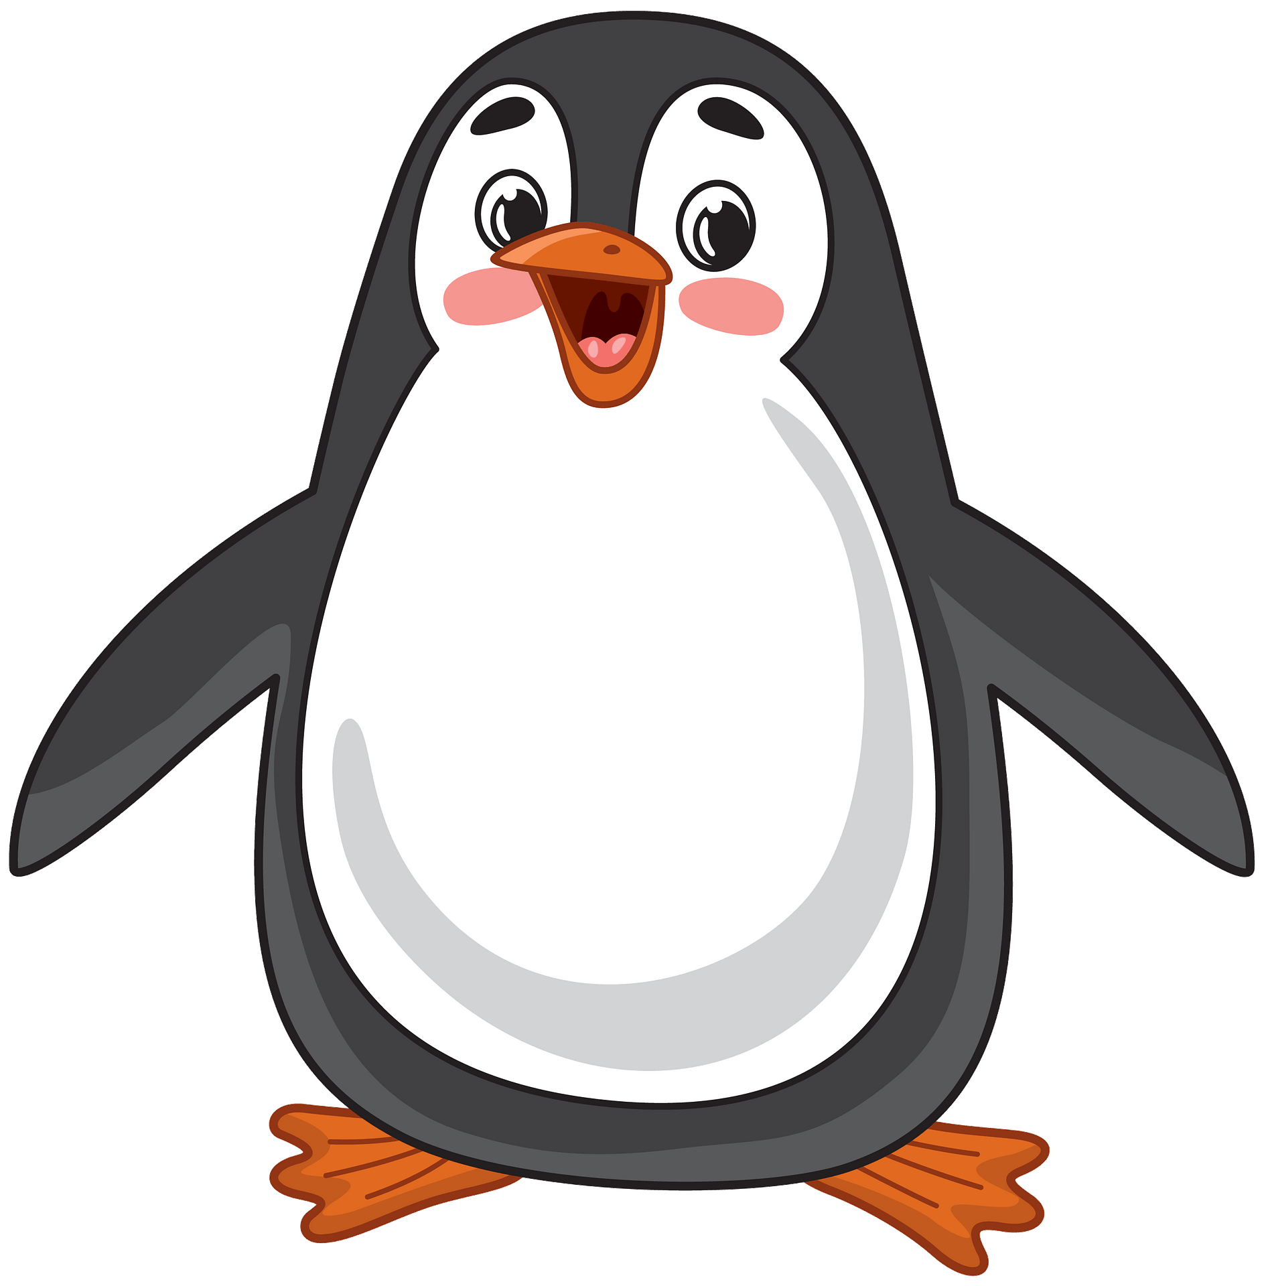

**PE**

As athletes, in our dance unit we will be using the skills of Travel, Turn, Jump, Gesture, Stillness to create a short routine. In fundamental movement skills we will be developing our skills in throwing over and under arm.

**Design and Technology**

As designers, we will be researching, designing, making and evaluating a structure to hold an object. The structure will have a focus on the stability and the strength to ensure it can hold the objects for a length of time.

**Science**

As scientists, we will be learning about animals. Recognising the difference between animals and their structure. Hopefully at the end of the unit of work we will visit some animals and learn even more about them at Wildlife Oasis.

**PSHE**

As caring community members, we will be learning about money and jobs – as part of our school Wealth and Work week. In this week, children will discover how you get money and think about what they might like to do to earn it.

**Computing**

As computer scientists, we will be learning all about Technology – what is it? Can we name types of Technology in the classroom and also outside of it? Which pieces of Technology do we think are most useful for us?

**RE**

As theologians, we will be diving into our new topic called ‘Galilee to Jerusalem’. We will learn more stories about Jesus, including when he was presented at the temple, and we will learn what Candlemas means.

**Geography**

As geographers, we will be learning all about hot and cold places. We will find out about the Equator and how places across the Earth are very different. This includes the landscape, the animals, and how people adapt to living in different places.

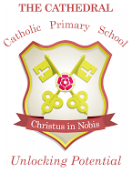

Unlocking potential together

in faith and love.

**English**

As readers and writers, we will learn stories through talk for write. Then we will have a go at writing our own story based upon ‘Lost and Found’. Using the knowledge we have learnt in science we will write an information booklet about an animal ready to show the experts at Wildlife Oasis.