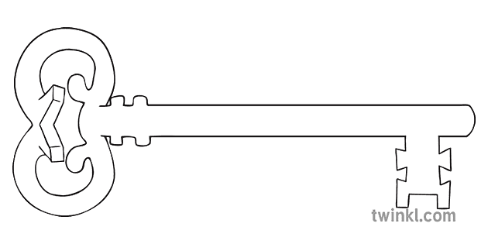

**Science**

As scientists, we will be looking how our human body works, naming and labelling the basic parts of the human body and learning the five senses.

Throughout the year in Science we will observe how our environment changes depending on the season we are in.

**Maths**

As mathematicians we will embed the learning from Reception and progress our skills in place value of numbers up to 20 and beyond. We will also focus on measuring length and mass, addition and subtraction and 2D/3D shapes.

**Curriculum Enrichment**

Trip to Judges Lodgings School Room and Cottage

**Year 1**

**Autumn Term 2025**

Family Album



**PE**

As athletes, in our dance unit we will be using the skills of Travel, Turn, Jump, Gesture, Stillness to create a short routine. In gymnastics we will be learning different ways to travel and to travel around the room with control and coordination.

**Art**

As artists, we will use Picasso to inspire our drawing and creative skills, look at his art work and how he created different shapes using drawing skills. Using a camera, we will take photographs of each other, cut them up and try and complete the picture using our own drawing and sketching skills.

**PSHE**

As caring community members, we are discovering how to have healthy lifestyles. This involves learning about healthy choices and personal hygiene routines. We will also consider all the different feelings we may have and how to cope with them.

**Computing**

As computer scientists, we are going to be learning how to be safe online. Then, we will progress onto exploring Purple Mash, where the majority of our Computing will take place. We will become familiar with our usernames and passwords and how to access the site.

**RE**

As theologians, we will be learning about how the world began and focusing on the early Bible stories. We will be continuing to follow the new RE curriculum.

**History**

As historians, we will be considering changes that have happened within memory – so how we have changed since we were born and how family members have changed. We will also discover other events in living memory that people can remember. For example, what birthdays and schools used to be like.

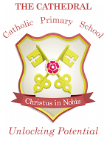

Unlocking potential together

in faith and love.

**English**

As readers and writers, we will re-cap and embed the knowledge the children have learnt in Reception. We will have daily phonics sessions, guided reading sessions and English lessons. During our English lessons we will take a look at the story of Little Red Riding Hood and we will write our own stories based upon it. We will also learn how to write a recount!