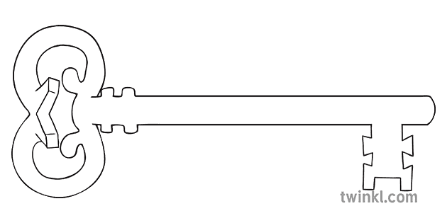

**Maths**

As mathematicians, we are going to be extending our understanding of the four rules of number; addition, subtraction, multiplication and division.

Additionally, we will investigate time and shape and focus on problem solving.

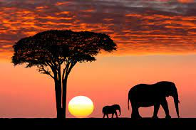.

**Year 2**

**Spring 2 Term 2024**

An African Safari

**PE**

As athletes, we will be developing throwing and catching skills through net and wall games. We will focus on the skills of concentration and self-belief as well as learning how to outwit an opponent.

**Art**

As artists, we will be looking at the landscape paintings of Ted Harrison. We will emulate his style and create our own African savannah prints using the same techniques he used.

**Science**

As scientists, we will be examining the needs of safari animals and how they survive in the wild. We will be finding out what their needs are and who their predators are as well as looking at their life cycles.

**Music**

As musicians, children will listen and appraise different styles of South African music. They will learn to sing, play, improvise and compose using the song Hands, Feet and Heart.

**Computing**

As computer scientists, we will learn how to present stories and reports in different ways. The children will also be learning how to create a quiz about safari animals. They will get the opportunity to make a presentation about the facts that they have learned.

**RE**

As theologians, we are learning about the different parts of the mass as well as focussing on the events of Holy week leading up to the crucifixion on Good Friday.

**Geography**

As geographers, we will be learning about the wider world and searching through world maps to find the continents and major oceans of the globe. We will also investigate more thoroughly the continent of Africa and the different cultures within it.

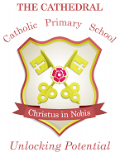

Unlocking potential together

in faith and love.

**English**

As readers and writers, we are going to explore the genres of non-chronological reports and writing fiction stories by innovating an African tale. We will compare different styles of writing and ensure we use appropriate punctuation throughout our work.