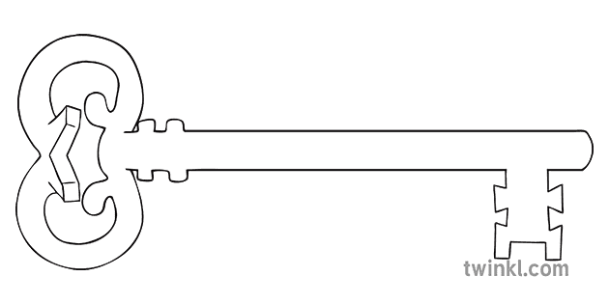DT

**Curriculum Enrichment**

Art Exhibition

Ascension Day Mass

May Procession

**Year 2**

**Summer 1 Term 2024**

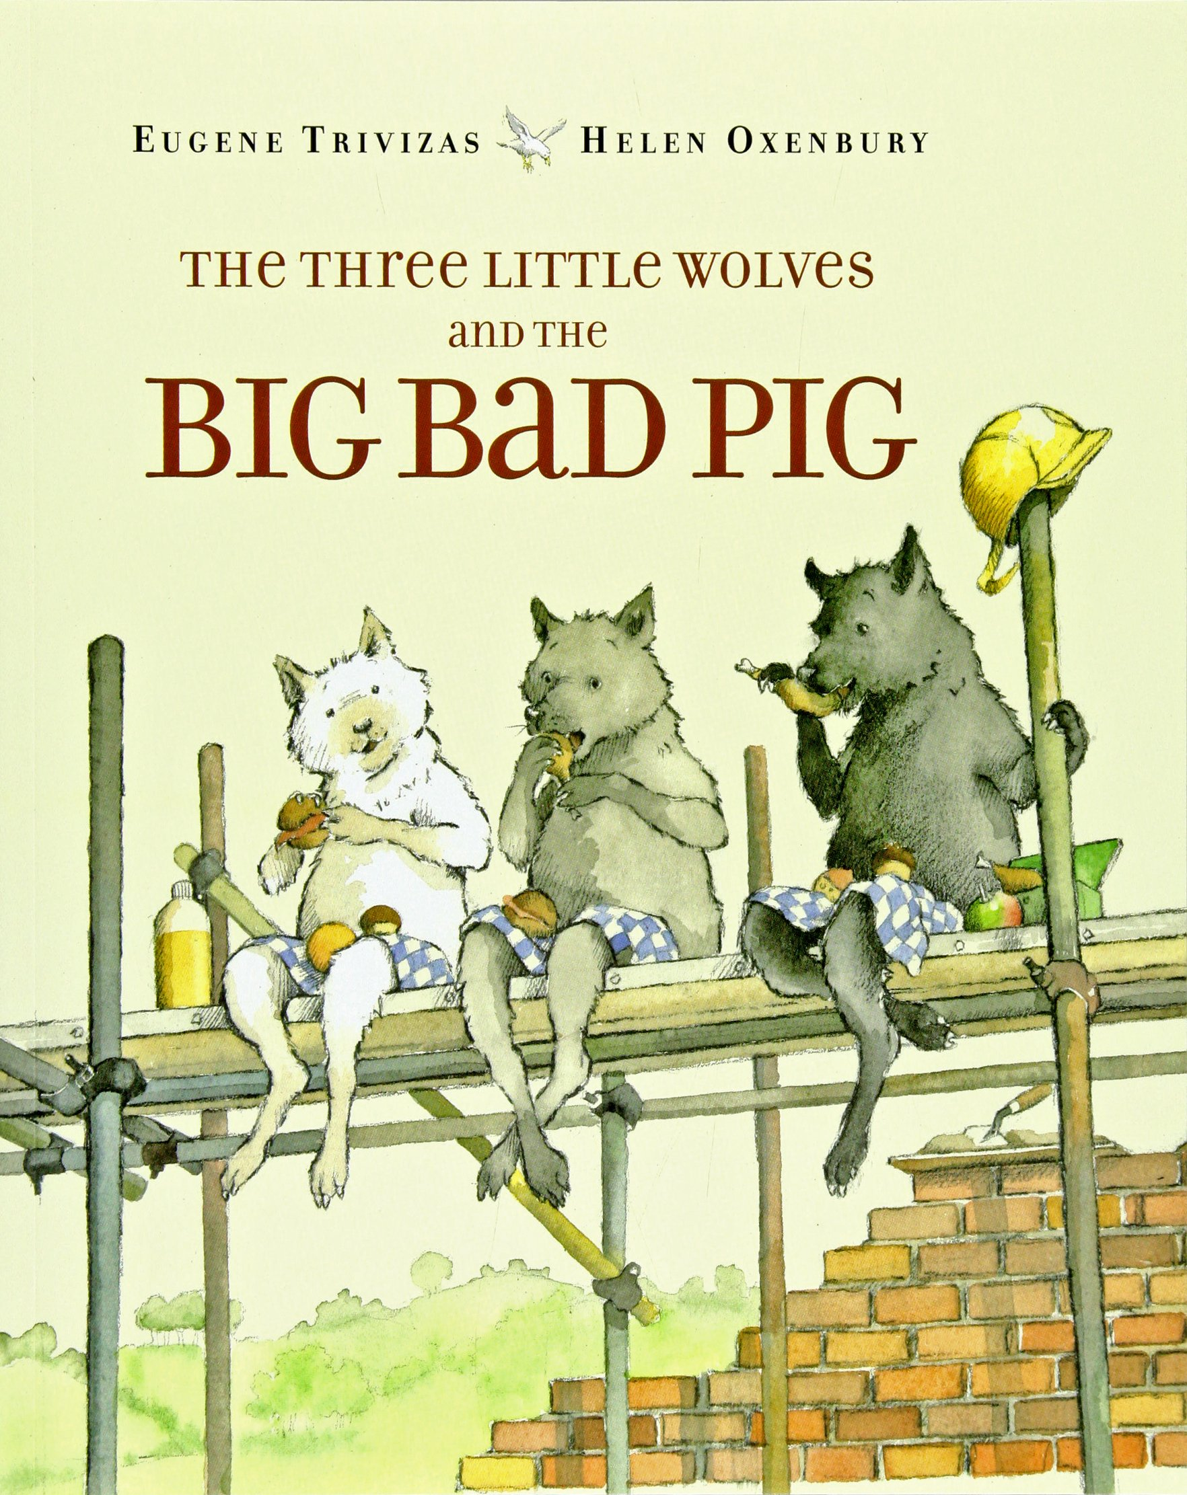

**Science**

As scientists, we will focus on used of materials which links in with this terms text. We will be looking at the properties of different materials and finding out which are the most suitable materials for different purposes.

**RE**

As theologians, we will learn about the events of Eastertide including Ascension day and Pentecost. We will learn how the disciples made it their mission to spread the Good News about Jesus.

**Art**

As artists we will be producing work for the art exhibition based upon the Platinum Jubilee theme. Our art work will be displayed at the end of the half term.



**DT**

As designers we will plan, design, make and evaluate a puppet. We will make a puppet for a reception child to enable them to retell the story of the Three Little Pigs.

**Maths**

As mathematicians, we will revising the four rules of number in order to prepare for assessments in May. We will also be learning more about fractions, time, money and shapes.

**English**

As readers and writers, we will be looking at alternative versions of traditional tales and comparing different versions. Our text will be The Three Little Wolves and the Big Bad Pig by Eugene Trivizas.

**P.E.**

As sports people, we will continue to develop athletics skills in preparation for sports day, especially striking the ball and fielding.

**Computing**

As computer scientists we will be creating music on the computer using software on Purple Mash.

**PSHE**

As caring community members, we will think about the feelings and emotions that we have each day. We will learn how to manage these and what we can do to help and influence the feelings and emotions of others

**MUSIC**

As musicians we will continue to develop our listening, appraising and performing skills using the Charanga scheme. Miss McShane will be teaching us songs about friendship and special times.



Unlocking potential together

in faith and love.