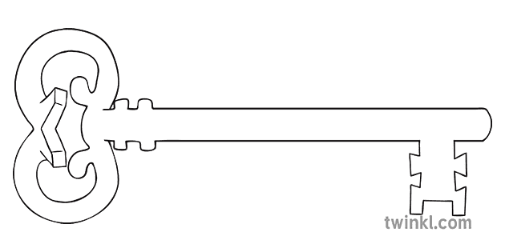

**History**

As historians we will be finding out about the history of the local area. We will start with school and then extend our research to Lancaster and the castle. We will use history skills including interpretation and chronology.

**PE**

As athletes, we will be developing gymnastic skills in the hall and creating sequences of movements and putting them together to create our final piece. We will also be developing our dancing skills and performimg routines for eachother.

**Computing**

As computer scientists, we will learn about data handling tools that can provide us with more information than pictograms. We will also use a database to answer more complex search questions.

**Art**

As artists, we will be looking at the art work of Italian artist Guiseppe Arcimboldo, who is best known for creating art work from fruits and vegetables. Using computer programmes we will emulate his work and make original pieces of our own.

**English**

As readers and writers, we are going to read classic fairytales and fantasy stories. We will be writing letters, recounts, narratives, explanations , and instructions throughout the topic and focussing on our non-negotaibles for writing including joining up letters.

**Music**

As musicians, children will listen and appraise different styles of music but especially music from South Africa. We will listen to ‘Hands, feet, heart’ and focus on the skills of appraising, listening, rhythm, pitch and dynamics through this music.

**Science**

As scientists, we will be working scientifically to find out about our bodies and how to stay fit and well. We will also be focussing on nutrition and hygiene and learning how to look after ourselves and stay healthy

**Curriculum Enrichment**

We will go for a walk to our own castle in Lancaster and use it as a stimulus for writing.

**RE**

As theologians, we will be studying the topics of ‘books’, ‘thanksgiving’. During these topics we will explore the significance of stories in the bible and the structure of the celebration of mass

**Year 2-Spring 1**

**Fantasy Worlds**

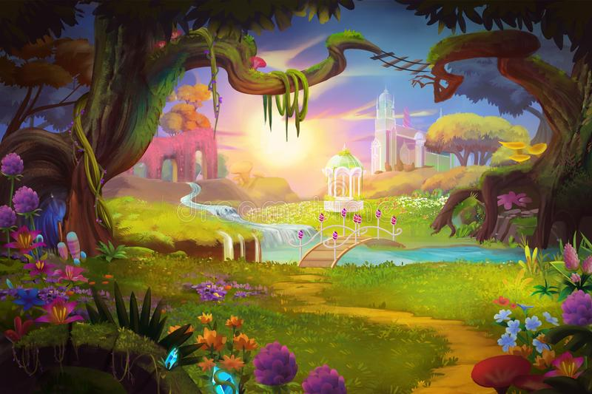

**Maths**

As mathematicians, we will begin by focussing on place value and ensuring a solid understanding of tens and units. We will move on to adding and subtracting tens and units. The children will also explore measurement of length and weight and use money in role play situations to understand the value of coins.

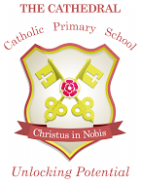

Unlocking potential together

in faith and love.