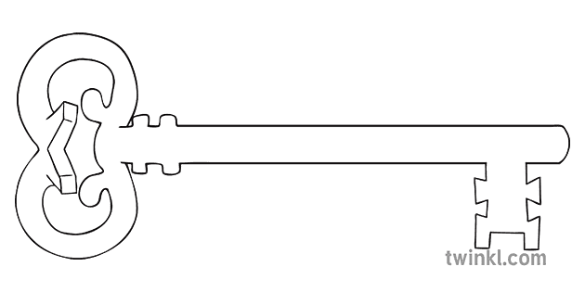DT

**Curriculum Enrichment**

Morecambe trip.

Enterprise week

SS Peter and Paul

**Year 2**

**Summer 2 Term 2025**

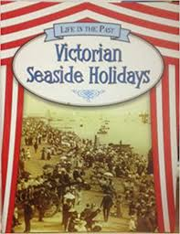

**P.E.**

As sports people, we will continue to develop athletics skills in preparation for sports day, especially striking the ball and fielding.

**Art**

As artists we will be creating different effects on fabric using tie dye techniques.



**History**

As historians we will learn about the history of the seaside focussing on Morecambe. We will compare how the Victorians were entertained at the seaside and compare this with things that entertain us today.

**Computing**

As computer scientists we will be coding, creating computer programmes using algorithms on Purple Mash.

**Science**

As scientists, we will focus on what can be found at the beach. As well as focussing on the creatures that can be found there, we will look at what shouldn’t be there and whether these things can be recycled.

**RE**

As theologians, we will find out more about Judaism and learn about other religions, learning to respect that in our community there are people that have different beliefs and faiths.

**Maths**

As mathematicians, we will be consolidating all the mathematical learning that we have covered this year as well as focussing on position and direction.

**English**

As readers and writers, we will be looking writing non chronological reports and making leaflets about the Victorian seaside. We will also learn and compose seaside poetry.

**PSHE**

As caring community members, we will think about what makes a healthy relationship. We will think about the different kinds of relationships that we have and what we can do to ensure these impact positively on our lives.

**MUSIC**

As musicians we will continue to develop our listening, appraising and performing skills using the Charanga scheme. Miss McShane will be teaching us songs about friendship and special times.

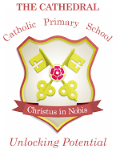

Unlocking potential together

in faith and love.