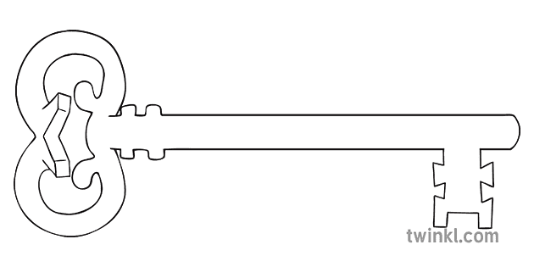

**Year 2-Autumn 1**

**EXPLORERS**

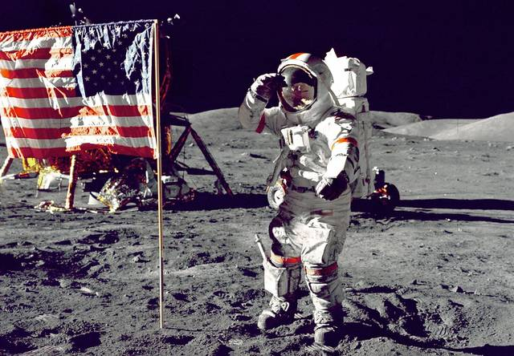

**Curriculum Enrichment**

We will visit the Maritime Museum in Lancaster to learn about explorers.

**Maths**

As mathematicians, we will begin by focussing on place value and ensuring a solid understanding of tens and units. We will move on to adding and subtracting tens and units. The children will also explore measurement of length and weight and identify the characteristics of 2D and 3D shapes.

**PE**

As athletes, we will be developing bouncing skills using our hands and feet.

In dance we will develop teamwork skills by working in groups and sharing movement ideas. We will also create sequences of dances and put these together to create a final piece.

**Art**

As artists, we will be looking at the art work of Keith Haring. Children in Y2 will be adding white to colours to make tints and black to colours to make tones. They will create colour wheels in order to understand the different shades of colours and will develop control in using colour.

**Science**

As scientists, we will be examining the needs of astronauts and thinking about what our own bodies need to survive and grow. We will also be thinking about the impact that exercise has on our bodies and planning and carrying out investigations around this theme.

**Music**

As musicians, children will listen and appraise different styles of rock music this half term. ‘I Wanna Play In A Band’ is a rock song written especially for children. In this song, children learn about singing and playing together in an ensemble. As well as learning to sing, play, improvise and compose with this song, children will listen and appraise classic rock songs.

**Computing**

As computer scientists, we will learn how to safely search the internet. These lessons allow the children to develop an understanding of what the Internet is. It will also give them the basic tools to help them search for information more effectively using Purple Mash.

**RE**

As theologians, we will be learning to recognise that we are called to make good choices to look after God’s creation and to love and look after each other, because in God’s eyes we are all brothers and sisters.

Children explore their friendships and realise that loving each other makes us strong.

**History**

As historians we will be finding out about some significant explorers including Neil Armstrong, the first man to land on the moon. We will also visit Lancaster Maritime Museum and learn about life on board ship, basic diet at sea and a brief look into what it means to be an explorer and discover things for the first time.

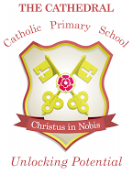

Unlocking potential together

in faith and love.

**English**

As readers and writers, we are going to explore the genre of non-chronological reports and write a fact file about the first moon landing. We will also be learning poetry off by heart and writing poetry of our own. In addition, we will be reinforcing grammar and punctuation skills as well as practising our spellings.