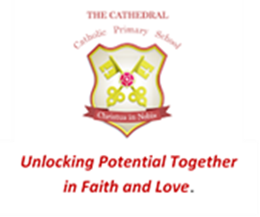
Wednesday 6th September 2023

Dear Parents and Carers,
I am so thrilled to be teaching your child in Year 2!
Miss Stevens, Mrs Norris and Mrs Porter will be supporting the children in class this year. Miss McShane will take the class when I am deputising in the office.
Year 2 have the responsibility of being the oldest and most experienced children in the infants and as such are great role models for the younger children. They will have class responsibilities such as table monitors, fruit monitors and library leaders as well as leading and supporting the younger children at playtimes and lunchtime. I know the children will enjoy rising to this challenge.
We work hard each day throughout Year 2 and working in partnership with parents as always is incredibly important. Writing is a huge focus in the classroom with reading, spelling and maths being the focus of homework.
Reading: Most children finish learning phonics at some point in Year 2. Children are still encouraged to use their phonics to read and write but are also taught lots of new vocabulary that doesn’t follow the previously taught phonic code. Children are expected to read to an adult at home every day.
Spelling: Children will use National Curriculum spellings for Y2 which are set on Purple Mash each week. These trickier words are often taught by sight. They practise these spellings each day in school but can also reinforce the spellings using the website at home.
Maths: A huge emphasis is placed on mastering times tables and number bonds in Year 2 and weekly homework will be set on Purple Mash in addition to learning the 2,5 and 10 times table by rote.
Other information…
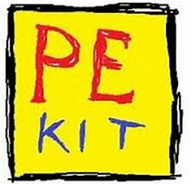
PE days this term are Tuesday and Friday. All children need a white t shirt, black shorts and black pumps for PE. Please send your child’s kit in on the first day of each half term and I will send it home again on the last day unless it needs washing in the meantime.

Communication
To find out what the children will be learning in Y2 this year you are invited to attend the ‘Meet the Teacher and Online Safety’ event on Wednesday 13th September at 3.15pm in the Y2 classroom. It is crucial someone from each family attends as recent changes on how to keep children safe online, may prevent your child accessing the internet in school otherwise. The powerpoint will be available on the website after this time.
We will continue to update the school website with our class news on the Year 2 blog. Please remember to check your parent app regularly to keep in touch with what is happening in school
Finally, we value good communication with parents so please don’t hesitate to get in touch if you have any questions or concerns about your child in school. Email is the best way to contact us – my email address is at the bottom of this letter. Alternatively, you can catch me before or after school in the playground.
I am looking forward to a wonderful time in Year 2 and if I can help you or your family in any way please get in touch.

Mrs S Grierson
Deputy Headteacher
s.grierson@cathedral.lancs.sch.uk

