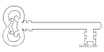

**Year 3**

**Spring 2025**

**Stones and Bones**

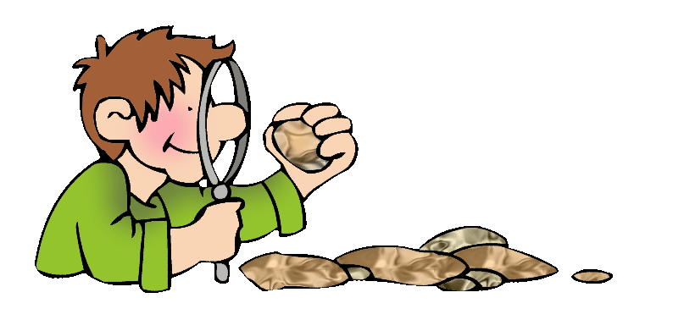

**Maths**

As mathematicians, we will be working to develop our place value through addition and subtraction. We will develop our skills in multiplication and division. We will explore fractions and further develop our work on measures. We will continue to practice our 2, 3, 4, 5, 8 and 10 x tables.

**Curriculum Enrichment**

Stone Age Day

Poetry performance

**PE**

As athletes, we are going to be working on developing our ball skills by playing rugby, and developing routines in dance. **PE will be on Mondays and Wednesdays. Please can all children have a correctly fitting, named PE kit in school.**

**Art**

As artists, we will be completing our final picture in the style of L.S. Lowry, and we will then be spending the rest of the Spring Term learning about sculpture. We will be studying the work of the sculptor Alberto Giacometti.

**Science**

As scientists, we will be learning all about the different types of rocks and soils. We will investigate their properties and what they are used for. We will also be learning about fossils and how these can be used to tell us about the past.

**PSHE**

As caring community members, we will be revisiting our Kid Safe work. We will also be thinking about the importance of money and what our aspirations are for the future.

**Computing**

As computer scientists, we are going to be developing our touch typing skills.

**Music**

In music we will be continuing to develop our understanding of pitch and rhythm.

**RE**

As theologians, we will be deepening our knowledge of the events in the Church’s Year. We will be learning about the events of Epiphany and the Kingdom of God. We will also be learning about the parables Jesus told and the miracles he performed. We will be spending time in prayer and will study the Our Father.

**History**

As historians we will be learning about the Stone Age and the way of life in Stone Age times. This will link closely to our work in English. It will also link to our work on fossils in Science.

**Latin**

This term the children will continue to learn about family life in Roman times

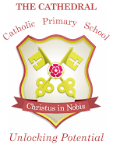

Unlocking potential together

in faith and love.

**English**

As readers and writers, we are going to explore stories on a theme, linked to our history work. We will be looking at poetry that follows a structure and we will be writing to persuade. We will continue to develop our spelling, grammar and sentence structure, and think about using adventurous and descriptive vocabulary.