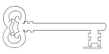

**Year 3**

**Spring 2 Term 2025**

Mighty Metals

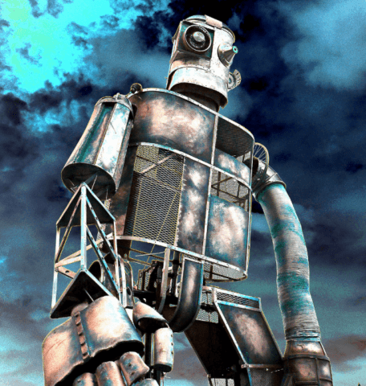

**Maths**

As mathematicians, we are going to develop our skills in written and mental addition and subtraction, 2D shape, statistics, fractions, position and direction and time. We will be using our knowledge of shape to help us in our DT work

**Curriculum Enrichment**

Easter Reflection

Williamson Park Visit

World Book Day

Mother’s Day

**PE**

As athletes, we are going to improve our ability to aim at targets by learning how to play Boccia. We will also be developing our gymnastic skills. PE will be on Mondays and Wednesdays. All children need to come into school in their PE kits on these days.

**Design & Technology/Art**

As designers, we are going to be exploring levers and linkages and using these to build moving monsters.

We will also be completing our sculptures from last term in the style of Alberto Giacometti.

**Science**

As scientists, we are looking at forces and magnets. We will work scientifically to investigate what magnets are and what they can be used for. We will also compare the strengths of different types of magnets.

**PSHE**

As caring community members, we will be learning about rights and responsibilities. This will include looking at why rules and laws exist, bullying, discrimination, anti-social behaviour and fair trade. We will also be discussing how we can contribute to and have a positive impact on our local community.

**Computing**

As computer scientists, we are going to learn about the safe use of email and electronic communication.

**Music**

As musicians, we will continue to develop our pitch, rhythm and singing skills.

**RE**

As theologians, we are going to learn about the miracles of Jesus.

We will also be spending time reading and understanding the Easter story and the ways that Christians commemorate and celebrate these events.

**Geography**

As geographers, we are going to be learning about volcanoes and earthquakes. We will be looking at the structure of the Earth and how the Earth’s plates moving causes these to happen. We will also be learning about what impact these have on where people build towns and cities.

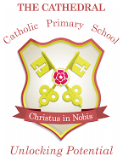

Unlocking potential together

in faith and love.

**English**

As readers and writers, we are going to explore a longer novel together. We will be using The Iron Man by Ted Hughes. We will explore the characters and plot and then innovate a new section for the story. Later in the half term, we will be focusing on recounts and diary extracts and will link this to the characters from the novel.