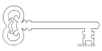

**Year 3**

**Summer 1 Term 2024**

**Healthy Humans**

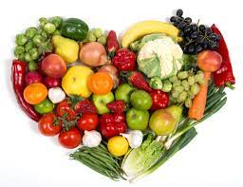

**Maths**

As mathematicians, we are going to develop our skills in addition, subtraction, multiplication and division. This will include the introduction of decimals. We will also be expanding our knowledge of the properties of 2D and 3D shape. We will be revisiting our learning on measures with a focus on time.

**Curriculum Enrichment**

Blackpool Zoo Trip

Sports Day

**PE**

As athletes, we are going to improve our balls skills and tactics through a selection of different striking and fielding games. We will also be spending time developing our Athletics skills. Please can all children have a named, complete PE kit in school.

**Design & Technology/Art**

As designers, we are going to be exploring healthy food and food hygiene. We will end by making a healthy snack.

As artists, we will be starting our topic on Printing. This will stretch across the whole Summer Term.

**Science**

As scientists, we are looking at human and animal health and nutrition. We will work scientifically to investigate what we need to do to keep our bodies healthy, and to explore what would happen if we made unhealthy choices. We will be linking our learning to our work in PSHE and DT.

**PSHE**

As caring community members, we will be learning about ways to keep ourselves healthy. We will be looking at health and hygiene as well as diet, exercise and self- care. We will also be looking at the way food is advertised and presented in the media. Our PSHE work will link closely to our Science topic.

**Computing**

As computer scientists, we are going to learn about branching databases and how data is stored.

**Music**

As musicians, we will be developing our pitch, rhythm and note reading skills by singing and using tuned percussion.

**RE**

As theologians, we are going to learn about the events following Jesus resurrection at Easter. We will look at the events of Ascension Day and will move on to discuss the gifts of the Holy Spirit at Pentecost and how they help us to share God’s love in the way we treat others. We will also be learning about the Holy Trinity.

**Geography**

As geographers, we will be learning all about earthquakes and volcanoes. We will be finding out about what our planet is made of and its structure. We will study how and why volcanoes and earthquakes are formed and the influence this has on the landscape and human settlement

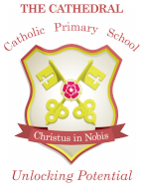

Unlocking potential together

in faith and love.

**English**

As readers and writers, we are going to explore play scripts together. We will be looking at how plays scripts are set out and the purpose of stage directions. We will have a go at writing and performing our own short plays. Later in the term, we will be exploring classic poetry and will be basing our work around ‘The Spider and the Fly’.