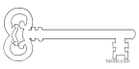

**Year 3**

**Summer 2 Term 2025**

**How Does Your Garden Grow**

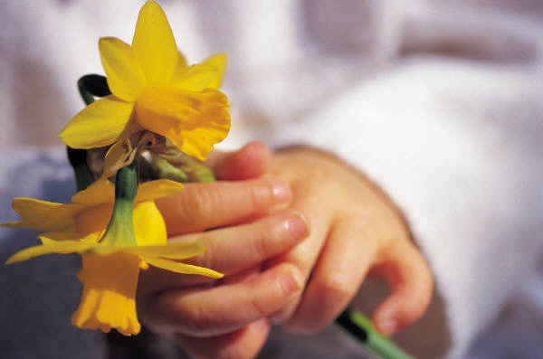

**Maths**

As mathematicians, we will use this half term to consolidate our learning from Year 3. We will revisit our calculation skills and introduce decimals to our calculations. We will develop our fractions work to include addition and subtraction of fractions and will continue to work on our x tables, ready for Year 4.

**Curriculum Enrichment**

Father’s Day

Morecambe Bay Story Writing Project

School Feast Day Celebrations

Williamson Park Visit

**PE**

As athletes, we are going to continue working on our striking and fielding skills and athletics

**Latin**

As linguists, we will be revising the vocabulary we have learned and develop our speaking and written skills.

**Art**

As artists, we will be studying the life and works of William Morris. We will be designing and making printing blocks in the style of William Morris wallpaper.

**DT**

We will be preparing for the Enterprise Fair.

**Science**

As scientists, we are looking at plant growth. We will work scientifically to explore the different parts of flowering plants and what plants require to grow. We will investigate the way in which water is transported within plants. We will also explore the part that flowers play in the life-cycle of a plant.

**PSHE**

As caring community members, we will be learning about how we form and maintain healthy relationships. We will be talking about what makes a good friend and how to resolve conflicts. We will be looking at how our actions have consequences for ourselves and others.

**Computing**

As computer scientists, we are going to continue our work on data handling including branching databases, and revisiting our work from the last year.

**Music**

As musicians, we will continue developing our pitch and rhythm skills.

**RE**

As theologians, we will be learning about Judaism and what happens at Passover. We will also be learning about how this links to the events of the Last Supper and the Mass. We will also be finding out about Islamic beliefs.

**Geography**

As geographers, we will be developing our understanding of physical geography and human geography and its impact on communities. We will be focusing our work on the Lake District and will be looking at rivers, mountains, vegetation, settlement, land use and distribution of resources.

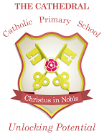

Unlocking potential together

in faith and love.

**English**

As readers and writers, we are going to explore Fantasy Stories and Explanation Texts. We will study the structure of explanation texts and will apply this to our learning in Geography. We will also explore the fantasy world created by Roald Dahl in The BFG. We will use this to develop our descriptive language and story structure.