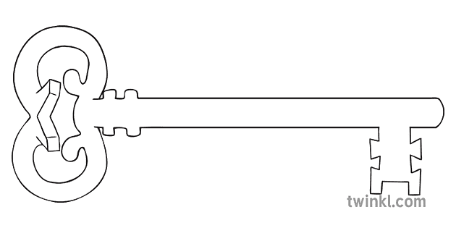

**Science**

As scientists, we will be exploring sound: how it is made, how we can alter the pitch and what happens when the volume changes. We will learn how our hearing works and how we are able to hear a range of sounds. We will also investigate how to make different kinds of musical instruments – a very noisy session!

**PSHE**

This term’s topic is ‘Staying Safe’ and we will consider how to stay safe in a range of settings, including at Bonfire Night, when cycling and when crossing roads. We will also reflect on the impact of peer pressure on our decisions and how to deal with negative peer pressure.

**Art & Design & Music**

As artists, we will be using technology to create art using different electronic techniques. This will include mosaics and preparing for Christmas!

In music, we will continue to use the glockenspiel to play a given melody and compose our own short sequence of notes. We will enjoy singing together as a class.



**Computing**

As computer scientists, we will be learning about the different threats we may experience when online and how to manage these situations so we can stay safe.

**P.E.**

P.E. days are now Tuesday mornings, and swimming continues on a Friday. In net and wall games, we will develop ball skills and playing as part of a team. We will also have a dodgeball afternoon!

**RE**

In our ‘Prophecy & Promise’ unit we study Old Testament prophets Elijah and Isaiah. This leads s onto John the Baptist in the New Testament and how he prepared others for the arrival of Jesus. As we get closer to Christmas, we look at the feast of Christ the King and then reflect on the time of Advent as a time of preparation.

**History**

As historians, we will be looking at the impact of invaders into our country, starting with the Romans – why they came, what they did, and how they changed the lives of the people. We will explore the Roman resources in Lancaster at the Museum.

**Maths**

As mathematicians, we will continue to practise and use our times tables facts, extend our mental addition and subtraction skills and secure written methods of subtraction and multiplication. We will learn about the properties of different groups of 2-D shapes and practise reading the time on analogue and digital clocks – this is something you could practise at home.

**English**

As readers, we will analyse the language features of both a fantasy fiction novel and a recount. We will then use what we discover to help us write our own versions of a story with a fantasy structure, and a newspaper recount linked to the Christmas story. In our writing, we will continue to work at using correct speech punctuation and introduce noun phrases into our writing.

**Latin**

As linguists, we will be looking at how some Latin words have developed into our English language. We will also learn to sing a few songs in Latin!

**Curriculum Enrichment**

Museum visit

Whole School Mass for Advent

Theatre visit

Christmas Carol Service

**Year 4**

**Autumn 2 Term 2024**

**FRESH STARTS**

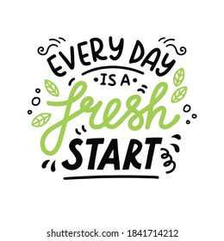

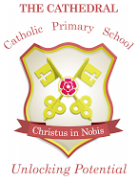

Unlocking potential together

in faith and love.